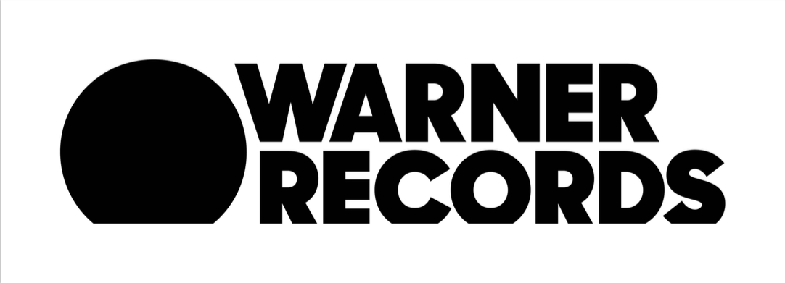
***MEDIA ALERT***MEDIA ALERT***MEDIA ALERT***

GOO GOO DOLLS UNVEIL COLORFUL NEW MUSIC VIDEO FOR “MIRACLE PILL”

WATCH NOW HERE

July 16, 2019 (Los Angeles, CA) — Multi-platinum, four-time GRAMMY-nominated rock band Goo Goo Dolls have unveiled the official music video for their single “Miracle Pill” today. The song marks the first release off of the band’s brand new upcoming album also titled Miracle Pill (Warner Records), which observes and reflects on the current landscape of instant gratification and relief that everyone seems to be seeking. Featuring lead singer & guitarist John Rzeznik and bassist & vocalist Robby Takac, the video shows the band in a plain white room. After taking the “miracle pill’, the walls start to bleed vivid technicolor paint, ultimately ending in chaos and an enormous mess. Earlier today, Billboard exclusively premiered the video HERE and called it a “vibrant pairing of lyrics and visual”. The piece was directed by Ed Gregory & Dan Cooper and the official music video link can be found HERE.

Goo Goo Dolls are currently in the midst of a massive co-headlining amphitheater tour alongside GRAMMY-winning band Train. The nationwide run will make numerous stops at outdoor venues across North America this summer before concluding on August 17, 2019 in Mansfield, MA at Xfinity Center. Goo Goo Dolls will then embark on several South American tour dates this fall, including a highly anticipated appearance at the iconic music festival Rock in Rio on September 29th, 2019 in Rio de Janeiro. For more information and a complete list of tour dates, please see below or visit GooGooDolls.com.

2019 Tour Dates
July 16th - Nashville, TN @ Ascend Amphitheater*
July 18th - Walker, MN @ Moondance Jam*
July 20th - Tinley Park, IL @ Hollywood Casino Amphitheater*
July 21st - Noblesville, IN @ Ruoff Home Mortgage Music Center*
July 23rd - Clarkston, MI @ DTE Energy Music Theatre*
July 24th - Cincinnati, OH @ Riverbend Music Center*
July 26th - Saratoga Springs, NY @ Saratoga Performing Arts Center*
July 27th - Bethel, NY @ Bethel Woods Center for the Arts*
July 28th - Gilford, NH @ Meadowbrook Music Pavilion*
July 30th - Bangor, ME @ Darling's Waterfront Park Pavilion*
August 1st - Scranton, PA @ Pavilion at Montage Mountain*
August 2nd - Canandaigua, NY @ Constellation Brands Marvin Sands Performing Arts Center*
August 3rd - Wantagh, NY @ Northwell Health at Jones Beach Theater*
August 5th - Lenox, MA @ Tanglewood Amphitheatre*
August 6th - Bethlehem, PA @ Musikfest*
August 7th - Burgettstown, PA @ KeyBank Pavilion*
August 9th - Columbia, MD @ Merriweather Post Pavilion*
August 10th - Camden, NJ @ BB&T Pavilion*
August 11th - Uncasville, CT @ Mohegan Sun Arena*
August 14th - Cuyahoga Falls, OH @ Blossom Music Center*
August 16th - Holmdel, NJ @ PNC Bank Arts Center*
August 17th - Mansfield, MA @ Xfinity Center*
September 22nd - Recife, Brazil @ Estádio do Arruda
September 25th - Sao Paulo, Brazil @ Allianz Parque
September 27th - Curitiba, Brazil @ Pedreira Paulo Leminski
September 29th - Rio de Janeiro, Brazil @ Rock in Rio 2019
October 2nd - Lima, Peru @ Estadio Monumental

*Co-headlining dates with Train
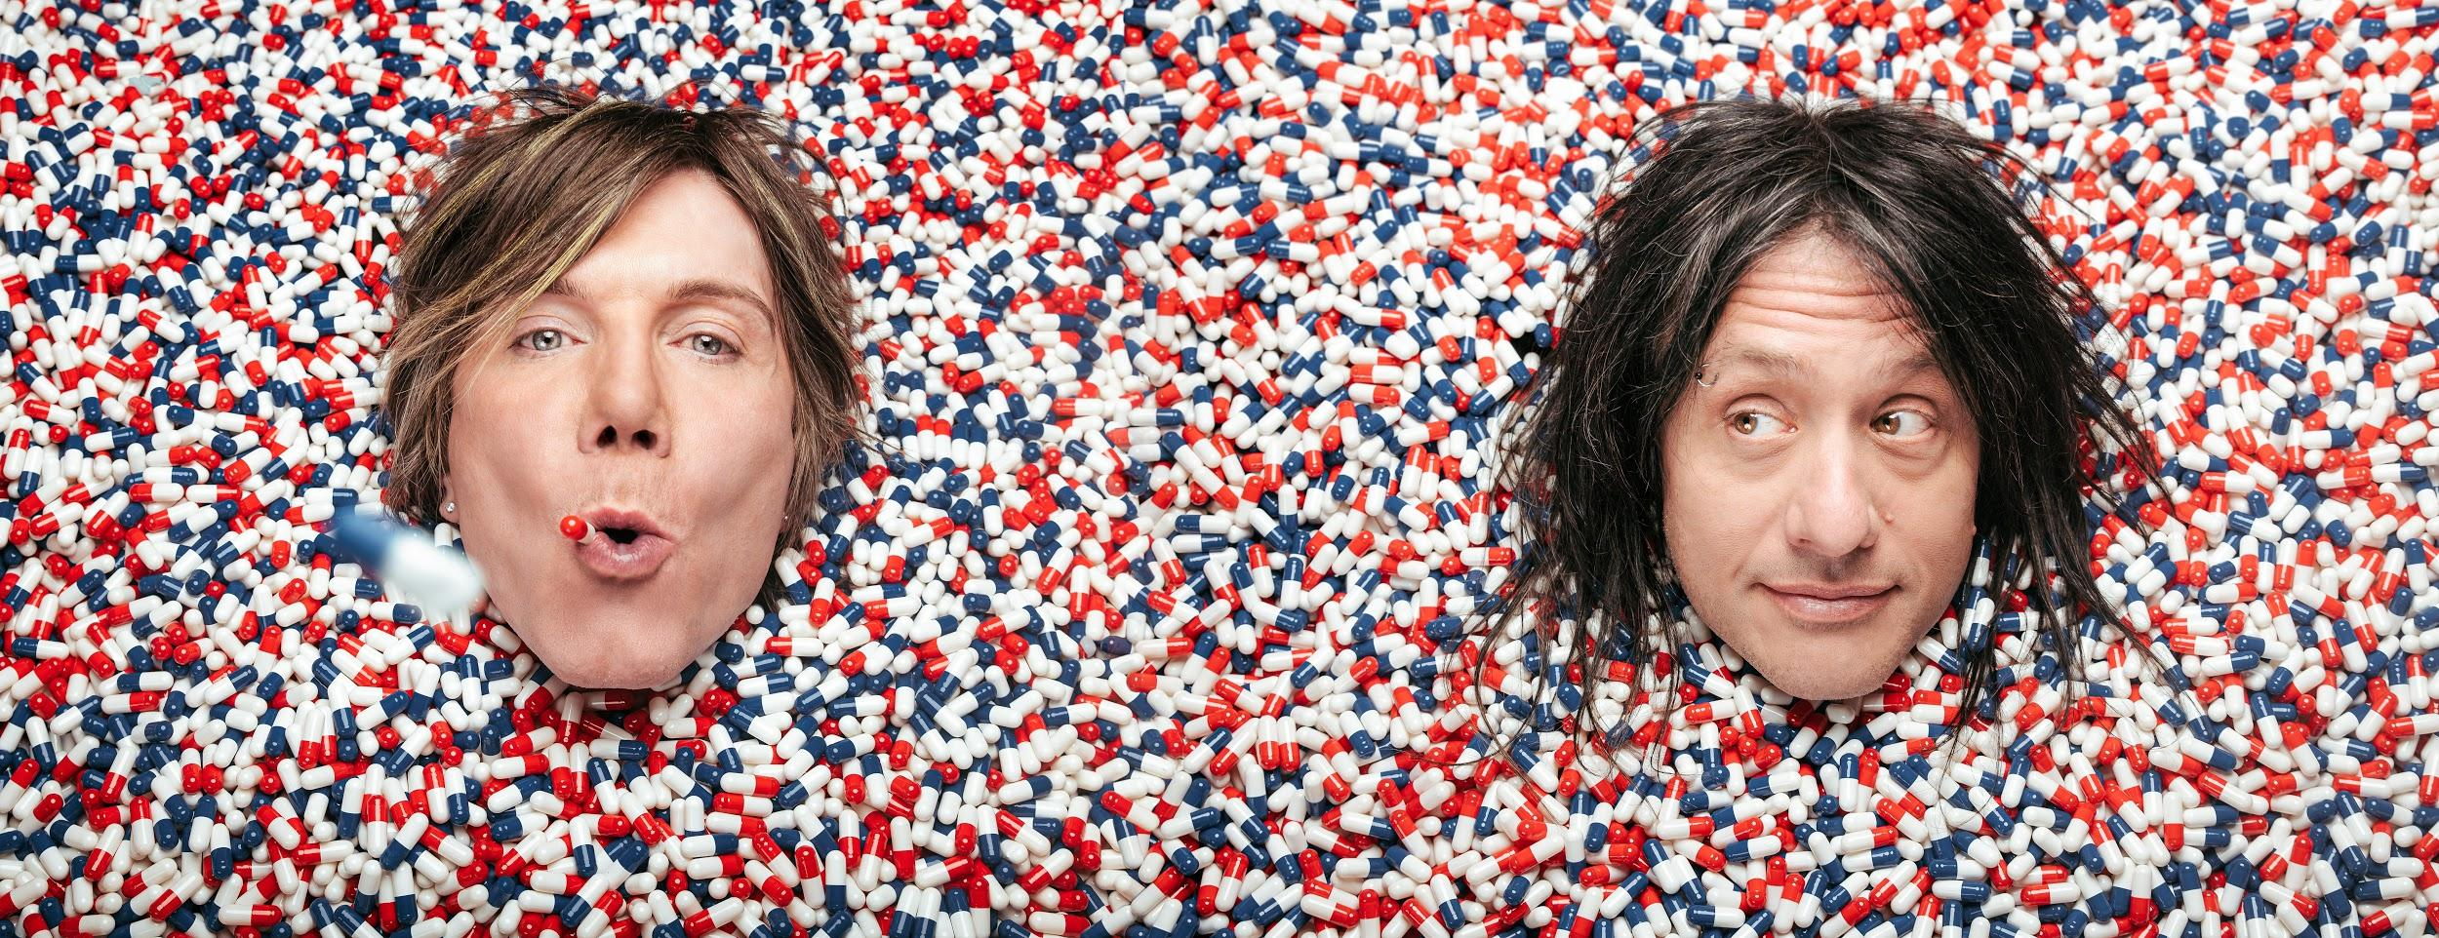
Goo Goo Dolls (Photo Credit: Ed Gregory & Dan Cooper)

ABOUT GOO GOO DOLLS:
Formed in Buffalo, NY during 1986 by John Rzeznik and Robby Takac, Goo Goo Dolls quietly broke records, contributed a string of staples to the American songbook, connected to millions of fans, and indelibly impacted popular music for three-plus decades. Beyond selling 12 million records worldwide, the group garnered four GRAMMY® Award nominations and seized a page in the history books by achieving 14 number one and Top 10 hits at Hot AC—"the most of any artist.” As a result, they hold the all-time radio record for “Most Top 10 Singles.” Among a string of hits, “Iris” clutched #1 on the Hot 100 for 18 straight weeks and would be named “#1 Top 40 Song of the Last 20 Years.” Thus far, A Boy Named Goo [1995] went double-platinum, Dizzy Up The Girl went quadruple-platinum, and Gutterflower [2002] and Let Love In [2006] both went gold as Something for the Rest of Us [2010] and Magnetic [2013] bowed in the Top 10 of the Billboard Top 200. 2016’s Boxes attracted the praise of People and Huffington Post as Noisey, Consequence of Sound, and more featured them. Their music has been covered by everyone from Taylor Swift to Leona Lewis. Among many accolades, John received the prestigious “Hal David Starlight Award” in 2008 as well.

Following a sold-out 2018 twentieth anniversary tour in celebration of Dizzy Up The Girl, Goo Goo Dolls wrote and recorded their twelfth full-length album, Miracle Pill [Warner Records]—ignited by the first single and title track “Miracle Pill” and kicking off a bold and bright new era in the process.

# # #

Contact:
Luke Burland / BB Gun Press
323.904.9094 / luke@bbgunpress.com

Peter Quinn / BB Gun Press
323.904.9094 / peter@bbgunpress.com

