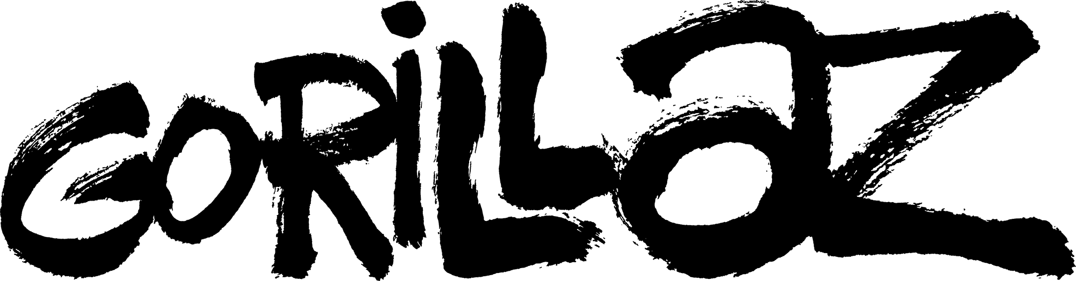

Song Machine
Season 1 Episode 3

“Aries”
Ft. Peter Hook and Georgia

WATCH HERE

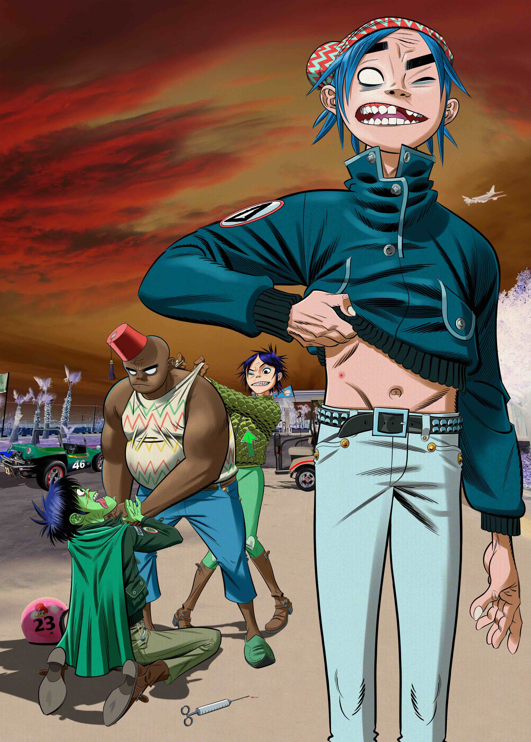

April 9, 2020 (Los Angeles, CA) – “Aries” is the third episode of Song Machine from Gorillaz. Featuring the legendary Peter Hook on bass, with alt-pop singer and producer Georgia on drums, “Aries” sees our virtual heroes capture much of the current mood with a soaring affirmation of human connection. Watch Aries ft. Peter Hook and Georgia HERE.

We last saw 2D, Noodle and Russel when they visited Lake Como, via a Kong Studios portal, while accidentally (or not) leaving bandmate Murdoc behind. Aries now picks up with Murdoc inviting longtime bandmate and rival 2D on a trip for some quality frenemy time, with a little truth serum on hand for the ride…

Gorillaz guitarist Noodle said - “Highly impatient and competitive, many Aries have the fighting spirit of your mythological ruler.”

With last week’s message from Murdoc Niccals, the band assured fans that the Song Machine remains ON... And now they are inviting the bold and the brave to escape the unreality of lockdown and Get Lost With Gorillaz as Murdoc, 2D, Noodle and Russel, drawn to various locations around the world, send back regular reports from the splendidly real confines of virtual isolation.

G Club is the band’s new virtual meeting space where social distancing does not apply, sign up here.

Gorillaz are once again disrupting the paradigm and breaking convention in their round the back door fashion with Song Machine, the newest concept from one of the most inventive bands around. Song Machine - the cartoon music contraption which spits out brand new episodes fresh from the studio, as and when they happen - will see Gorillaz joined by an exciting and ever-evolving roster of as yet unannounced collaborators captured live in Kong Studios alongside the world’s most successful virtual band*. The cameras are rolling 24/7, the fourth wall is broken, the kettle is on, the chaos is real, the door is open… What’s coming next? Stay tuned.

Watch Episode 1 - Momentary Bliss ft. slowthai and Slaves - here.
Watch Episode 2 - Désolé ft Fatoumata Diawara – here.

Follow Song Machine here to catch Machine Bitez – bite sized conversation between cartoon band members and collaborators, overheard in Kong Studios.

Follow Get Lost With Gorillaz on your chosen platform here.

www.gorillaz.com
About Gorillaz:
Virtual band Gorillaz is singer 2D, bassist Murdoc Niccals, guitarist Noodle and drummer Russel Hobbs. Created by Damon Albarn and Jamie Hewlett, their acclaimed eponymous debut album was released in 2001. The BRIT and Grammy Award winning band’s subsequent albums are Demon Days (2005), Plastic Beach (2010), The Fall (2011), Humanz (2017) and The Now Now (2018). A truly global phenomenon, Gorillaz have achieved success in entirely ground-breaking ways, touring the world from San Diego to Syria, winning numerous awards including the coveted Jim Henson Creativity Honor.

* The band are recognised by The Guinness Book Of World Records as the planet’s Most Successful Virtual Act.

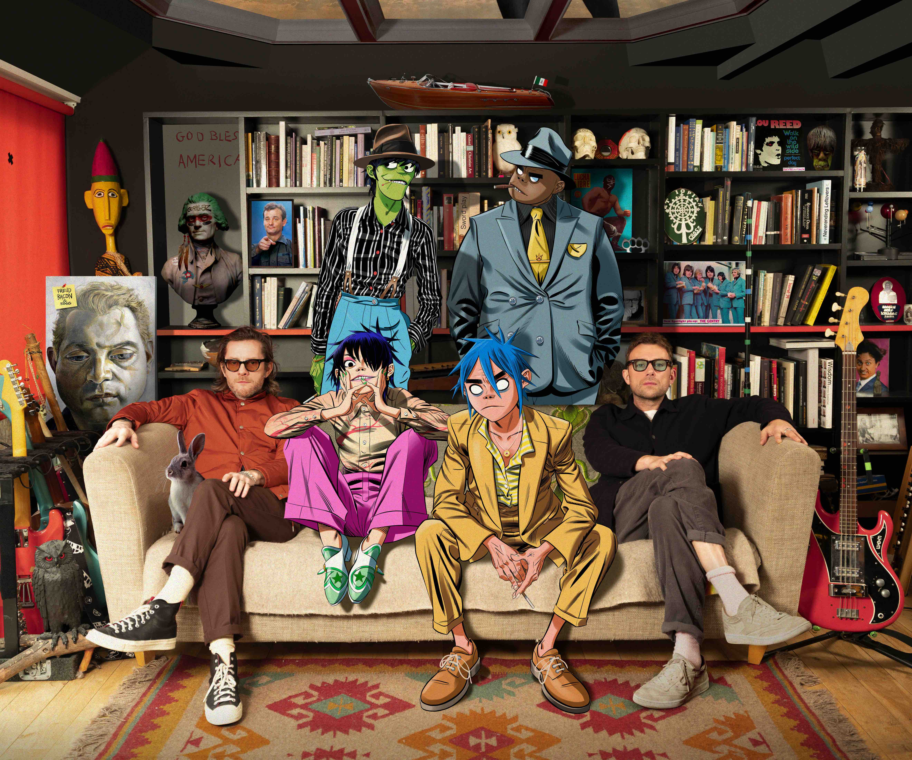
Download press shots here
# # #
For further information, contact Warner Records Publicity:
Rick Gershon at Warner Records
818-953-3473 / rick.gershon@warnerrecords.com

Follow Gorillaz
Website | Instagram | Twitter | Facebook | YouTube | Press Materials

