GLOBAL SUPERSTAR JOSH GROBAN RELEASES “GRANTED”
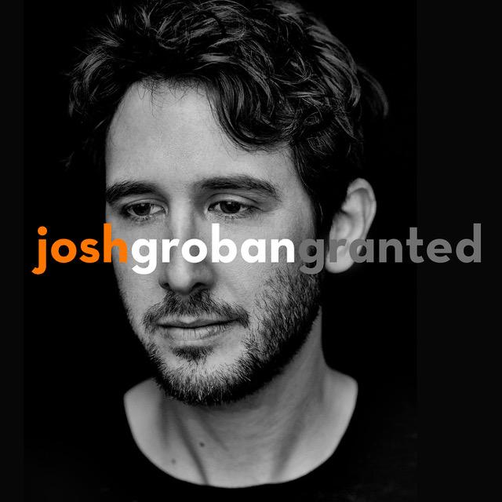
FIRST SINGLE FROM FORTHCOMING 8TH STUDIO ALBUM
DUE THIS FALL

GROBAN TO CO-HOST THE 72ND ANNUAL TONY AWARDS IN
NEW YORK CITY THIS SUNDAY, JUNE 10TH

ARENA TOUR
W/ VERY SPECIAL GUEST, IDINA MENZEL
THIS FALL

June 8, 2018 (Los Angeles, CA) - Today, multi-platinum award-winning singer/songwriter and global superstar Josh Groban releases “Granted,” the first single from his highly anticipated forthcoming album, slated for release this fall via Warner Bros. Records. Groban wrote “Granted” with Toby Gad (Beyonce, Madonna, John Legend) and Bernie Herms (Selena Gomez, Kelly Clarkson, Barbra Streisand). “Granted” available now, HERE.

Groban also released a lyric video for this beautifully uplifting song which features some amazingly talented students from Groban’s alma mater, Los Angeles County High School of the Arts, to help convey the song’s lyrics. LACHSA is one of the many recipients of Josh’s Find Your Light Foundation, which has funded over 80 children’s arts education programs around the country (focusing on low-income areas), educating the public on the importance of arts education and advocating for arts education through a myriad of different channels. Their mission is dedicated to ensuring that each child has the opportunity to experience a quality arts education. Watch the video HERE.

This Sunday, June 10th, Groban will co-host the 72nd Annual Tony® Awards alongside Sara Bareilles, live from Radio City Music Hall in New York City on CBS at 8:00 PM EST. This will be both Bareilles and Groban’s first time hosting the show.

In March Groban announced his Fall 2018, Arena tour. This is Josh’s first tour since his sold-out Stages Tour 2015/2016 and joining him throughout the tour is Tony-Award winning, multi-platinum recording artist and actress, Idina Menzel.

Dates below:
Thurs., October 18 Duluth, GA Infinite Energy Center
Fri., October 19 Nashville, TN Bridgestone Arena
Tues., October 23 Houston, TX Toyota Center
Wed., October 24 Dallas, TX American Airlines Center
Fri., October 26 Phoenix, AZ Talking Stick Resort Arena
Sat., October 27 Inglewood, CA The Forum
Mon, October 29 Salt Lake City, UT Vivint Smart Home Arena
Tues, October 30 Denver, CO Pepsi Center
Fri., November 2 St. Paul, MN Xcel Energy Center
Sat., November 3 Milwaukee, WI WI Entertainment & Sports Center
Tues., November 6 Chicago, IL United Center
Wed., November 7 Detroit, MI Little Caesars
Fri., November 9 Boston, MA TD Garden
Mon., November 12 Philadelphia, PA Wells Fargo Arena
Tues., November 13 Rochester, NY Blue Cross Arena
Thurs., November 15 Washington DC Capital One Arena
Fri., November 16 Pittsburgh, PA PPG Paints Arena
Sun., November 18 New York, NY Madison Square Garden

Possessing one of the most outstanding and instantly recognizable voices in music, GRAMMY nominated singer, songwriter, and actor Josh Groban has entertained fans across the globe with his multi-platinum albums and DVDs (over 30 million sold worldwide), electrifying live performances, and comedic film and television appearances. The 36-year-old Los Angeles native is the only artist who has had two albums appear on the Top 20 Best-Selling Albums list of the past decade, according to Billboard. He has appeared in the feature films Crazy, Stupid, Love, The Hollars, Coffee Town, and Muppets Most Wanted, as well as on NBC’s The Office, FX’s It’s Always Sunny in Philadelphia, and CBS’ The Crazy Ones. Groban has released seven studio albums, his 2001 self-titled 5x-platinum debut, 2003’s 6x-platinum Closer, 2006’s double-platinum Awake, 2007’s 6x platinum Grammy-nominated Noel, 2010’s gold-certified Illuminations, and 2013’s gold-certified All That Echoes, which debuted at No. 1 on the Billboard Top 200 chart, giving Groban his first No. 1 debut and third chart-topper. In 2017, Groban concluded his Broadway run in Natasha, Pierre & The Great Comet of 1812, which Time Out New York called, “one of the best musicals of the decade”. He also released his first coffee table book, Stage to Stage: My Journey to Broadway. which documented the past two years of his life on Broadway. Groban remains an active arts education philanthropist and advocate as a member of Americans for the Arts Artists Committee and Groban’s Find Your Light Foundation helps enrich the lives of young people through arts, education, and cultural awareness. Currently, Groban just wrapped filming for the new Netflix series, The Good Cop, starring opposite Tony Danza, and working on his eighth studio album due out later this year.

JoshGroban.com | Facebook.com/JoshGroban | Twitter:@JoshGroban | Instagram:@JoshGroban

# # #

For further information please contact:
Luke Burland, BB Gun Press / 323 904 9094
luke@bbgunpress.com

