GREEN DAY CELEBRATE 25TH ANNIVERSARY OF INSOMNIAC WITH SPECIAL-EDITION VINYL TODAY

Double Vinyl Set Features Eight Previously Unreleased Live Tracks
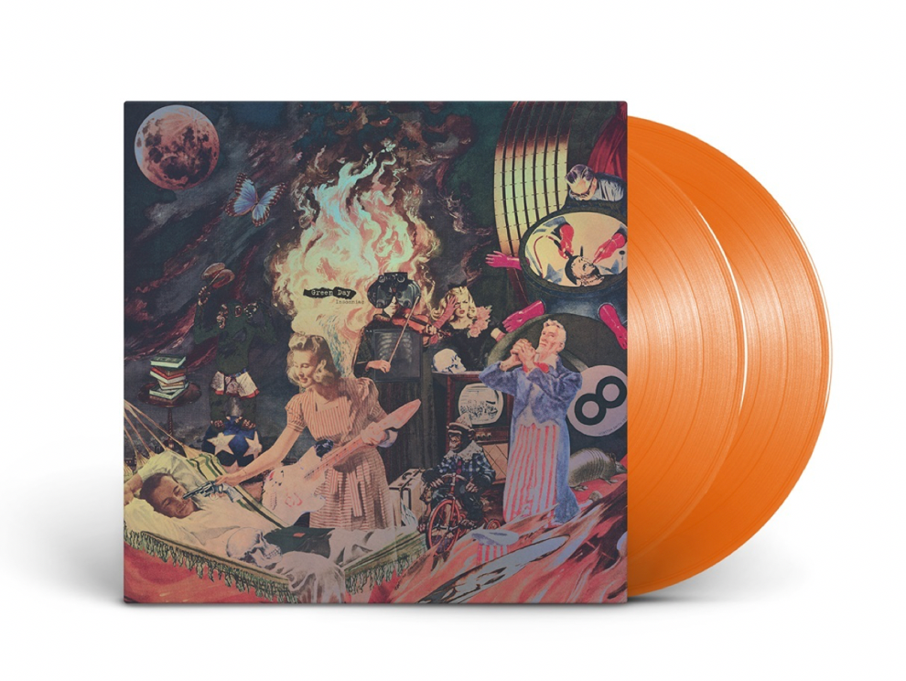
Click here for hi-res image

March 19, 2021 (Los Angeles, CA) – To celebrate the 25th birthday of their fourth full-length album in style, five-time GRAMMY® Award-winning band Green Day unleash the Insomniac 25th Anniversary Vinyl (Reprise/Warner Records). The commemorative collection is available today as a limited-edition translucent orange vinyl double LP with the iconic art recast on prismatic silver foil with an etched B-side. The remastered original tracks – along with the 8 new live tracks – are available on all DSPs. Order and stream HERE.

Bringing audiences back to the Insomniac era, the Rock & Roll Hall of Fame band rediscovered eight rare and previously unreleased live tracks from a particularly unforgettable March, 1996 gig in Prague during the Insomniac World Tour. The music featured on the additional LP includes hyper-charged renditions of classics such as “Brain Stew,” “Jaded,” and “Walking Contradiction.”

Insomniac holds a very special place in Green Day’s discography. The 14 tracks are a stark, dynamic, introspective, and infectious collection of anthems which the band cut at Hyde Street in San Francisco. The critically-acclaimed album has since become the subject of numerous think-pieces and retrospectives, emerging as something of a middle finger-raising dark horse in the band’s catalog. Looking back, KERRANG! lauded it as “a master class in buzzsaw efficiency, the songs are so economical, not to mention harsh, that the removal of even a single chord would cause each composition to collapse in on itself” before going on to christen it a “magnificent 14-song set.”

INSOMNIAC 25th Anniversary Tracklisting
Side 1
1. Armatage Shanks
2. Brat
3. Stuck with Me
4. Geek Stink Breath
5. No Pride
6. Bab’s Uvula Who?
7. 86

Side 2
1. Panic Song
2. Stuart and the Ave.
3. Brain Stew
4. Jaded
5. Westbound Sign
6. Tight Wad Hill
7. Walking Contradiction

Side 3
1. Armatage Shanks (Live in Prague)
2. Brat (Live in Prague)
3. Geek Stink Breath (Live in Prague)
4. Stuck with Me (Live in Prague)
5. Brain Stew (Live in Prague)
6. Jaded (Live in Prague)
7. Walking Contradiction (Live in Prague)
8. 86 (Live in Prague)
ABOUT GREEN DAY:
Berkley-formed, five-time Grammy Award-winning rock band Green Day is one of the world’s best-selling bands of all time, with more than 70 million records sold worldwide and 10 billion cumulative audio/visual streams. Their breakout album Dookie, which sold over 10 million and achieved diamond status, is widely credited with popularizing and reviving mainstream interest in punk rock, catapulting a career-long run of #1 hit singles. Green Day’s release of rock opera American Idiot captured the nation’s attention, selling more than 7 million copies in the U.S. alone, taking home the Grammy Award for Best Rock Album and lead to a critically acclaimed stage adaptation on Broadway. Released on February 7, 2020, Green Day’s thirteenth studio album Father Of All... (Reprise/Warner Records) debuted at #1 on Billboard’s Album Sales Chart and #1 in both the U.K. and Australia. Pitchfork declared, “Green Day’s most fetching and youthful songs in ages. The trio sounds reinvigorated, more like hungry newcomers staking their claim.”

FOLLOW GREEN DAY
Facebook | Twitter | Instagram | YouTube | Press Site | Website

