GREEN DAY UNVEIL NEW SINGLE “FATHER OF ALL…,” FROM FORTHCOMING ALBUM FATHER OF ALL… OUT FEBRUARY 7, 2020 VIA REPRISE/WARNER RECORDS

GLOBAL STADIUM THE HELLA MEGA TOUR PRESENTED BY HARLEY-DAVIDSON ANNOUNCED WITH FALL OUT BOY AND WEEZER, PLUS ADDITIONAL SOLO DATES THROUGHOUT EUROPE AND ASIA

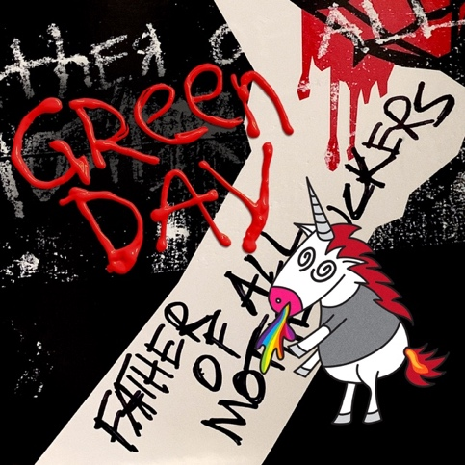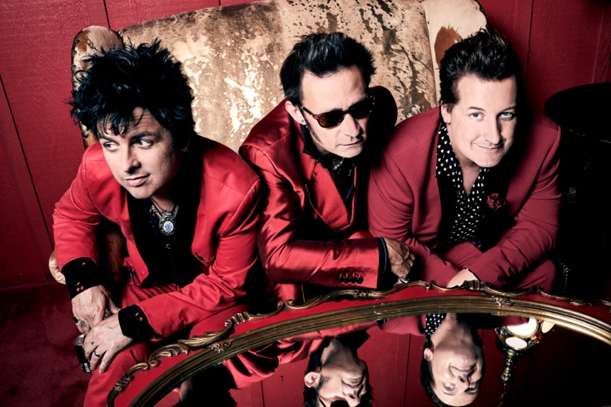
Click here for hi-res album art and press photo

September 10, 2019 (Los Angeles, CA) - Five-time Grammy Award-winning Rock and Roll Hall of Fame inductees Green Day unleash their brand new single “Father Of All…,” which is the lead track on their forthcoming thirteenth studio album of the same name, out February 7, 2020 on Reprise / Warner Records.

The rock icons announced today that they will embark on a global stadium tour with Fall Out Boy and Weezer. The Hella Mega Tour presented by Harley-Davidson kicks off June 13 in Paris and will visit cities throughout Europe, the U.K. and North America. Additionally, Green Day will perform a series of solo dates throughout Europe and Asia. Click here for all dates. Pre-order the album Father Of All… here. Listen to their single “Father of All…” here.

Formed in 1986 in Berkeley, CA, Green Day is one of the world’s best-selling bands of all time, with more than 70 million records sold worldwide and 10 billion cumulative audio/visual streams. Their 1994 breakout album Dookie, which sold over 10 million and achieved diamond status, is widely credited with popularizing and reviving mainstream interest in punk rock, catapulting a career-long run of #1 hit singles.

Entertainment Weekly calls Green Day, “The most influential band of their generation,” while Rolling Stone attests, “Green Day have inspired more young bands to start than any act this side of KISS, and that doesn't seem to be changing.”

In 2004, Green Day released the rock opera American Idiot which captured the nation’s attention, selling more than 7 million copies in the U.S. alone and taking home the Grammy Award for Best Rock Album. Mojo declared “It's exhilarating stuff, the kind of record that sets new parameters as to what is possible from a punk rock'n'roll band in the 21st century.” In 2010, a stage adaptation of American Idiot debuted on Broadway to critical and commercial acclaim.

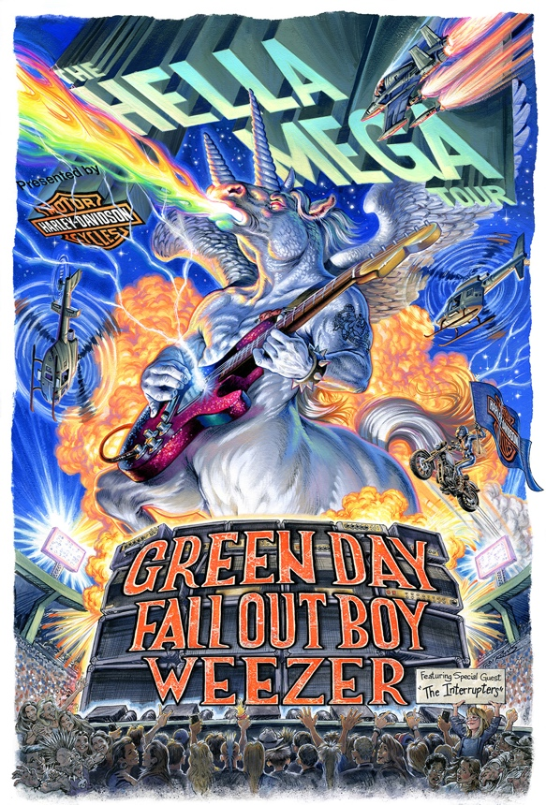
Click here for hi-res image

Green Day Solo Dates:

DATE CITY VENUE
Sunday, March 8 SINGAPORE, SG Singapore Indoor Stadium
Wednesday, March 11 BANGKOK, TH Impact Arena
Saturday, March 14 MANILA, PH Mall of Asia Arena
Tuesday, March 17 TAIPEI, TW Taipei Arena
Friday, March 20 HONG KONG, CN Asia World Expo
Sunday, March 22 SEOUL, KR Jamsil Indoor Gym
Wednesday, March 25 OSAKA, JP Intex
Friday, March 27 TOKYO, JP Makuhari Messe
Sunday, May 24 MOSCOW, RU Spartak Stadium
Wednesday, May 27 HELSINKI, FI Suvilhati
Friday, May 29 STOCKHOLM, SE Tele2 Arena
Sunday, May 31 ALESUND, NO Colorline Stadium
*Wednesday, June 3 BERLIN, GER Wuhlheide
*Wednesday, June 10 MILAN, ITL Ippodromo San Siro
*With Weezer

THE HELLA MEGA TOUR Europe & UK Dates:

DATE CITY VENUE
Saturday, June 13 PARIS, FRANCE La Defense Arena
Sunday, June 14 GRONINGEN, NETHERLANDS Stadspark
Wednesday, June 17 ANTWERP, BELGIUM Sportpaleis
Sunday, June 21 VIENNA, AUSTRIA Ernst Happel Stadium
Wednesday, June 24 GLASGOW, SCOTLAND Bellahouston Park
Friday, June 26 LONDON, ENGLAND London Stadium
Saturday, June 27 HUDDERSFIELD, ENGLAND The John Smith’s Stadium
Monday, June 29 DUBLIN, IRELAND RDS Arena

THE HELLA MEGA TOUR North American Dates:

DATE CITY VENUE
Friday, July 17 SEATTLE, WA T-Mobile Park
Tuesday, July 21 SAN FRANCISCO, CA Oracle Park
Friday, July 24 SAN DIEGO, CA Petco Park
Saturday, July 25 LOS ANGELES, CA Dodger Stadium
Tuesday, July 28 COMMERCE CITY, CO DICK’s Sporting Goods Park
Friday, July 31 ARLINGTON, TX Globe Life Field
Saturday, August 1 HOUSTON, TX Minute Maid Park
Wednesday, August 5 MIAMI, FL Hard Rock Stadium
Thursday, August 6 JACKSONVILLE, FL TIAA Bank Field
Saturday, August 8 ATLANTA, GA SunTrust Park
Tuesday, August 11 MINNEAPOLIS, MN Target Field
Thursday, August 13 CHICAGO, IL Wrigley Field
Saturday, August 15 PITTSBURGH, PA PNC Park
Sunday, August 16 HERSHEY, PA Hersheypark Stadium
Wednesday, August 19 DETROIT, MI Comerica Park
Friday, August 21 WASHINGTON, DC Nationals Park
Saturday, August 22 NEW YORK, NY Citi Field
Monday, August 24 TORONTO, ON Rogers Centre
Thursday, August 27 BOSTON, MA Fenway Park
Saturday, August 29 PHILADELPHIA, PA Citizens Bank Park

