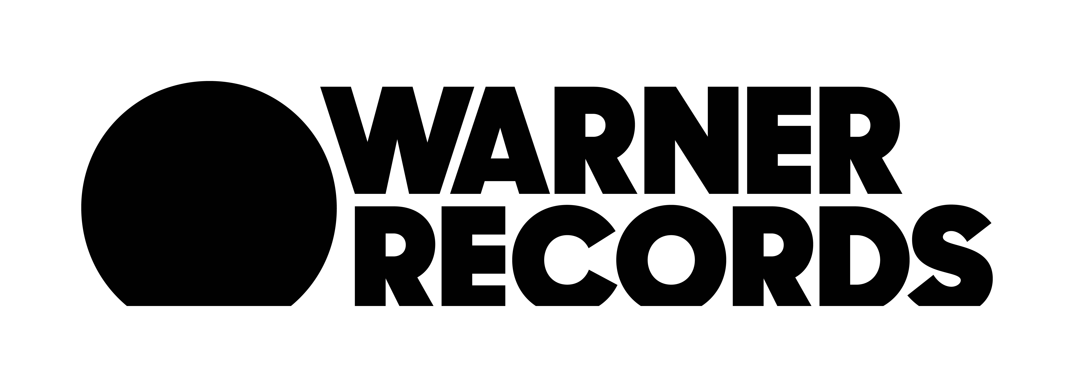
GRIFF Releases New Holiday Track “Eternal Flame” HERE
The Mirror Talk EP Available Now
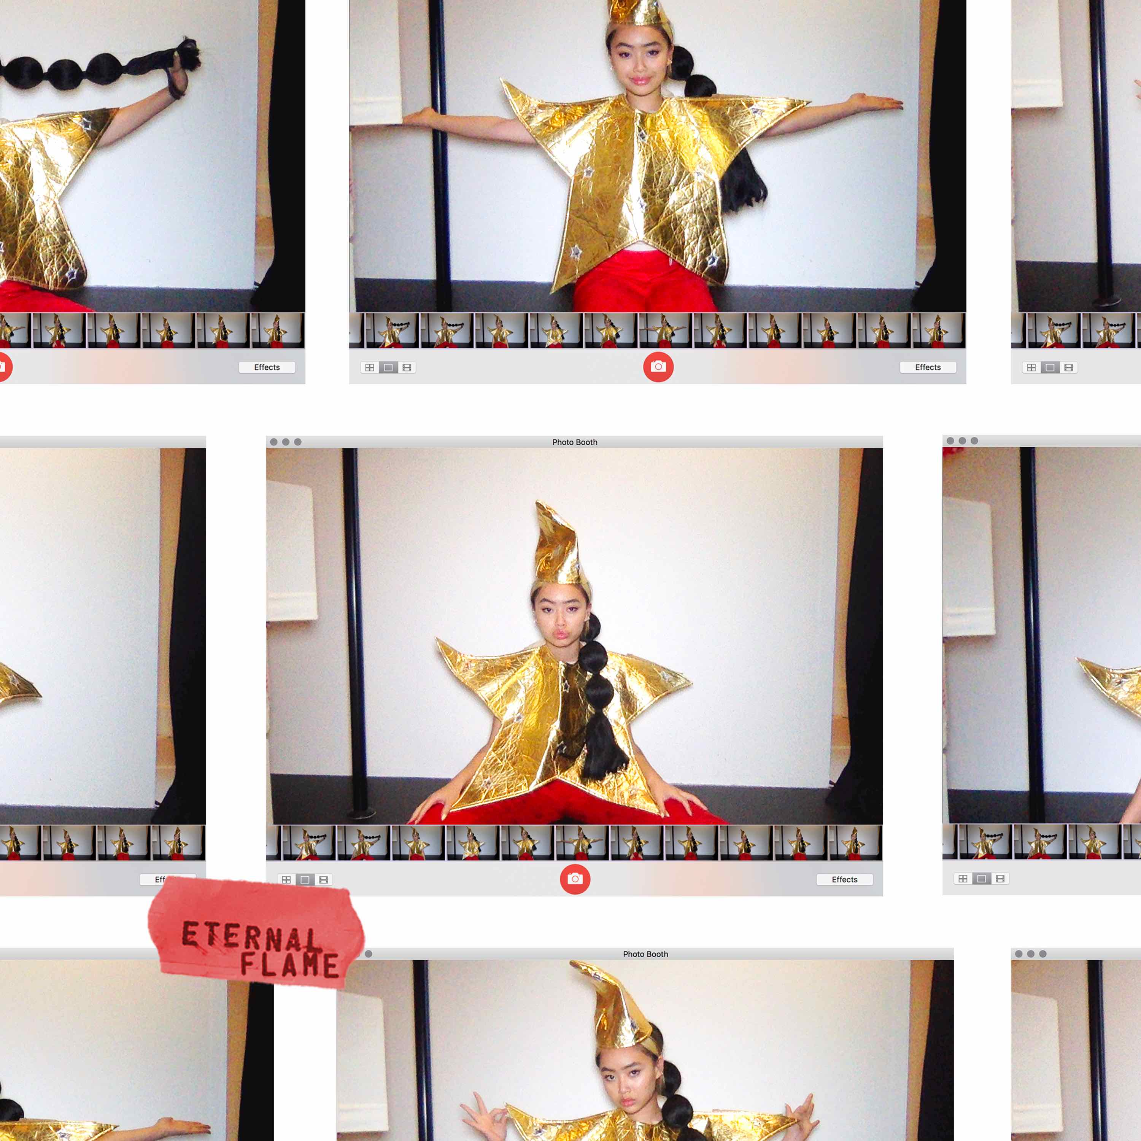
"Startlingly good...think Lorde meets FKA Twigs" - Sunday Times
"Griff is the hottest new artist to come out of the UK since Dua Lipa." - V Mag
"Writer, producer, stylist, designer and creative director, it's clear that Griff is a force to be reckoned with" - Vogue
"A no-nonsense debut…Griff cuts a strong, empowering female voice: she knows the weight of her strength as well as her flaws" - The Line of Best Fit

December 13, 2019 (Los Angeles, CA) – Today, GRIFF has released a surprise cover of The Bangles' classic “Eternal Flame,” available via Warner Records. The multi-disciplined 18-year-old recently released her debut EP, The Mirror Talk, which includes acclaimed lead track “Sound Of Your Voice.” Watch HERE. GRIFF played her first ever live show earlier this month before a sold-out Hoxton Hall, an experience and creative process (right down to her DIY curtains) which is captured in the “Sound Of Your Voice” music video also available today.

The version of “Eternal Flame” that has emerged is a classic pop anthem given the GRIFF treatment: self-produced, stripped-back, and requiring little more than bedroom electronics, gentle orchestration and GRIFF's soaring, gospel and R&B-inspired vocals to make even a Bangles classic sound totally her own.

GRIFF is a one-woman production, songwriting and visual powerhouse, who - on the strength of The Mirror Talk EP alone, not to mention her signature bubble ponytail – is already honing future-pop powers. On the one hand, GRIFF is your textbook girl next door: a straight-A student from a city just outside London, who recently graduated from school. On the other hand, she is already showcasing a wisdom beyond her years, with songs that carefully examine those highs and lows of modern teenage life. Born to Chinese and Jamaican parents, GRIFF was brought up alongside two brothers and the family's foster children, in and amongst which she found quiet by borrowing her brother’s Logic, teaching herself how to make music, and writing songs in secret from her classmates. Indeed, the first time many of them knew GRIFF was making music occurred when they heard Annie Mac gave “Mirror Talk” its first play.
Having completed her exams earlier this summer, GRIFF's reworking of “Eternal Flame” follows hot on the heels of her debut release, The Mirror Talk EP. Hers is an all-encompassing approach which extends to GRIFF not only producing the bulk of these songs herself, but making her own clothes - as exhibited on her striking artwork - shooting live visuals crammed into her home studio, or trying her hand in the creative direction of her live shows. It’s this fearlessness (coupled with the hopes and fears of any 18 year old) that make GRIFF truly special. Over the next twelve months, GRIFF’s star-shaped outfit on the “Eternal Flame” artwork looks set to become an increasing reality.

Follow GRIFF
Press Site | YouTube | Instagram | Twitter | Facebook

Press Contact:
Bre Flores | Warner Records
818-953-3638
Breanne.Flores@warnerrecords.com

