UK POP SIREN GRIFF RELEASES NEW SONG “FORGIVE MYSELF”

LISTEN HERE

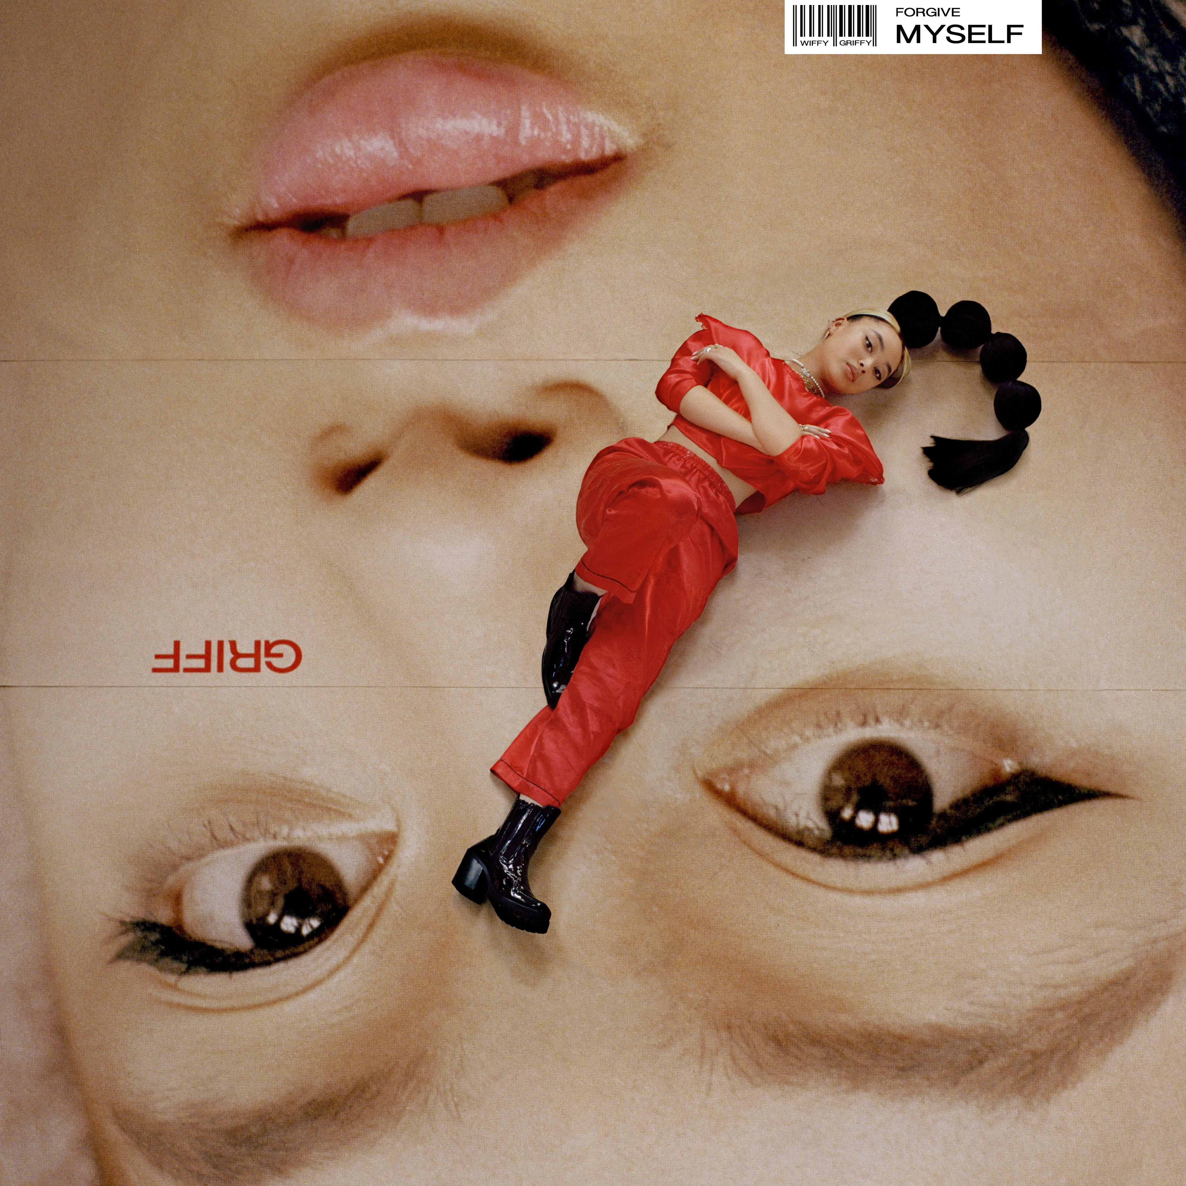
"Writer, producer, stylist, designer and creative director, it's clear that Griff is a force to be reckoned with." - Vogue
"Griff is the hottest new artist to come out of the UK since Dua Lipa." - V Mag
“The teenage boss about to take charge of pop.” - NME

"Griff looks every bit like pop’s bright new star...it is, quite frankly, all rather brilliant." - i-D
May 29, 2020 (Los Angeles, CA) – Rising 19-year old UK songstress GRIFF who was named one of NME’s “essential new artists for 2020,” releases her latest pop anthem “Forgive Myself,” today via Warner Records. Listen HERE.

On “Forgive Myself,” GRIFF confirms her potential as the new face of British pop ready to take over the world. Flipping the break-up song on its head, it's less about an ex or teenage heartache as it is the relationship you have with yourself: those doubts, insecurities and questions of self-worth that only you can fix, if you are to have the courage to love again. As rawly intimate as it is spiritually empowered, “Forgive Myself” takes influences of electronic music, soul and R&B rendered in richly DIY style (all held together by Griff's soon-to-be instantly identifiable voice).

About writing “Forgive Myself,” GRIFF said, "I think I find it easy to be quite hard on myself when it comes to making decisions and trusting people. So this song was just about cutting myself some slack and forgiving myself for past relationships that maybe didn't end in the way I thought they would.”

“Forgive Myself” follows the February release of GRIFF’s beautifully stripped-back ballad “Good Stuff” which Paper Magazine lauded as “a gorgeous new piano ballad” and Idolator proclaimed “is a soaring, largely-acoustic ballad that showcases the newcomer’s powerful pipes." The song has amassed over 20 million streams, GRIFF’s most successful song to date. Earlier this month she released an inventive acappella video for the track that she created and recorded herself at her family home outside of London. Watch the video here.

GRIFF also made her U.S. live debut in February, playing shows in Los Angeles and New York.
After her show at the Sayers Club in LA, Ones To Watch proclaimed, “we were fortunate enough to witness a star being born. Her jaw-dropping performance left the crowd in absolute awe.”

GRIFF finished high school last year and released her debut EP The Mirror Talk last November which Billboard called an “Electrifying Debut” and includes stand out tracks “Mirror Talk” and “Paradise.”

GRIFF is a one-woman production, songwriting and visual powerhouse, who - on the strength of her early releases, not to mention her signature bubble ponytail – is already honing future-pop powers. Born to Chinese and Jamaican parents just outside Watford, United Kingdom, she started making music by borrowing her brother’s Logic; teaching herself how to produce, and writing songs in secret from her classmates (many of whom only found out what GRIFF was up to when they heard “Mirror Talk” on Annie Mac). A straight-A student, GRIFF uses a multi-disciplined approach which extends to not only producing the bulk of these songs herself, but making her own clothes as exhibited on her striking artwork, shooting live visuals crammed into her home studio, and trying her hand in the creative direction of her live shows. It’s this fearlessness (coupled with the hopes and fears of any 19-year-old) that make GRIFF truly special.

###
For more information please contact Warner Records Publicity:
National: Darren Baber | 818-953-3751
Darren.baber@warnerrecords.com

Regional: Bre Flores | 818-953-3638
Breanne.flores@warnerrecords.com

Follow GRIFF
Press Materials | YouTube | Instagram | Twitter | Facebook

