BREAK-OUT UK ARTIST GRIFF RELEASES NEW SONG AND VIDEO “GOOD STUFF”

LISTEN/WATCH HERE
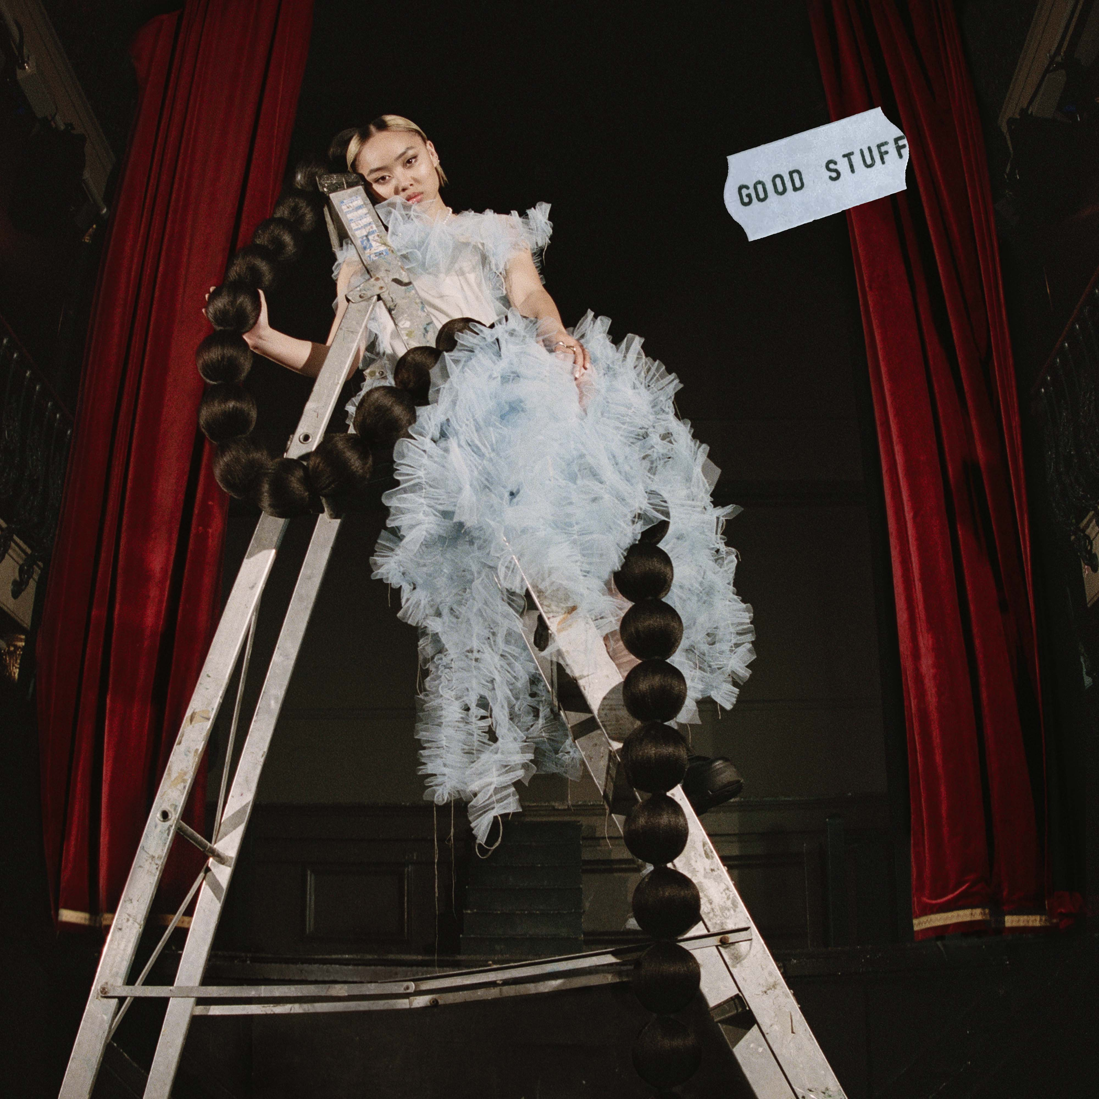

"Griff is the hottest new artist to come out of the UK since Dua Lipa." – V Mag
"the teenage boss about to take charge of pop" – NME
"Writer, producer, stylist, designer and creative director, it's clear that Griff is a force to be reckoned with" – Vogue
February 7, 2020 (Los Angeles, CA) – Rising songstress GRIFF has released her beautiful new track “Good Stuff,” available today via Warner Records. “Good Stuff” is a gorgeously stripped-back ballad with a twist. Over a little more than delicate piano and her soaring R&B vocals, what might at first appear to be a break-up anthem is in fact about a different sort of separation. Listen to “Good Stuff” HERE and watch the video HERE.

The release of “Good Stuff” follows a standout 2019 for the still-just-19-year-old, who recently finished high school and released her debut EP The Mirror Talk last November. Stand out tracks “Mirror Talk” and “Paradise” have amassed over 2 million streams and 1 million video views.

Already named one of NME’s “essential new artists for 2020,” GRIFF is primed to become a stand-out global star this year. She played her debut U.S. show last night in Los Angeles at the Sayer’s Club and will perform for the first time in New York City on February 10th at Baby’s All Right. Tickets available here.

GRIFF explains, “So my family foster children in care, and we've had kids come and live with us for as long as four years, but they always end up moving on to a more permanent situation. Every time they do, as a family we always only ever remember 'the good stuff' - even though fostering can be super difficult and hard. So about a year ago I came into the studio with 'only remember the good stuff when you go' written down in my phone notes, and that became this song.”

GRIFF is a one-woman production, songwriting and visual powerhouse, who - on the strength of her early releases, not to mention her signature bubble ponytail – is already honing future-pop powers. Born to Chinese and Jamaican parents just outside Watford, United Kingdom, she started making music by borrowing her brother’s Logic; teaching herself how to produce, and writing songs in secret from her classmates (many of whom only found out what GRIFF was up to when they heard “Mirror Talk” on Annie Mac). A straight-A student, GRIFF uses a multi-disciplined approach which extends to not only producing the bulk of these songs herself, but making her own clothes as exhibited on her striking artwork, shooting live visuals crammed into her home studio, and trying her hand in the creative direction of her live shows. It’s this fearlessness (coupled with the hopes and fears of any 19-year-old) that make GRIFF truly special.

###
For more information please contact Warner Records Publicity:
National: Darren Baber | 818-953-3751
Darren.baber@warnerrecords.com

Regional: Bre Flores | 818-953-3638
Breanne.flores@warnerrecords.com

Follow GRIFF
Press Materials | YouTube | Instagram | Twitter | Facebook

