
Saweetie Drops Her First Project "High Maintenance"
Justin Ivey on March 15, 2018
https://hiphopdx.com/news/id.46233/title.saweetie-drops-her-first-project-high-maintenance#

Saweetie burst onto the scene with her popular single “ICY GIRL” in 2017. Now, she aims for new heights with the release of her debut project, High Maintenance.

The West Coast up-and-comer’s first project features nine tracks and clocks in at just over 20 minutes, so it’s relatively brief introduction. Fans at SXSW will get a chance to hear Saweetie perform some of the songs live at HipHopDX’s Rap Rising showcase, which takes place on Friday (March 16).

View the stream, cover art and tracklist for High Maintenance below.
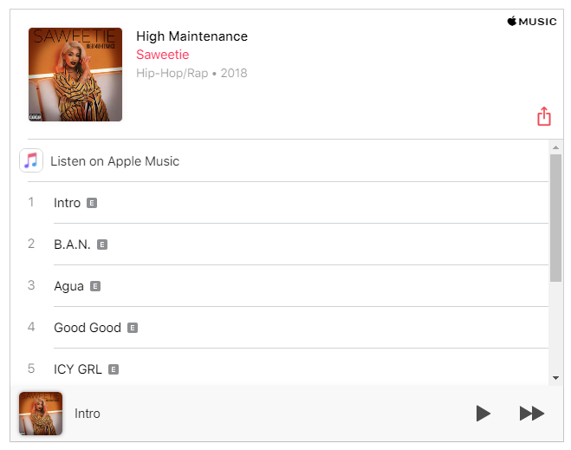
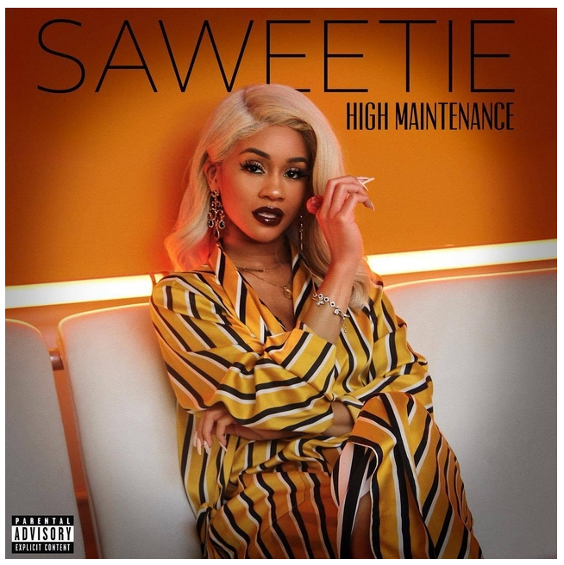
1. Intro
2. B.A.N.
3. Agua
4. Good Good
5. ICY GRL
6. High Maintenance
7. 23
8. Respect
9. Too Many

