

https://www.insider.com/bet-awards-daring-celebrity-fashion-at-after-parties-2022-6

THE MOST DARING LOOKS CELEBRITIES WORE TO THE BET AWARDS AFTER-PARTIES

LAYA looked edgy in a leather minidress and matching boots.

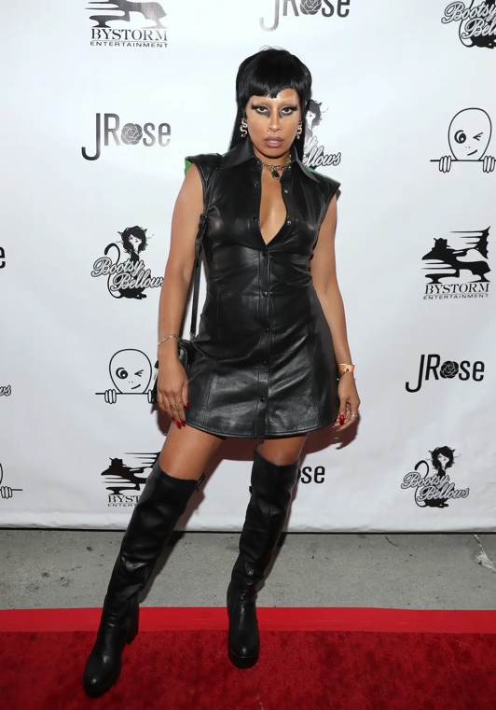

The musician's all-black outfit was made even more bold thanks to her long mullet, dark eye makeup, and metallic face jewelry.

