RISING TROUBADOUR JOHN-ROBERT RELEASES DEBUT EP
BAILEY BARLEY KNEW ME TODAY

PREMIERES “LOVE WON’T YOU STAY” ACOUSTIC VIDEO - WATCH HERE

COVERS FIONA APPLE’S “CRIMINAL” FOR GRAMMY REIMAGINED SERIES
WATCH HERE

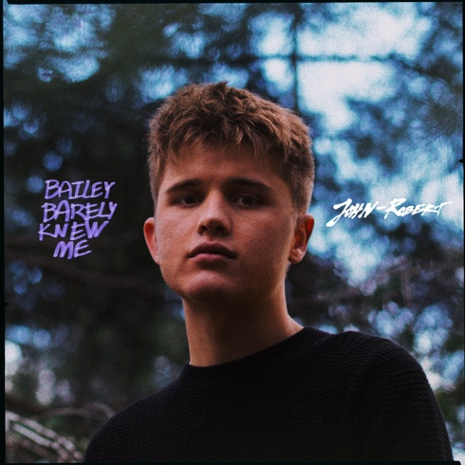

May 21, 2020 (Los Angeles, CA) - Rising artist and producer John-Robert releases his debut EP, Bailey Barley Knew Me today via Nice Life Recording Company and Warner Records. Listen to Bailey Barley Knew Me HERE.

The 19-year old also reveals an intimate acoustic video for new track “Love Won’t You Stay” which was filmed in his Shenandoah Valley hometown of Edinburg, Virginia, where he is currently spending quarantine.
Watch the “Love Won’t You Stay” acoustic video HERE.

Earlier today, Recording Academy® released John-Robert’s raw and soulful rendition of Fiona Apple’s GRAMMY® - winning breakthrough “Criminal” as part of the Recording Academy’s ‘ReImagined’ video series where artists bring a fresh take on classic GRAMMY-winning/nominated songs by their favorite artists. He previously performed his debut release “Adeline” for the Recording Academy’s ‘Press Play’ series – watch HERE. Watch his performance of “Criminal” HERE.

John-Robert explains, "I wrote ‘Love Won’t You Stay’ when I was at a crossroad, searching for a sense of identity and purpose. At the time I was confused and frustrated to find myself between high school, and college, with no job; no plan. I began questioning my sheltered understanding of sex, drugs, and religion, while recognizing my co-dependent tendencies.”

About Bailey Barely Knew Me, the influential music blog Earmilk proclaimed that the EP “beautifully fuses together haunting melodies with an endearing voice that leaves listeners utterly mesmerized.” Last month, John-Robert released “Pelican” and the accompanying video directed by Brockhampton collaborator Spencer Ford. In March, he released the vulnerable “Urs” which Idolator proclaimed “displays craftsmanship and conviction that belies his age and the subject matter.” Just over a year ago, John-Robert made his debut with the original track “Adeline,” an Americana patchwork of delicate folk, haunting soul, and understated pop. “Adeline” has amassed over 1 million streams and received early acclaim from OnesToWatch, who said “John-Robert’s stripped-back style is utterly refreshing and comforting.” All three songs appear on Bailey Barely Knew Me along with “Love Won’t You Stay” and “Friends.”

Bailey Barely Knew Me track listing:
1. Adeline
2. Urs
3. Pelican
4. Friends
5. Love Won’t You Stay

Watch the “Pelican” video HERE.

Watch the “Urs” video HERE.

Watch the “Adeline” video HERE.

###

For further information, contact Warner Records Publicity:
National: Darren Baber | 818-953-3751
Darren.Baber@warnerrecords.com

Regional: Bre Flores | 818-953-3638
Breanne.Flores@warnerrecords.com

Follow John-Robert
Official | Instagram | Twitter | Facebook | Press Materials

