JOJO ANNOUNCES 2022 TOUR

40+ DATE NORTH AMERICA, U.K. & EUROPE TREK TO KICK OFF FEBRUARY 19, 2022

TICKETS ON SALE FRIDAY, OCTOBER 29

LISTEN TO JOJO’S LATEST PROJECT TRYING NOT TO THINK ABOUT IT HERE
“HER RAWEST AND MOST COHESIVE PROJECT TO DATE” – PITCHFORK
“ON HER NEW RECORD, JOJO SHINES” – AMERICAN SONGWRITER

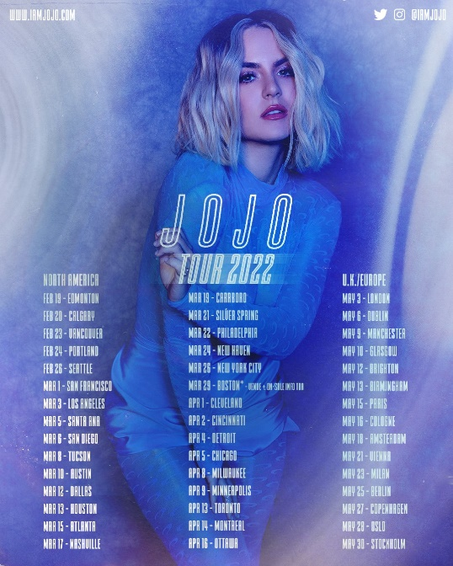
Download Tour Admat HERE
Download Trying Not To Think About It Cover Art HERE
Download JoJo Press Image HERE

October 25, 2021 (Los Angeles, CA) – Off the heels of a massively successful sold out intimate run of tour dates, GRAMMY Award-winning singer songwriter JoJo announces her 2022 Tour. The first leg of the 45-date headline tour kicks off February 19, 2022 in Edmonton, AB and continues through to 24 cities in the United States before concluding in Ottawa, ON on April 16, 2022. The second leg of the tour will take JoJo overseas to the U.K. and Europe for 15 shows, starting with a May 3, 2022 date in London and concluding on May 30 in Stockholm. Tickets go on-sale to the general public starting Friday, October 29 at 10:00 AM local time. For all details, please visit www.iamjojoofficial.com.

“Performing live is one of my favorite parts of being an artist,” says JoJo. “It felt so right being back onstage for those dates in October, and I can’t wait to do it on a bigger scale in more cities next year!”
On October 1, JoJo released her capsule project Trying Not To Think About It to critical and fan acclaim. Pitchfork praised the project as “her rawest and most cohesive project to date… an elegant EP with deliberate and defined parameters.” UPROXX writes: “JoJo beautifully tackles issues surrounding her anxiety, depression, negative thoughts, relationship self-sabotage, and emotional immaturity with honesty, vulnerability, and transparency.” Additional coverage of the EP was featured in MTV News, HYPEBAE, Glamour Coveteur and as the first digital cover of Verywell Mind. Listen to Trying Not To Think About It HERE.

Of the six-date, sold out intimate run of live shows across the country, celebrating the release of Trying Not To Think About It with her fans, JoJo told E! News: "To have the audience singing back the lyrics of this new music was just so special and so affirming and gratifying. It's been really amazing and it's been a part of me coming back to feeling like myself again and even feeling like a version of myself that I really am enjoying right now through writing through it and connecting with other people around the world." See JoJo’s behind-the-scenes, exclusive tour diary for E!’s Backstage Pass HERE.

JOJO TOUR 2022 DATES
DATE | CITY | VENUE
Saturday, February 19 | Edmonton, AB | Midway
Sunday, February 20 | Calgary, AB | MacEwan Hall
Wednesday, February 23 | Vancouver, BC | Commodore
Thursday, February 24 | Portland, OR | Wonder Ballroom
Saturday, February 26 | Seattle, WA | The Showbox SoDo
Tuesday, March 1 | San Francisco, CA | Warfield Theater
Thursday, March 3 | Los Angeles, CA | The Novo
Saturday, March 5 | Santa Ana, CA | The Observatory
Sunday, March 6 | San Diego, CA | House of Blues
Tuesday, March 8 | Tucson, AZ | Rialto Theater
Thursday, March 10 | Austin, TX | Scoot Inn
Saturday, March 12 | Dallas, TX | Studio at The Factory
Sunday, March 13 | Houston, TX | House of Blues
Tuesday, March 15 | Atlanta, GA | Variety Playhouse
Thursday, March 17 | Nashville, TN | Cannery Ballroom
Saturday, March 19 | Carrboro, NC | Cat’s Cradle
Monday, March 21 | Silver Spring, MD | Fillmore
Tuesday, March 22 | Philadelphia, PA | Union Transfer
Thursday, March 24 | New Haven, CT | Toad’s Place
Saturday, March 26 | New York, NY | Terminal 5
Tuesday, March 29 | Boston, MA | TBA
Friday, April 1 | Cleveland, OH | House of Blues
Saturday, April 2 | Cincinnati, OH | Bogarts
Monday, April 4 | Detroit, MI | St Andrews Hall
Tuesday, April 5 | Chicago, IL | Vic Theater
Friday, April 8 | Milwaukee, WI | The Rave II
Saturday, April 9 | Minneapolis, MN | First Avenue
Wednesday, April 13 | Toronto, ON | Danforth Music Hall
Thursday, April 14 | Montreal, QC | Corona
Saturday, April 16 | Ottawa, ON | Bronson Centre
Tuesday, May 3 | London, England | The Roundhouse
Friday, May 6 | Dublin, Ireland | Academy
Monday, May 9 | Manchester, England | O2 Ritz
Tuesday, May 10 | Glasgow, Scotland | The Garage
Thursday, May 12 | Brighton, England | Concorde 2
Friday, May 13 | Birmingham, England | O2 Institute
Sunday, May 15 | Paris, France | Alhambra
Monday, May 16 | Cologne, Germany | Luxor
Wednesday, May 18 | Amsterdam, Netherlands | Paradiso
Saturday, May 21 | Vienna, Austria | Grelle Forelle
Monday, May 23 | Milan, Italy | Santeria Toscana 31
Wednesday, May 25 | Berlin, Germany | Lido
Friday, May 27 | Copenhagen, Denmark | DR Concert House, Studio 2
Saturday, May 28 | Oslo, Norway | Parkteatret
Monday, May 30 | Stockholm, Sweden | Fryshuset (Klubben)
# # #
About JoJo
JoJo [born Joanna Levesque] is a chart-topping, award-winning singer, songwriter, and actress who, at just 30 years old, is already a veteran of the music industry. 17 years into her career, JoJo made a “triumphant return” [Uproxx] last year with her fourth studio album good to know, debuting at #1 on the Billboard R&B Albums Chart and earning widespread global acclaim from Vulture, TIME, Variety, NYLON, NPR, The FADER, and more, with Associated Press proclaiming “good to know is more than good. It’s grand.” At just 13, JoJo burst onto the scene with her self-title debut album, whose breakout smash “Leave (Get Out)” made her the youngest-ever solo artist to have a debut #1 single in the U.S. JoJo went on to sell over four million copies and became the singer’s first Platinum record, which she followed with a string of additional hits, including the Top 3 single “Too Little Too Late.” In 2016, following 10 years of legal battles with her former label that prevented her from releasing new music, JoJo returned with Mad Love., which debuted in the Top 10 on the Billboard Top 200. In 2018, JoJo re-recorded and re-released her first two albums (JoJo and The High Road) under her own label Clover Music, so her fans could finally get the nostalgia they had been missing for so many years. She has also pushed herself outside the confines of genre, collaborating with artists ranging from PJ Morton [on the GRAMMY Award-winning R&B hit “Say So”] to Jacob Collier [lending her vocal stylings to the jazzy “It Don’t Matter”]. On October 1, 2021, JoJo released Trying Not To Think About It. The capsule project is a musical expression of her continued honesty, vulnerability and transparency around mental health, tackling the different shades of it – including anxiety, depression, negative thoughts, relationship self-sabotage, and emotional immaturity. Following its release, JoJo embarked on a sold out run of six live performance dates across the United States in Boston, New York City, Philadelphia, Atlanta, Nashville and Los Angeles.

Press Contacts:
full coverage communications / Erica.Gerard@fullcov.com + natasha@fullcov.com
Warner Records / Ceri.Roberts@warnerrecords.com
JoJo Press Materials:
press.warnerrecords.com/jojo
Follow JoJo:
Instagram | YouTube | Twitter | Facebook | Website

