JOJO RELEASES good to know ACOUSTIC ALBUM

WATCH THE NEW VIDEO FOR “THINK ABOUT YOU” (ACOUSTIC) HERE

RESCHEDULED TOUR DATES CONFIRMED FOR 2021

July 10, 2020 (Los Angeles, CA) – Today, JoJo drops good to know (Acoustic), featuring nine acoustic versions of tracks off her critically-acclaimed album good to know, out now on Clover Music/Warner Records. JoJo teamed up with longtime collaborators on the stripped-back record, including producer Lido [Halsey, Chance The Rapper]. In the new video for “Think About You” (Acoustic), which is also released today, JoJo enlisted friend and director Zelda Williams, who previously created her stunning video for “Lonely Hearts.”

Listen/Share good to know (Acoustic) HERE

Additionally, JoJo announces the rescheduled North American and UK/Europe dates for her upcoming good to know tour, now slated for 2021. All tickets will be honored for the new dates. If you are unable to attend the new date, ticket holders will be able to request a refund through point of purchase. See a full list of North American dates below, plus UK/Europe dates here.

JoJo’s new album good to know – featuring empowering anthem “Man” and steamy collaboration “Comeback” (feat. Tory Lanez & 30 Roc) – made its debut at #1 on the Billboard R&B Albums Chart and has earned global accolades from the likes of Vulture, NPR, TIME, Variety, NYLON, Rolling Stone, and The FADER, with Associated Press proclaiming “good to know is more than good. It’s grand.”

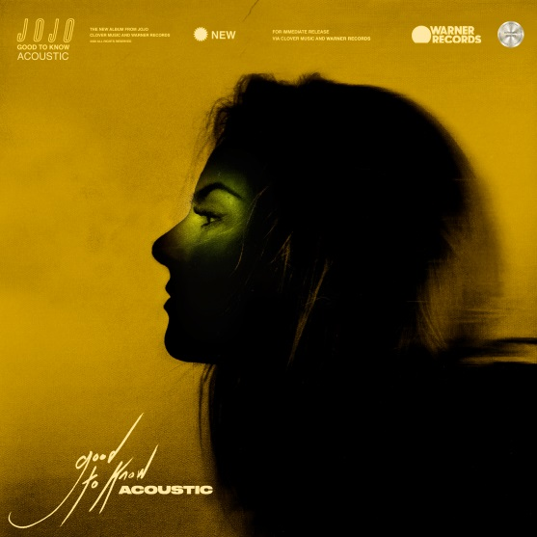

More about JoJo
JoJo [born Joanna Levesque] is a chart-topping, award-winning singer, songwriter, and actress who, at 29 years old, is already a veteran of the music industry. At just 13, JoJo burst onto the scene with her self-title debut album, whose breakout smash “Leave (Get Out)” made her the youngest-ever solo artist to have a debut #1 single in the U.S. JoJo went on to sell over four million copies and became the singer’s first Platinum record, which she followed with a string of additional hits, including the Top 3 single “Too Little Too Late.” In 2016, following 10 years of legal battles with her former label that prevented her from releasing new music, JoJo returned with Mad Love. – debuting Top 10 on the Billboard Top 200. In 2018, JoJo re-recorded and re-released her first two albums (JoJo and The High Road) under her own label Clover Music. She has also recently collaborated with artists ranging from PJ Morton [on the GRAMMY Award-winning R&B hit “Say So”] and Jacob Collier [lending her vocal stylings to the jazzy “It Don’t Matter”] to Tank on “Somebody Else.”

good to know Rescheduled Tour Dates
April 2 Seattle, WA The Showbox
April 3 Portland, OR Wonder Ballroom
April 6 San Francisco, CA Regency
April 9 Los Angeles, CA The Novo
April 10 Santa Ana, CA The Observatory
April 12 San Diego, CA House of Blues
April 13 Tucson, AZ Rialto Theater
April 15 Houston, TX House of Blues
April 17 Dallas, TX Canton Hall
April 19 Nashville, TN Cannery Ballroom
April 20 Atlanta, GA Variety Playhouse
April 22 Carrboro, NC Cat’s Cradle
April 24 New York, NY Terminal 5
April 25 Silver Spring, MD Fillmore
April 27 Boston, MA Royale
April 28 Boston, MA Sinclair
April 30 New Haven, CT College Street Music Hall
May 1 Philadelphia, PA Union Transfer
May 3 Cleveland, OH House of Blues
May 4 Cincinnati, OH Bogarts
May 6 Detroit, MI St. Andrews Hall
May 8 Milwaukee, WI The Rave
May 10 Chicago, IL Vic Theater
May 11 Minneapolis, MN First Avenue

###
For further information, please contact Warner Records Publicity:
National: Ceri Roberts
Ceri.Roberts@warnerrecords.com

Tour/Regional: Patrice Compere
Patrice.Compere@warnerrecords.com

Bio, Photos, & Additional Press Materials:
press.warnerrecords.com/jojo

Follow JoJo:
Instagram | YouTube | Twitter | Facebook | Website

