JOJO DELIVERS THE HOLIDAY CHEER WITH NEW ALBUM DECEMBER BABY,
FEATURING ORIGINAL SONGS + HOLIDAY FAVORITES
LISTEN HERE

PERFORMING “THE CHANGE” ON THE LATE SHOW WITH STEPHEN COLBERT ON MONDAY, NOVEMBER 2

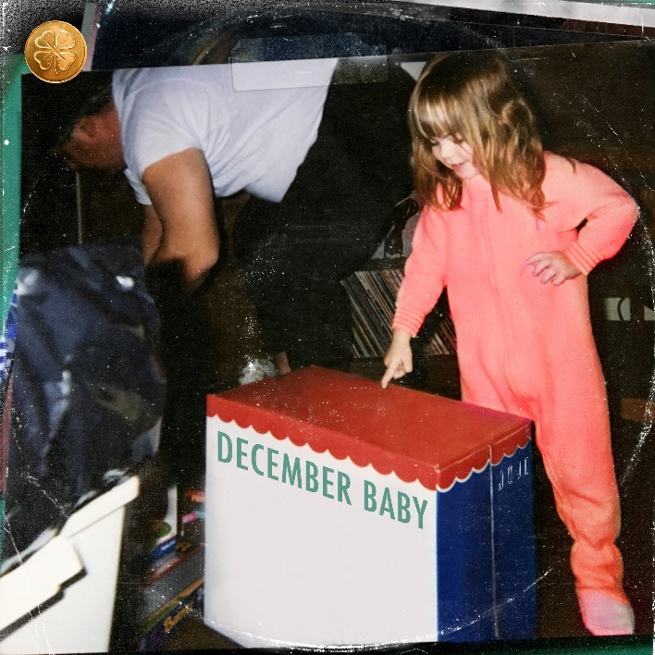

October 30, 2020 (Los Angeles, CA) – Acclaimed singer and songwriter JoJo is bringing the holiday cheer early with the release of her first ever holiday album, December Baby, out today on Clover Music/Warner Records. The 13-track record features five brand new originals alongside JoJo’s take on holiday favorites like “Silent Night” and “The Christmas Song,” plus collaborations with Jacob Collier and JoJo’s GRAMMY-winning duet partner PJ Morton. Listen to December Baby here.

This Monday, November 2, JoJo will perform her powerful new anthem “The Change” on The Late Show with Stephen Colbert, in support of the Biden-Harris Campaign’s “Get Out the Vote” effort. Tune into CBS at 11:35/12:35c on Monday night!

December Baby is the cherry on top of what has been a career year for the R&B/pop powerhouse. JoJo kicked off 2020 at the GRAMMYs with PJ Morton; when quarantine hit, she took to her IG Lives to bring some comfort to her fans, and remixed her breakout hit to encourage everyone to “Chill/Stay In”; she released a soul-baring body of work with good to know, hitting #1 on the Billboard R&B Albums Chart; she gave her fans both an acoustic and a Deluxe version of good to know, adding features with fellow pop/R&B queens Demi Lovato and Tinashe; she’s stepped up to use her voice for action and change; and now she’s bringing us the holiday spirit when we need it the most.

December Baby Tracklist:
- Noelle featuring Jacob Collier
- Have Yourself A Merry Little Christmas
- O Come All Ye Faithful (Interlude)
- December Baby*
- Coming Home*
- The Christmas Song
- Deck The Halls (Interlude)
- Wrap Me Up*
- North Pole*
- What Child Is This (Interlude)
- Silent Night
- Wishlist featuring PJ Morton*
- We Wish You A Merry Christmas (Outro)
* Denotes original song

###

For further information, please contact Ceri Roberts at Warner Records Publicity:
Ceri.Roberts@warnerrecords.com

Press Materials:
press.warnerrecords.com/jojo

Follow JoJo:
Instagram | YouTube | Twitter | Facebook | Website

