JOJO UNVEILS DELUXE EDITION OF CRITICALLY-ACCLAIMED ALBUM good to know FEATURING DEMI LOVATO & TINASHE
LISTEN HERE

“good to know is more than good. It’s grand.” – Associated Press

“JoJo sounds right on time: She’s grown into herself.” – Variety

“JoJo has always had a voice that was mature beyond her years; finally, her music has caught up.” – TIME

“JoJo inspires cult devotion like few other pop singers” – The Fader

“[JoJo is] reclaiming her seat at the table of this century's top R&B talents” – HotNewHipHop

“a confident declaration of her vocal prowess that fits neatly into 2020’s new R&B landscape”– NYLON

August 28, 2020 (Los Angeles, CA) – Today, JoJo unveils the deluxe edition of her critically-acclaimed album good to know on Clover Music/Warner Records. The 16-track record features a highly-anticipated collaboration with Demi Lovato on “Lonely Hearts (Remix),” plus five new tracks, including “Love Reggae” (feat. Tinashe) and addictive single “What U Need,” both of which were co-written and produced by GRAMMY Award-winning production duo NOVA WAV [Beyoncé, Rihanna, Ariana Grande].

JoJo explains, "The silver lining to my quarantine was being able to work on and record these new records. It also allowed me the opportunity to collaborate with Demi Lovato and Tinashe. Both women are talented, smart, resilient, bold, and beautiful. Really happy they jumped on these songs and elevated them to another level."

Released earlier this year to global acclaim, good to know – featuring empowering single “Man” and the steamy fan-favorite “Comeback” – made its debut at #1 on the Billboard R&B Albums Chart. Earlier this summer, JoJo released good to know (Acoustic), featuring nine acoustic versions of tracks off the critically-acclaimed album, and recently collaborated with DJ/producer Y2K on “Damage Is Done.”

good to know (Deluxe) Tracklisting
- Bad Habits
- So Bad
- Pedialyte
- Gold
- Man
- Small Things
- Lonely Hearts (feat. Demi Lovato)
- Think About You
- Comeback
- Don’t Talk Me Down
- Proud
- Kiss
- Love Reggae (feat. Tinashe)
- What U Need
- X (1 Thing Wrong)
- In Your Room

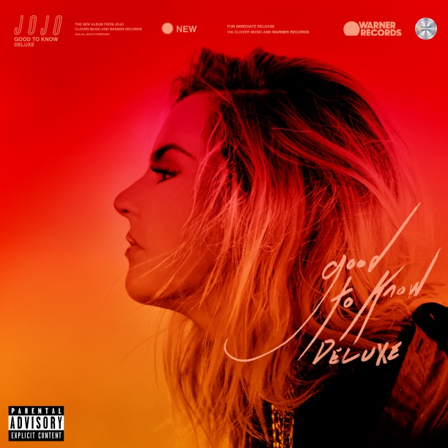
Hi-res artwork available here.

More about JoJo
JoJo [born Joanna Levesque] is a chart-topping, award-winning singer, songwriter, and actress who, at 29 years old, is already a veteran of the music industry. At just 13, JoJo burst onto the scene with her self-title debut album, whose breakout smash “Leave (Get Out)” made her the youngest-ever solo artist to have a debut #1 single in the U.S. JoJo went on to sell over four million copies and became the singer’s first Platinum record, which she followed with a string of additional hits, including the Top 3 single “Too Little Too Late.” In 2016, following 10 years of legal battles with her former label that prevented her from releasing new music, JoJo returned with Mad Love. – debuting Top 10 on the Billboard Top 200. In 2018, JoJo re-recorded and re-released her first two albums (JoJo and The High Road) under her own label Clover Music. She has also recently collaborated with artists ranging from PJ Morton [on the GRAMMY Award-winning R&B hit “Say So”] and Jacob Collier [lending her vocal stylings to the jazzy “It Don’t Matter”] to Tank on “Somebody Else.”

###
For further information, please contact Warner Records Publicity:
National: Ceri Roberts
Ceri.Roberts@warnerrecords.com

Tour/Regional: Patrice Compere
Patrice.Compere@warnerrecords.com

Bio, Photos, & Additional Press Materials:
press.warnerrecords.com/jojo

Follow JoJo:
Instagram | YouTube | Twitter | Facebook | Website

