JOJO ANNOUNCES good to know (DELUXE) OUT AUGUST 28TH
FEATURING DEMI LOVATO & TINASHE

ADDICTIVE NEW SINGLE “WHAT U NEED” OUT TODAY
WATCH THE OFFICIAL VIDEO HERE

August 7, 2020 (Los Angeles, CA) – JoJo has announced the deluxe edition of her critically-acclaimed album good to know, due out on August 28 via Clover Music/Warner Records. The 16-track record features highly-anticipated collaborations with Demi Lovato and Tinashe plus five brand new tracks. Today, she gives the first taste with addictive new single “What U Need,” co-written and produced by GRAMMY Award-winning production duo NOVA WAV [Beyoncé, Rihanna, Ariana Grande]. JoJo shows off her moves in the accompanying video, with choreography from Bec Morris [Nicki Minaj, Charli XCX, Justin Bieber] and directed by JoJo’s go-to quarantine video collaborator Santiago Salviche [Jennifer Lopez].

Pre-Order/Pre-Save good to know (Deluxe) HERE

JoJo explains, "The silver lining to my quarantine was being able to work on and record these new records. It also allowed me the opportunity to collaborate with Demi Lovato and Tinashe. Both women are talented, smart, resilient, bold, and beautiful. Really happy they jumped on these songs and elevated them to another level."

good to know – featuring empowering single “Man” and the steamy fan-favorite “Comeback” – made its debut at #1 on the Billboard R&B Albums Chart and has earned global accolades from the likes of Vulture, NPR, TIME, Variety, NYLON, Rolling Stone, and The FADER, with Associated Press proclaiming “good to know is more than good. It’s grand.” Earlier this summer, JoJo released good to know (Acoustic), featuring nine acoustic versions of tracks off the critically-acclaimed album, and most recently collaborated with DJ/producer Y2K on “Damage Is Done.”

good to know (Deluxe) Tracklisting
- Bad Habits
- So Bad
- Pedialyte
- Gold
- Man
- Small Things
- Lonely Hearts (feat. Demi Lovato)
- Think About You
- Comeback
- Don’t Talk Me Down
- Proud
- Kiss
- Love Reggae (feat. Tinashe)
- What U Need
- X (1 Thing Wrong)
- In Your Room

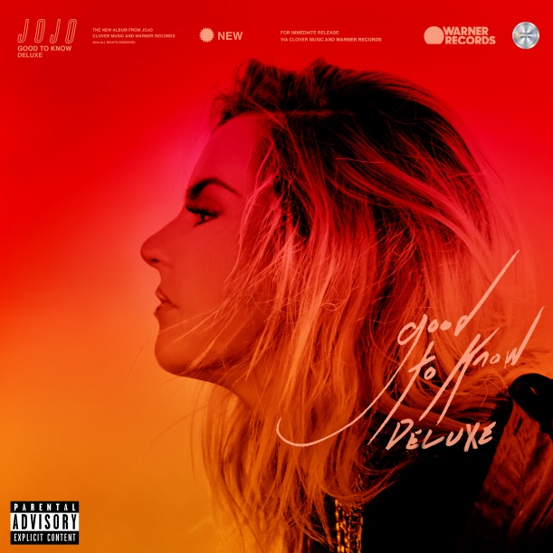
Hi-res artwork available here.

More about JoJo
JoJo [born Joanna Levesque] is a chart-topping, award-winning singer, songwriter, and actress who, at 29 years old, is already a veteran of the music industry. At just 13, JoJo burst onto the scene with her self-title debut album, whose breakout smash “Leave (Get Out)” made her the youngest-ever solo artist to have a debut #1 single in the U.S. JoJo went on to sell over four million copies and became the singer’s first Platinum record, which she followed with a string of additional hits, including the Top 3 single “Too Little Too Late.” In 2016, following 10 years of legal battles with her former label that prevented her from releasing new music, JoJo returned with Mad Love. – debuting Top 10 on the Billboard Top 200. In 2018, JoJo re-recorded and re-released her first two albums (JoJo and The High Road) under her own label Clover Music. She has also recently collaborated with artists ranging from PJ Morton [on the GRAMMY Award-winning R&B hit “Say So”] and Jacob Collier [lending her vocal stylings to the jazzy “It Don’t Matter”] to Tank on “Somebody Else.”

###
For further information, please contact Warner Records Publicity:
National: Ceri Roberts
Ceri.Roberts@warnerrecords.com

Tour/Regional: Patrice Compere
Patrice.Compere@warnerrecords.com

Bio, Photos, & Additional Press Materials:
press.warnerrecords.com/jojo

Follow JoJo:
Instagram | YouTube | Twitter | Facebook | Website

