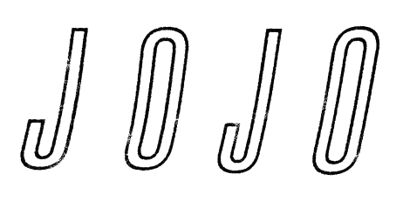
JOJO BEGINS A NEW CHAPTER WITH “JOANNA”

First Release on Warner Records / Clover Music,
More New Sh*t Dropping Soon

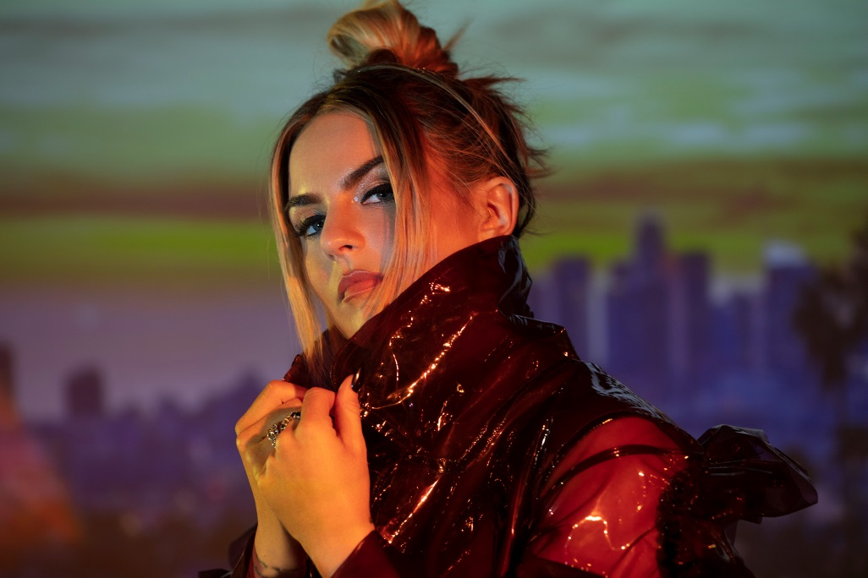
Photo Credit: Dennis Leupold, download hi-res here

October 11, 2019 – Chart-topping, award-winning singer and songwriter JoJo is starting a new chapter today with the release of “Joanna,” a highly personal reflection and prelude for the music to come. The track started as a freestyle – with JoJo voicing the thoughts of her critics as well as her own internalized negativity – but became a thoughtful commentary on cancel culture: how social media emboldens people to say whatever they want without fear of repercussions. JoJo explains:

“For someone to write someone off and tell them when their story ends or what’s possible for them is just ridiculous. Anything is possible. You are on a path all your own – I am more confident than ever about mine.”

LISTEN TO “JOANNA” HERE AND WATCH THE OFFICIAL VIDEO HERE

The track is JoJo’s first new release since signing with Warner Records earlier this year, through a joint venture with her own Clover Music. Aaron Bay-Schuck, Co-Chairman and CEO of Warner Records, says, “We couldn’t be more excited for JoJo to be a part of the Warner Records family. I’ve had the pleasure of working with her at various stages over the years, and can confidently say she’s making the best and most self-assured music of her career right now. Lyrically, it’s brutally honest; sonically, it’s current yet timeless; and of course still showcases that one of a kind vocal prowess for which Jojo has always been known. Tom Corson, myself, and all of us at Warner Records are so proud to be her partners for this new chapter.”

As the final lyric of “Joanna” indicates, there’s plenty more “new sh*t” coming from JoJo very soon… Next up is the soulful hip-hop-infused “Sabotage,” feat. CHIKA, out October 25 and available now to pre-save HERE.

While “Joanna” allows time for reflection, in “Sabotage,” JoJo is confident in the present, especially when that means holding herself accountable in relationships. Together with producers Doc McKinney [The Weeknd, Santigold] and Lido [Halsey, Chance The Rapper], JoJo has honed together an upcoming body of work centered around this new-found confidence – both musically and emotionally. There’s a lightness, a joy, a sense of satisfaction: JoJo doesn’t want to avoid the past, but it’s time to open the next chapter.

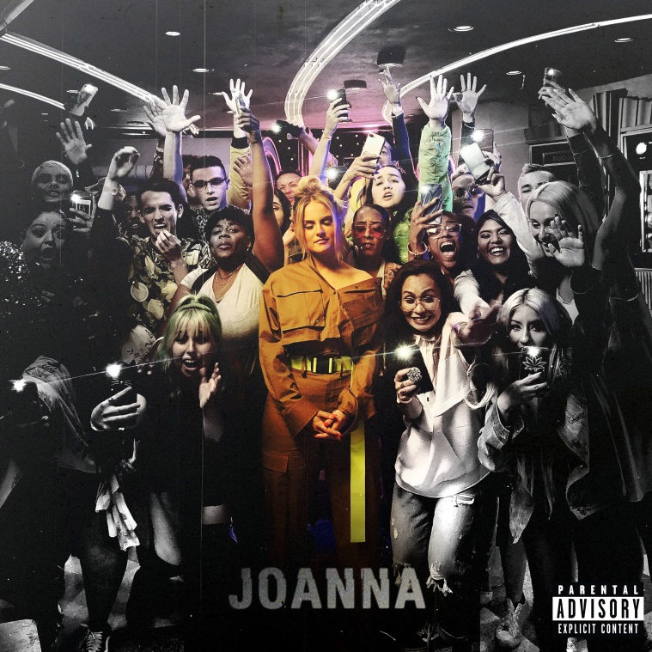
Download hi-res cover art here

ABOUT JOJO
JoJo [born Joanna Levesque] is a chart-topping, award-winning singer, songwriter, and actress who, at just 28 years old, is already a veteran of the music industry, having released her self-titled debut album when she was just 13. JoJo’s breakout smash “Leave (Get Out)” rocketed to the top of the charts, making JoJo the youngest-ever solo artist to have a debut #1 single in the U.S. and to be nominated for “Best New Artist” at the MTV Video Music Awards. The album went on to sell over four million copies and became the singer’s first Platinum record, which she followed with a string of additional hits, most notably the Top 3 single “Too Little Too Late” from sophomore album The High Road. In 2016, JoJo made a heralded return to music with her first new album in 10 years, Mad Love. – debuting Top 10 on the Billboard Top 200 and earning her unanimous critical acclaim from the likes of TIME, Pitchfork, Rolling Stone, Cosmo, Entertainment Weekly and more. Most recently, JoJo re-recorded and re-released her first two albums (JoJo and The High Road) under her own label Clover Music, not wanting anyone to erase her legacy and story. She took back ownership, and was able to, as she explained, “give the fans the nostalgia that they couldn’t get” during her years of legal battles with her former label that prevented the albums from existing on digital platforms. She has also pushed herself outside the confines of genre, in the past year alone collaborating with artists ranging from PJ Morton [on the Top 10 R&B hit “Say So”] to Jacob Collier [lending her vocal stylings to the jazzy “It Don’t Matter”]. Now signed to Warner Records as a joint venture with her own Clover Music, JoJo is a self-made, authoritative and impassioned 28-year-old woman who is ready to write her next chapter.

###

For further information, contact:
Ceri Roberts, Warner Records
Ceri.Roberts@warnerrecords.com / 212-707-2259

Follow JoJo:
Instagram | YouTube | Twitter | Facebook | Website

Press Materials:
http://press.warnerrecords.com/jojo/

