

JOJO ANNOUNCES “DECEMBER BABY LIVESTREAM CONCERT SPECIAL”
Presented by NoCap, Airing Live from The Roxy in L.A. on December 18th

“DECEMBER BABY” VIDEO OUT NOW, FEATURING JACOB COLLIER – WATCH HERE

Plus Upcoming Collaborations:
Performing with PJ Morton on The Tamron Hall Show on December 16th
+ Brand New Duet with Tori Kelly on December 18th

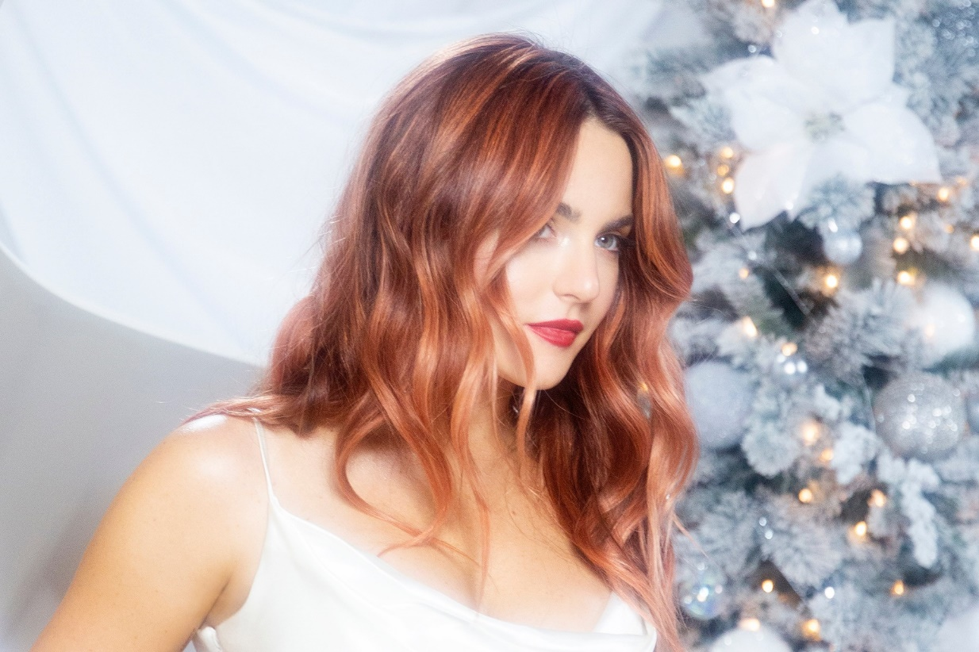

December 7, 2020 (Los Angeles, CA) – This holiday season, the gifts keep coming from acclaimed singer and songwriter JoJo, who just announced the “December Baby Livestream Concert Special,” presented by No Cap, airing live from The Roxy on Friday, December 18th at 6pm PT. There will be no in-person audience, and all COVID protocols will be strictly enforced for band and crew. Tickets are available here starting today, and fans in the U.S. who purchase tickets today only will receive a complimentary signed 8x10 poster. Exclusive new merchandise, afterparty access, and VIP virtual meet and greet packages are available for an additional cost.

Today, JoJo also shares the official video for “December Baby,” with an intro featuring GRAMMY winner and 2021 Album of the Year GRAMMY nominee Jacob Collier for a taste of their holiday song “Noelle.” Both tracks are off her newly released debut holiday album out now on Warner Records. Watch the “December Baby” video HERE and listen to December Baby HERE.

JoJo most recently shared the festive video for “Wishlist,” another December Baby favorite featuring her GRAMMY-winning duet partner PJ Morton. The pair will perform the original holiday song on The Tamron Hall Show on December 16. JoJo has also teamed up with Tori Kelly for a duet on the upcoming album STAND UP, executive produced by Raphael Saadiq and created in partnership with Global Citizen, Parlophone Records, and Atlantic Records. Look out for its release on December 18th!

ABOUT JOJO:
JoJo [born Joanna Levesque] is a chart-topping, award-winning singer, songwriter, and actress who, at just 29 years old, is already a veteran of the music industry. 15 years into her career, JoJo made a “triumphant return” [Uproxx] this year with her fourth studio album good to know, debuting at #1 on the Billboard R&B Albums Chart and earning widespread global acclaim from Vulture, TIME, Variety, NYLON, NPR, The FADER, and more, with Associated Press proclaiming “good to know is more than good. It’s grand.” At just 13, JoJo burst onto the scene with her self-title debut album, whose breakout smash “Leave (Get Out)” made her the youngest-ever solo artist to have a debut #1 single in the U.S. JoJo went on to sell over four million copies and became the singer’s first Platinum record, which she followed with a string of additional hits, including the Top 3 single “Too Little Too Late.” In 2016, following 10 years of legal battles with her former label that prevented her from releasing new music, JoJo returned with Mad Love. – debuting Top 10 on the Billboard Top 200. In 2018, JoJo re-recorded and re-released her first two albums (JoJo and The High Road) under her own label Clover Music, so her fans could finally get the nostalgia they had been missing for so many years. She has also pushed herself outside the confines of genre, collaborating with artists ranging from PJ Morton [on the GRAMMY Award-winning R&B hit “Say So”] to Jacob Collier [lending her vocal stylings to the jazzy “It Don’t Matter”]. Most recently, JoJo released the Biden-Harris campaign anthem “The Change,” and has capped off her 2020 with her debut holiday album December Baby, out now on Clover Music/Warner Records.

ABOUT NOCAP:
NoCap, the brainchild of Roxy Theater co-owner and musician Cisco Adler along with an all-star list of partners in the music and tech industries, is both a platform and promoter of venue-based livestream concerts giving fans around the world access to intimate live performances with unlimited capacity. With its easy-to-use text-based ticketing technology and custom concert streaming solution, NoCap is providing a much-needed lifeline for artists, crews and venues suffering during the Covid-19 pandemic that will remain a viable outlet post pandemic while becoming the new general admission creating unlimited profit potential for a new live music model. NoCap gives fans globally a chance to experience live shows by top-tier talent in storied venues, including The Roxy (Los Angeles), Belly Up (Solana Beach, CA/Aspen, CO), SOhO (Santa Barbara), Sony Theatre ( NYC ) and even Drive-In Concert Venues across the country , from home or on the go with visually stunning concert-quality sound, creating unforgettable performances. For more info, visit www.nocapshows.com.

###

For further information about JoJo, please contact Ceri Roberts:
Ceri.Roberts@warnerrecords.com

For further information about NoCap, please contact Jean Sievers:
jean@beachwood.la

JoJo Press Materials:
press.warnerrecords.com/jojo

Follow JoJo:
Instagram | YouTube | Twitter | Facebook | Website



