JOJO DROPS VIDEO FOR LATEST TRACK “LONELY HEARTS”: WATCH HERE
Directed by Zelda Williams

NEW ALBUM good to know OUT FRIDAY, MAY 1: PRE-ORDER HERE
Featuring Single “Man”: Listen Here

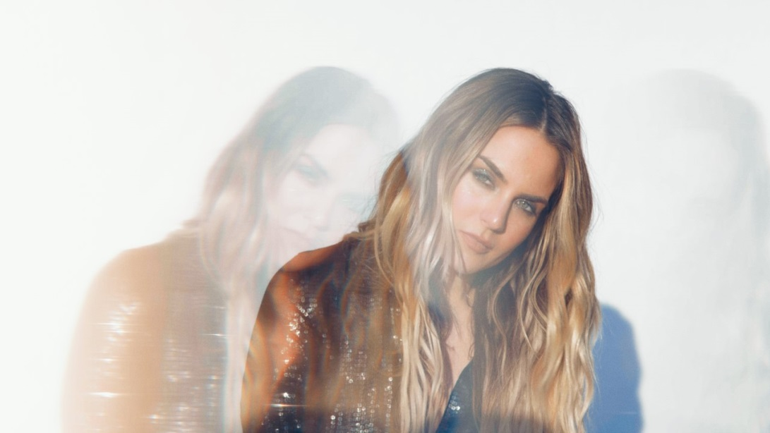

“good to know [is] a confident declaration of her vocal prowess that fits neatly into 2020’s new R&B landscape”
NYLON

“JoJo inspires cult devotion like few other pop singers”
The FADER

“she’s the social distancing pop queen we all need (but don't necessarily deserve)”
Teen Vogue

“[JoJo is] reclaiming her seat at the table of this century's top R&B talents”
HotNewHipHop

“JoJo is on fire”
MTV News

“reminding everyone that JoJo's voice is just as incredible as ever.”
Bustle

“[JoJo’s] looking more confident and at ease with herself than we’ve ever seen her before”
Bossip

“[JoJo is] back in a big way”
UPROXX

ABOUT JOJO
JoJo [born Joanna Levesque] is a chart-topping, award-winning singer, songwriter, and actress who, at just 29 years old, is already a veteran of the music industry – but she is ready to write her next chapter. Now signed to Warner Records through a joint venture with her own Clover Music, JoJo has begun with her fiery new single “Man” and her new album good to know out May 1, 2020. Having released her self-titled debut album when she was just 13, JoJo’s breakout smash “Leave (Get Out)” made her the youngest-ever solo artist to have a debut #1 single in the U.S. and to be nominated for “Best New Artist” at the MTV Video Music Awards. The album went on to sell over four million copies and became the singer’s first Platinum record, which she followed with a string of additional hits, most notably the Top 3 single “Too Little Too Late” from sophomore album The High Road. In 2016, JoJo made a heralded return to music with her first new album in 10 years, Mad Love. – debuting Top 10 on the Billboard Top 200 and earning her unanimous critical acclaim. In 2018, JoJo re-recorded and re-released her first two albums (JoJo and The High Road) under her own label Clover Music, after years of legal battles with her former label that prevented the albums from existing on digital platforms. She has also pushed herself outside the confines of genre, recently collaborating with artists ranging from PJ Morton [on the GRAMMY-winning R&B hit “Say So”] and Jacob Collier [lending her vocal stylings to the jazzy “It Don’t Matter”] to Tank on “Somebody Else.”

###

For further information, please contact Warner Records Publicity:
National: Ceri Roberts
Ceri.Roberts@warnerrecords.com

Regional: Patrice Compere
Patrice.Compere@warnerrecords.com

Bio, Photos, & Additional Press Materials:
press.warnerrecords.com/jojo

Follow JoJo:
Instagram | YouTube | Twitter | Facebook | Website

