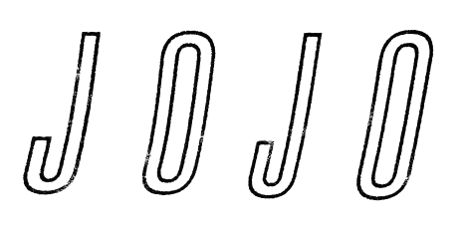
JOJO GETS REAL ABOUT RELATIONSHIPS IN NEW SONG
“SABOTAGE” FEAT. CHIKA

Track Follows Introspective “Joanna” & Sets the Stage for New Album
Coming In 2020

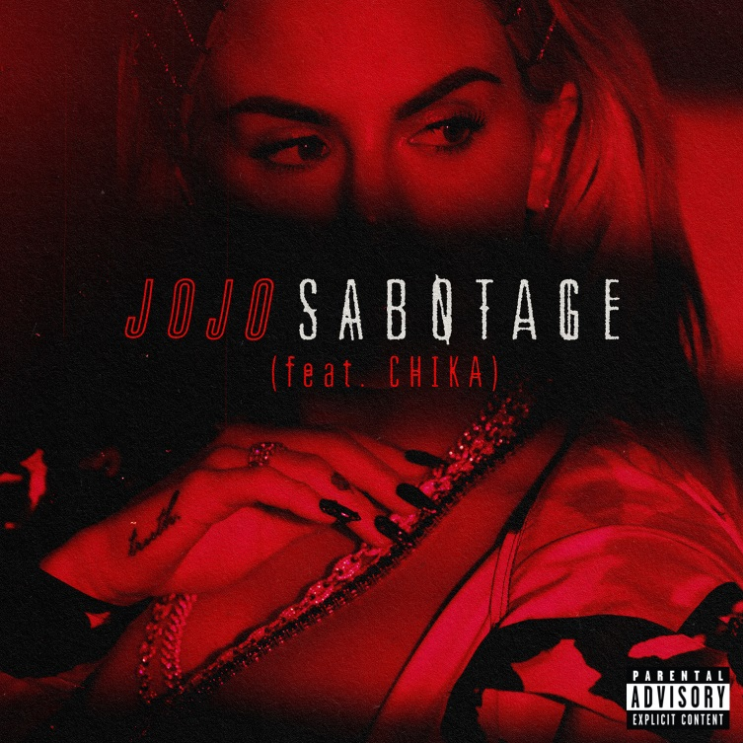
Download hi-res here

October 25, 2019 – Following the release of “Joanna,” praised as “beautiful, touching fan-service done right” (GQ) and “brutally honest” (Vulture), today JoJo drops the soulful, hip-hop infused new track “Sabotage,” featuring a guest verse by fellow Warner Records artist CHIKA. Listen to “Sabotage” HERE, watch the lyric video HERE, and look out for the official video coming soon.

JoJo explains: “A lot of people self-sabotage… I tend to do it in romantic relationships. And I think most of it roots to fear - fear of being inadequate, fear of getting hurt, fear of rejection, fear of not measuring up... This song is about asking a lot of questions, dealing with shame and embarrassment, and really just owning up to certain patterns.”

The new tracks are JoJo’s first new music since signing with Warner Records earlier this year through a joint venture with her own Clover Music, and preview the album to come in 2020. Together with producers Doc McKinney [The Weeknd, Santigold] and Lido [Halsey, Chance The Rapper], JoJo has honed together an upcoming body of work centered around her new-found confidence – both musically and emotionally. There’s a lightness, a joy, a sense of satisfaction: JoJo doesn’t want to avoid the past, but it’s time to open the next chapter.

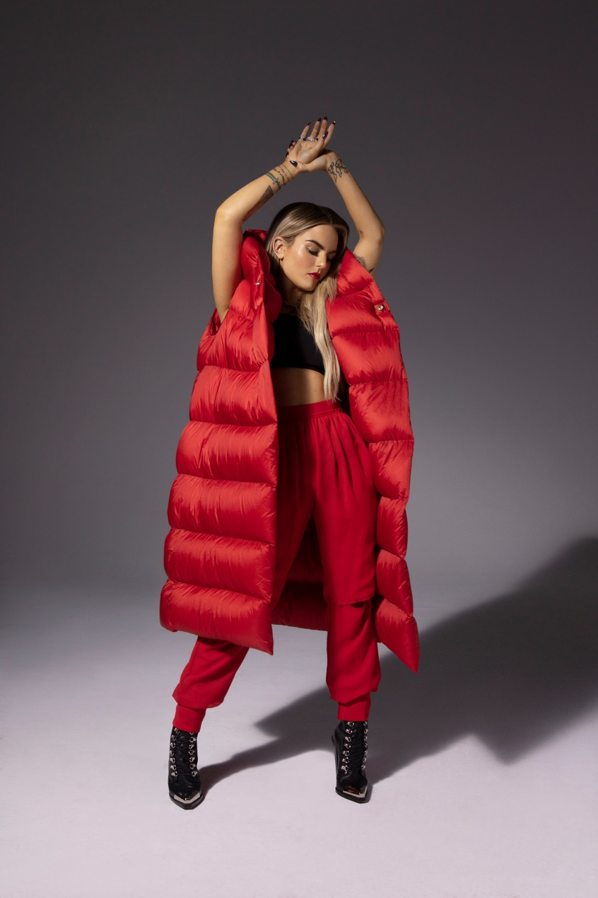
Photo Credit: Dennis Leupold, download hi-res here

ABOUT JOJO
JoJo [born Joanna Levesque] is a chart-topping, award-winning singer, songwriter, and actress who, at just 28 years old, is already a veteran of the music industry, having released her self-titled debut album when she was just 13. JoJo’s breakout smash “Leave (Get Out)” rocketed to the top of the charts, making JoJo the youngest-ever solo artist to have a debut #1 single in the U.S. and to be nominated for “Best New Artist” at the MTV Video Music Awards. The album went on to sell over four million copies and became the singer’s first Platinum record, which she followed with a string of additional hits, most notably the Top 3 single “Too Little Too Late” from sophomore album The High Road. In 2016, JoJo made a heralded return to music with her first new album in 10 years, Mad Love. – debuting Top 10 on the Billboard Top 200 and earning her unanimous critical acclaim from the likes of TIME, Pitchfork, Rolling Stone, Cosmo, Entertainment Weekly and more. Most recently, JoJo re-recorded and re-released her first two albums (JoJo and The High Road) under her own label Clover Music, not wanting anyone to erase her legacy and story. She took back ownership, and was able to, as she explained, “give the fans the nostalgia that they couldn’t get” during her years of legal battles with her former label that prevented the albums from existing on digital platforms. She has also pushed herself outside the confines of genre, in the past year alone collaborating with artists ranging from PJ Morton [on the Top 10 R&B hit “Say So”] to Jacob Collier [lending her vocal stylings to the jazzy “It Don’t Matter”]. Now signed to Warner Records as a joint venture with her own Clover Music, JoJo is a self-made, authoritative and impassioned 28-year-old woman who is ready to write her next chapter.

ABOUT CHIKA
CHIKA is a self-made star who turned down going to Berklee College of Music to focus on honing her craft. Now just a few short years later at 22 years old, she’s using her powerful voice as a much needed call to action for the marginalized and disenfranchised. With an instinct for creating impactful viral moments in the music, film / television, fashion, brand and social media space, CHIKA's ethos and persona have resonated with fans and peers so deeply that she's already a Gen Z icon with just a few songs out in the world.

In less than a year, the Alabama-born, LA-residing, rapper / singer / songwriter / poet has gained critical darling status, calling out her foes with fierce battle hymns that put her on the map as one of the toughest new rappers out - even singled out by Cardi B as one of the brightest young stars in the game. In early 2019, after starring in an unprecedented Calvin Klein campaign, she dropped her first single "No Squares." CHIKA went on to perform it on Jimmy Kimmel Live!, hand-selected by guest host Lena Waithe who was an early supporter. CHIKA again collaborated with Waithe and director SH00TER for the official video for her most recent single, "High Rises," filmed with a cast of young students in both CHIKA and SH00TER's home state of Alabama. CHIKA is signed to Warner Records and is working on her forthcoming debut EP. If early praise from press is any indication, with the likes of Billboard, TIME, Newsweek, i-D, V MAGAZINE, them., CR Fashion Book, Teen Vogue, and many more showing love for this young superstar and modern American role model, the best is truly yet to come!

###

For further information on JoJo, contact:
Ceri Roberts, Warner Records
Ceri.Roberts@warnerrecords.com

For further information on CHIKA, contact:
Aishah White, Warner Records
Aishah.White@warnerrecords.com

Follow JoJo:
Instagram | YouTube | Twitter | Facebook | Website

Press Materials:
http://press.warnerrecords.com/jojo/

