JOJO RELEASES “SMALL THINGS” VIDEO
FROM CRITICALLY-ACCLAIMED NEW ALBUM good to know
WATCH HERE

TUNE IN: LIVESTREAM PERFORMANCE WITH MELODYVR ON JUNE 27TH

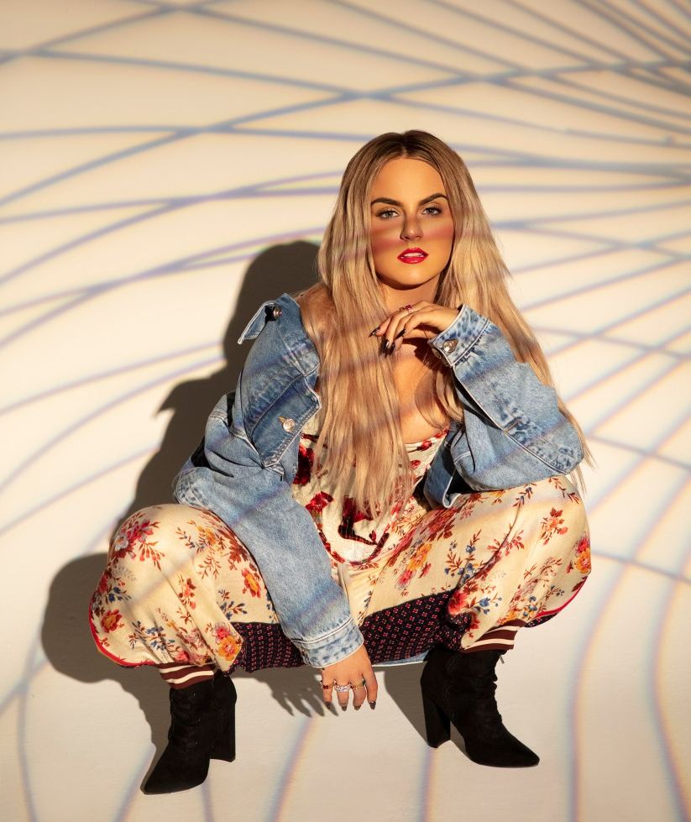

June 23, 2020 (Los Angeles, CA) – Today, JoJo releases the official video for “Small Things,” off her critically-acclaimed new album good to know, out now on Clover Music/ Warner Records. good to know – featuring empowering anthem “Man,” which is climbing the charts at Top 40 Radio – made its debut at #1 on the Billboard R&B Albums Chart and has earned global accolades from the likes of Vulture, NPR, TIME, Variety, NYLON, Rolling Stone, and The FADER, with Associated Press proclaiming “good to know is more than good. It’s grand.”

Watch the “Small Things” video here, which includes a call to action from JoJo to support the ACLU. As Toni Morrison said, "The function of freedom is to try to free someone else."

This Saturday, June 27, JoJo will perform tracks from good to know live for the first time on MelodyVR for its Live in LA series, giving viewers an exclusive 360° performance inside its state-of-the-art studio space. Fans can tune for free at 5pm PT/8pm ET/1am + 1 day BST on the MelodyVR app and JoJo’s YouTube channel, or watch on-demand directly following the livestream. Available on smartphones and VR headsets, the MelodyVR app can be downloaded at on.melodyvr.com/App.

More about JoJo
JoJo [born Joanna Levesque] is a chart-topping, award-winning singer, songwriter, and actress who, at 29 years old, is already a veteran of the music industry. At just 13, JoJo burst onto the scene with her self-title debut album, whose breakout smash “Leave (Get Out)” made her the youngest-ever solo artist to have a debut #1 single in the U.S. JoJo went on to sell over four million copies and became the singer’s first Platinum record, which she followed with a string of additional hits, including the Top 3 single “Too Little Too Late.” In 2016, following 10 years of legal battles with her former label that prevented her from releasing new music, JoJo returned with Mad Love. – debuting Top 10 on the Billboard Top 200. In 2018, JoJo re-recorded and re-released her first two albums (JoJo and The High Road) under her own label Clover Music. She has also recently collaborated with artists ranging from PJ Morton [on the GRAMMY Award-winning R&B hit “Say So”] and Jacob Collier [lending her vocal stylings to the jazzy “It Don’t Matter”] to Tank on “Somebody Else.”

###
For further information, please contact Warner Records Publicity:
National: Ceri Roberts
Ceri.Roberts@warnerrecords.com

Tour/Regional: Patrice Compere
Patrice.Compere@warnerrecords.com

Bio, Photos, & Additional Press Materials:
press.warnerrecords.com/jojo

Follow JoJo:
Instagram | YouTube | Twitter | Facebook | Website

