JOJO RELEASES NEW CAPSULE EP PROJECT
TRYING NOT TO THINK ABOUT IT
LISTEN HERE

NEW SINGLE “ANXIETY (BURLINDA’S THEME)” OUT NOW
WATCH HERE

SOLD OUT 6-DATE RUN OF INTIMATE LIVE SHOWS BEGINS TOMORROW IN BOSTON, MA

JOJO FEATURED AS FIRST EVER VERYWELL MIND DIGITAL COVER STAR

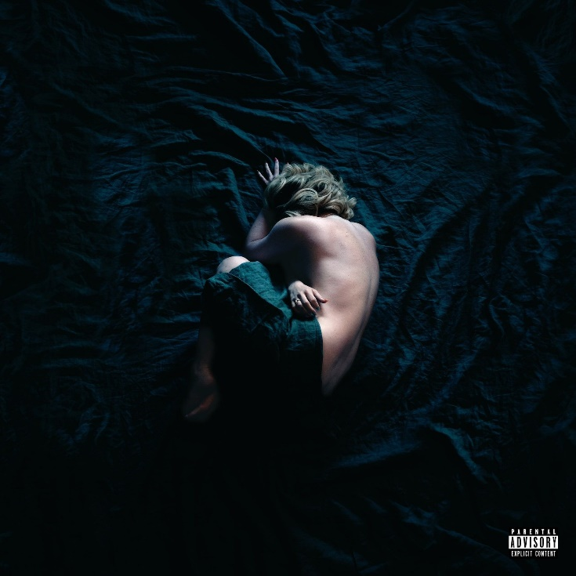
Download Trying Not To Think About It Cover Art HERE
Download Trying Not To Think About It Admat HERE
Download JoJo Press Image HERE

October 1, 2021 (Los Angeles, CA) – Today, GRAMMY Award-winning singer songwriter JoJo releases her capsule project, Trying Not To Think About It via Clover Music/Warner Records. The 12-track EP is a musical expression of her continued honesty, vulnerability and transparency around mental health, tackling the different shades of it – including anxiety, depression, negative thoughts, relationship self-sabotage, and emotional immaturity. Listen to Trying Not To Think About It HERE and find the project’s tracklist reveal HERE.

Along with the EP release, JoJo has unveiled the music video for new single “Anxiety (Burlinda’s Theme)” in which she masterfully compares her internal battle with anxiety to the cycle of an abusive relationship. The title of the track is a nod to the name JoJo has assigned to her anxiety and negative thoughts. Watch HERE.

“Somewhere over the years I became someone who wore all my fears and anxieties and hang ups and negative self-beliefs like armor. This song is about wanting to break up with your anxiety – talking to it like it’s an abusive relationship. CUZ IT IS. It can keep you small, isolated, unhappy, afraid, unable to perform to the best of your ability and reach your potential,” JoJo has said of the song. “Someone once told me that naming your depressed/anxious self and keeping it separate from who you really are can be helpful. So I named mine Burlinda. I haven’t conquered my anxiety, but slowly but surely… I’m learning how to work with Burlinda and let her know she is not needed and can take a fucking seat.”

The music video for “Anxiety (Burlinda’s Theme)” made its broadcast premiere on MTV Live and MTVU. The tongue-in-cheek visual finds JoJo as the unwilling star of an advertisement for “Tryesta®,” mimicking the often-ridiculous tropes of mental health medication ads on television. The video also features cameos from Omarion and Lauren Jauregui.

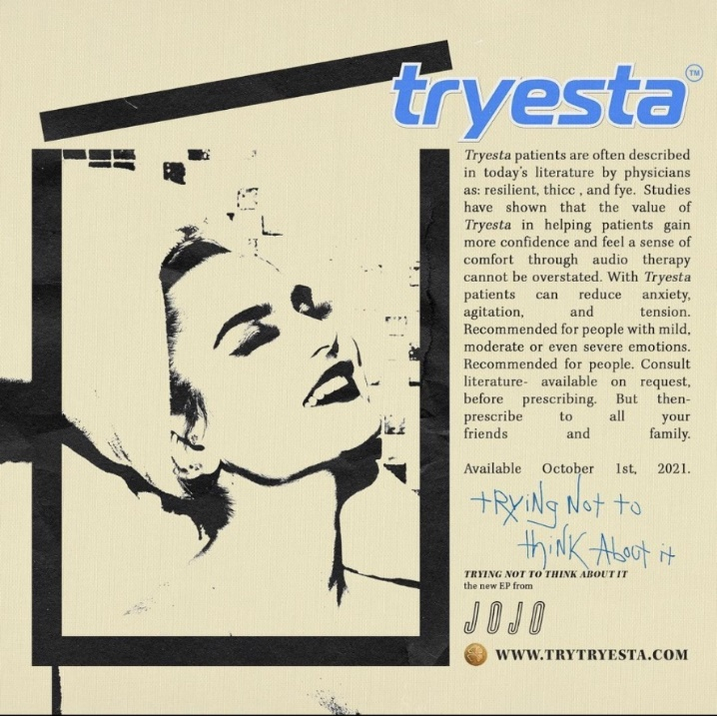

Beginning tomorrow night, October 2, in Boston, JoJo will embark on a sold out, six-date run of intimate live shows to celebrate Trying Not To Think About It and share the music with her fans across the country. The run includes stops in NYC, Philadelphia, Atlanta, Nashville & Los Angeles. Full dates below.

JoJo also appears as the inaugural digital cover star for VeryWell Mind’s October The Breakout Issue where she discusses Trying Not To Think About It along with physical, mental, and emotional wellbeing. In tandem with the cover feature, JoJo’s episode of The Verywell Mind Podcast with therapist, best-selling author, and Verywell Mind Editor-In-Chief Amy Morin, where listeners can hear JoJo candidly discuss her personal experiences with mental health. View the full cover story HERE and listen to the podcast HERE.

Photo Credit: Felisha Tolentino

Last week, JoJo appeared on Global Citizen Live at the Greek Theatre in Los Angeles, where she spoke up on the impending threats of climate before presenting Demi Lovato’s performance of “Anyone.” Watch HERE. Global Citizen Live raised more than $1.1 billion to tackle the climate and hunger crises.

In August, JoJo released her first single off the Trying Not To Think About It, “The Worst (I Assume)” – its accompanying music video was directed by Alfredo Flores and shot in one continuous take to bring the song’s emotion to life through performance. The video concludes with a heartfelt note from JoJo. It has amassed over a million views to date. Watch the video HERE.

In May 2020, JoJo’s fourth studio album good to know debuted at #1 on the Billboard R&B Albums Chart and earned widespread global acclaim from Vulture, TIME, Variety, NYLON, NPR, The FADER, and more, with Associated Press proclaiming “good to know is more than good. It’s grand.”
JoJo – Trying Not To Think About It Live 2021 Dates
Date | City | Venue
October 2, 2021 | Boston, MA | Sinclair
October 4, 2021 | New York City, NY | Music Hall of Williamsburg
October 5, 2021 | Philadelphia, PA | Underground Arts
October 7, 2021 | Atlanta, GA | Terminal West
October 9, 2021 | Nashville, TN | Exit/In
October 11, 2021 | Los Angeles, CA | El Rey

# # #
About JoJo
JoJo [born Joanna Levesque] is a chart-topping, award-winning singer, songwriter, and actress who, at just 30 years old, is already a veteran of the music industry. 17 years into her career, JoJo made a “triumphant return” [Uproxx] last year with her fourth studio album good to know, debuting at #1 on the Billboard R&B Albums Chart and earning widespread global acclaim from Vulture, TIME, Variety, NYLON, NPR, The FADER, and more, with Associated Press proclaiming “good to know is more than good. It’s grand.” At just 13, JoJo burst onto the scene with her self-title debut album, whose breakout smash “Leave (Get Out)” made her the youngest-ever solo artist to have a debut #1 single in the U.S. JoJo went on to sell over four million copies and became the singer’s first Platinum record, which she followed with a string of additional hits, including the Top 3 single “Too Little Too Late.” In 2016, following 10 years of legal battles with her former label that prevented her from releasing new music, JoJo returned with Mad Love., which debuted in the Top 10 on the Billboard Top 200. In 2018, JoJo re-recorded and re-released her first two albums (JoJo and The High Road) under her own label Clover Music, so her fans could finally get the nostalgia they had been missing for so many years. She has also pushed herself outside the confines of genre, collaborating with artists ranging from PJ Morton [on the GRAMMY Award-winning R&B hit “Say So”] to Jacob Collier [lending her vocal stylings to the jazzy “It Don’t Matter”]. On October 1, 2021, JoJo released a 12-track EP titled Trying Not To Think About It. The capsule project is a musical expression of her continued honesty, vulnerability and transparency around mental health, tackling the different shades of it – including anxiety, depression, negative thoughts, relationship self-sabotage, and emotional immaturity. Following its release, JoJo will embark on the road for a set of six live performance dates across the United States beginning October 2, 2021 in her hometown of Boston, MA and concluding October 11, 2021 in Los Angeles, CA.
Press Contacts:
full coverage communications / Erica.Gerard@fullcov.com + natasha@fullcov.com
Warner Records / Ceri.Roberts@warnerrecords.com
JoJo Press Materials:
press.warnerrecords.com/jojo

Follow JoJo:
Instagram | YouTube | Twitter | Facebook | Website

