IT’S TIME: JOJO RAISES HER VOICE FOR “THE CHANGE”

POWERFUL NEW ANTHEM RELEASED AS PART OF ‘GET OUT THE VOTE’ EFFORT FOR
PRESIDENTIAL CANDIDATE JOE BIDEN & VP RUNNING MATE KAMALA HARRIS

“THE CHANGE” HERE
“I’M GONNA STAND A LITTLE TALLER
HOLD MY HEAD A LITTLE HIGHER
RAISE MY VOICE A LITTLE LOUDER
IT’S TIME
I’M GONNA BE THE CHANGE”
– Music & Lyrics by GRAMMY®-Award Winning Songwriter Diane Warren

TUNE IN TO THE LATE SHOW WITH STEPHEN COLBERT ON OCTOBER 22 TO
WATCH JOJO PERFORM “THE CHANGE” FOLLOWING THE FINAL PRESIDENTIAL DEBATE

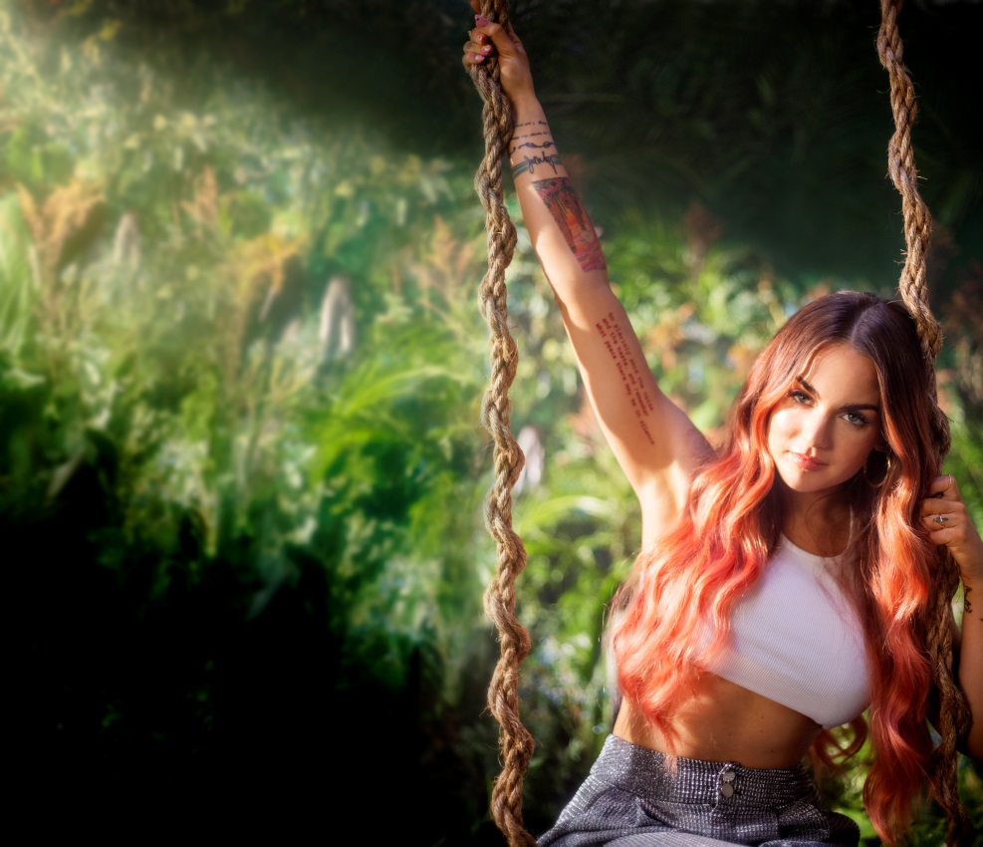

October 2, 2020 – Acclaimed singer JoJo, described as the voice of her generation, is lifting her voice to even greater heights to bring about “The Change” we need to see. Her powerful new anthem “The Change” is out now as part of the Joe Biden and Kamala Harris campaign’s ‘Get Out the Vote’ effort, with just 32 days left to take action before the November 3rd election.

“The Change” was written by iconic songwriter Diane Warren, an 11-time Oscar® nominee and GRAMMY®, Emmy® and Golden Globe® award winner, and carries a clear message of empowerment and action. Over a swirling orchestral crescendo, JoJo’s voice rings loud as a battle cry for change, driving forward lyrical freedoms that only she can convey: “I’m gonna be the change, I’m gonna start with my heart,” and “I’m not gonna waste no more time being blind.” The change starts by looking within, and the time to do so is now.

JoJo will perform “The Change” on The Late Show with Stephen Colbert on October 22, airing during the show’s live broadcast following the final presidential debate. Tune in to CBS at 11:35/10:35c.

Diane Warren states, “I am honored and humbled that Joe Biden has chosen to feature my song ‘The Change’ as part of the Get Out the Vote effort in this critical election. ‘The Change’ is a song about how change begins with us. We live in a time where a change is needed now more than ever. I hope this song inspires us all to realize that each one of us has the power to change the world.”

JoJo adds, “Diane Warren is one of the most prolific songwriters of any generation, and over the years she has become a friend and mentor. When she sent me ‘The Change’ a few weeks ago, I felt passionately about being the voice to bring her song to life. I always try to use my voice for good, but it’s especially meaningful to be singing these words at a time when our country needs to hear them more than ever. For the song to be chosen by Joe Biden and Kamala Harris as their "campaign anthem" is an absolute honor. I hope it can help make a difference.”

About JoJo
JoJo [born Joanna Levesque] is a chart-topping, award-winning singer, songwriter, and actress who, at just 29 years old, is already a veteran of the music industry. 15 years into her career, JoJo made a “triumphant return” [Uproxx] with her fourth studio album good to know, debuting at #1 on the Billboard R&B Albums Chart and earning widespread global acclaim from Vulture, TIME, Variety, NYLON, NPR, The FADER, and more, with Associated Press proclaiming “good to know is more than good. It’s grand.” At just 13, JoJo burst onto the scene with her self-title debut album, whose breakout smash “Leave (Get Out)” made her the youngest-ever solo artist to have a debut #1 single in the U.S. JoJo went on to sell over four million copies and became the singer’s first Platinum record, which she followed with a string of additional hits, including the Top 3 single “Too Little Too Late.” In 2016, following 10 years of legal battles with her former label that prevented her from releasing new music, JoJo returned with Mad Love. – debuting Top 10 on the Billboard Top 200. In 2018, JoJo re-recorded and re-released her first two albums (JoJo and The High Road) under her own label Clover Music, so her fans could finally get the nostalgia they had been missing for so many years. She has also pushed herself outside the confines of genre, recently collaborating with artists ranging from PJ Morton [on the GRAMMY Award-winning R&B hit “Say So”] and Jacob Collier [lending her vocal stylings to the jazzy “It Don’t Matter”] to Tank on “Somebody Else.”

About Diane Warren
Diane Warren is one of the most continuously prolific and successful contemporary songwriters of our time. During her impressive career, Warren has written for iconic artists such as Whitney Houston, Cher, Aerosmith, Celine Dion, Aretha Franklin, Mariah Carey, and many more, and continues to work with many of today’s most popular acts, including Beyoncé, Lady Gaga, Justin Bieber, Christina Aguilera, Snoop Dogg, Kelly Clarkson, Carrie Underwood, Mary J. Blige, Jennifer Hudson, Paloma Faith, Andra Day, Demi Lovato, LeAnn Rimes, Common, Janelle Monáe, Missy Elliott and Zendaya. Her songs have been featured in more than 100 motion pictures, earning 11 Academy Award® nominations, one GRAMMY Award® win and 15 nominations, one Golden Globe Award® and five nominations, and one Emmy Award® win. Over the past decade, Warren has become especially esteemed for her socially conscious anthems, including “I’m Standing With You” performed by Chrissy Metz from Breakthrough (2020), “I’ll Fight” performed by Jennifer Hudson from RBG (2019), “Stand Up for Something” performed by Andra Day and Common from Marshall (2018), “Til It Happens to You” performed by Lady Gaga from The Hunting Ground (2016), “This Is For My Girls” performed by Kelly Clarkson, Chloe & Halle, Missy Elliott, Jadagrace, Lea Michele, Janelle Monáe, Kelly Rowland and Zendaya from First Lady Michelle Obama's Let Girls Learn initiative (2016), “I Was Here” (2011) performed by Beyoncé, which was filmed at the U.N. to launch World Humanitarian Day and most recently “Free” performed by Charlie Puth from The One and Only Ivan. She was inducted into the Songwriters Hall of Fame in 2001 and is the sole owner of her publishing company Realsongs.

###

For further information on JoJo, please contact:
Ceri Roberts / Warner Records
Ceri.Roberts@warnerrecords.com

For further information on Diane Warren, please contact:
Jeff Sanderson / Chasen PR
jeff@chasenpr.com



