JoJo Releases Brand-New Rendition of “The Christmas Song”
Only on Amazon Music

Listen to “The Christmas Song,” an Amazon Original HERE

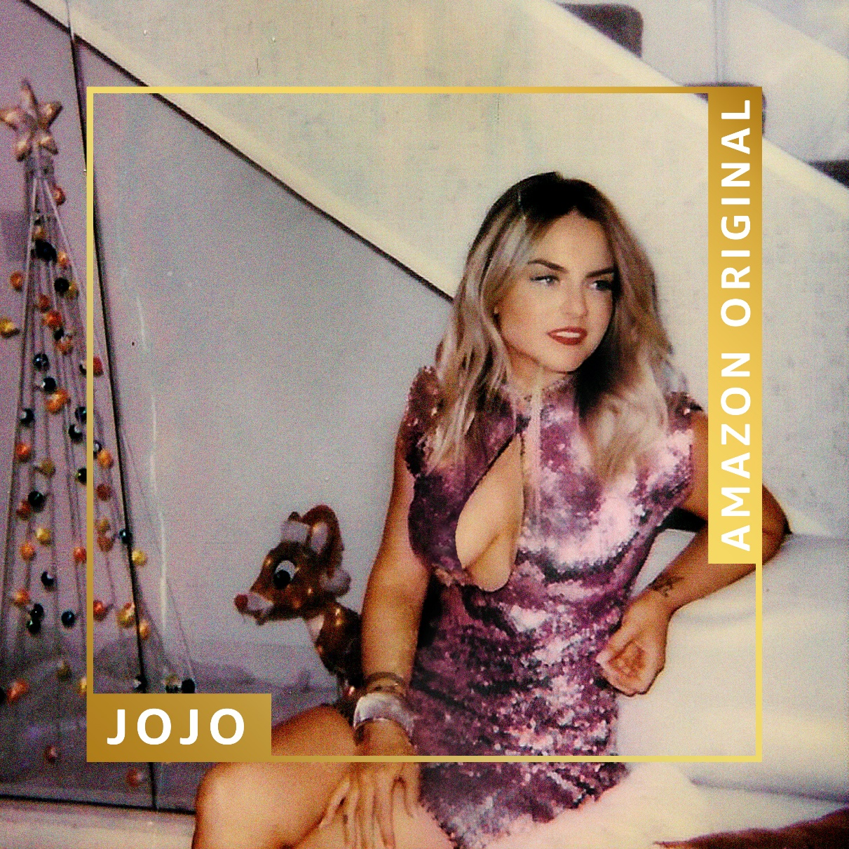

December 13, 2019 - Today, chart-topping, award-winning singer, songwriter, and actress JoJo released a brand-new rendition of the timeless holiday classic, “The Christmas Song.” Available to stream and purchase only on Amazon Music, the track finds JoJo putting a vintage, R&B twist on one of the most iconic Christmas songs. Part of a recent slate of brand-new, holiday-themed Amazon Originals, the track can be heard on the Christmas Present playlist, Amazon Music’s home for new holiday classics.

“‘The Christmas Song’ makes me feel like I’m home. My mom was part of a caroling troop and I learned ‘The Christmas Song’ from hearing her sing it year after year. We love holiday music in my family, and we start playing it right after Thanksgiving,” said JoJo about the song. “It makes me feel nostalgic, and I’m instantly transported back to the holidays in New England. There’s nothing like coming inside from the cold of the fresh December snow and warming up with hot chocolate by a wood burning stove. This is gonna be my first Christmas in Los Angeles, but singing this song makes me feel like a kid again waiting for Santa to slide down the chimney.”

Listen to JoJo’s Version of “The Christmas Song” only on Amazon Music:
http://amzn.to/JoJoChristmas

Embed Code:
<iframe id='AmazonMusicEmbedB08235QJN3'src='https://music.amazon.com/embed/B08235QJN3/?id=MzFtD6J688&marketplaceId=ATVPDKIKX0DER&musicTerritory=US' width='100%' height='290px' style='border:1px solid rgba(0, 0, 0, 0.12);max-width:500px'></iframe>

JoJo, born Joanna Levesque, is a chart-topping, award-winning singer, songwriter, and actress who, at just 28 years old, is already a veteran of the music industry. Now signed to Warner Records through a joint venture with her own Clover Music, JoJo has returned with new releases “Joanna” and the Doc McKinney-produced “Sabotage (feat. CHIKA),” and is looking ahead to her new album to come in spring 2020.

JoJo released her self-titled debut album when she was just 13. Her breakout smash “Leave (Get Out)” made JoJo the youngest-ever solo artist to have a debut #1 single in the U.S. and to be nominated for “Best New Artist” at the MTV Video Music Awards. The album went on to sell over four million copies and became the singer’s first Platinum record, which she followed with a string of additional hits, most notably the Top 3 single “Too Little Too Late” from sophomore album The High Road.In 2016, JoJo made a heralded return to music with her first new album in 10 years, Mad Love, which debuted in the Top-10 on the Billboard Top 200 and earned her unanimous critical acclaim.

“The Christmas Song” joins brand-new Amazon Original songs for the holidays, released this month from John Legend, Ellie Goulding, H.E.R., Ingrid Michaelson & Jason Mraz, Next Town Down, Sebastian Yatra, The Band Perry, Nina Nesbitt, and Chloe Flower. Amazon Original holiday songs are available to stream on all of Amazon Music’s tiers, including Amazon Music's newly expanded ad-supported streaming tier; Prime Music; Amazon Music Unlimited; and the recently-announced lossless streaming tier, Amazon Music HD. Subscribers to the high-quality streaming tier can hear the tracks in Ultra HD, the highest quality streaming audio available.

To listen to JoJo’s Amazon Original, fans can ask “Alexa, play holiday music by JoJo.” To hear the new slate of holiday releases and many more festive tracks, Amazon Music listeners can simply ask, "Alexa, play the Best of Amazon Holiday Originals playlist” in the Amazon Music app for iOS and Android and on Alexa-enabled devices. In addition to the new holiday songs launching today, Amazon Music listeners can access hundreds of Amazon Original songs and numerous albums featuring both emerging and established artists across numerous genres, only available to stream and purchase on Amazon Music.

For more information, please contact:
David Marek (davmarek@amazon.com)
at Amazon Music

For more information on JoJo, please contact:
Ceri Roberts (ceri.roberts@warnerrecords.com)
at Warner Records

