JOJO UNVEILS NEW TRACK & VIDEO “WORST (I ASSUME)”
LISTEN HERE – WATCH HERE

FORTHCOMING CAPSULE COLLECTION PROJECT TRYING NOT TO THINK ABOUT IT
OUT OCTOBER 1

TICKETS ON SALE NOW FOR EXCLUSIVE RUN OF INTIMATE LIVE SHOWS THIS FALL

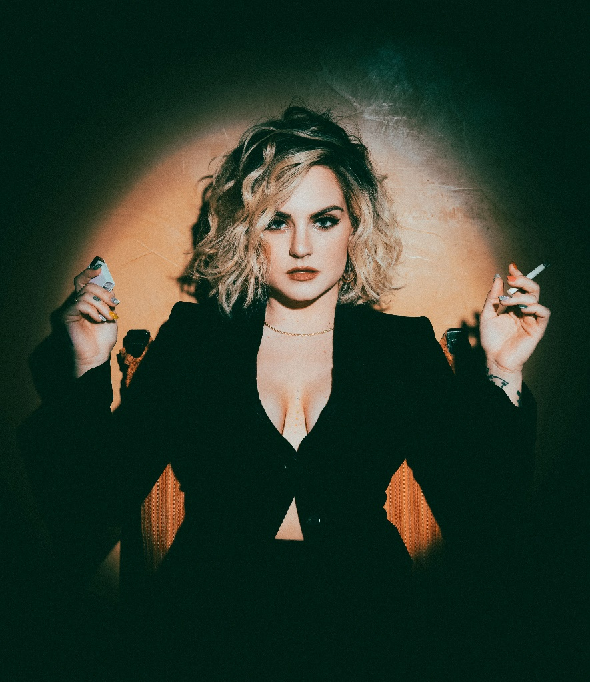

Download high res photos + artwork here

August 20, 2021 (Los Angeles, CA) – Today, GRAMMY Award-winning singer and songwriter JoJo unveils her brand new track “Worst (I Assume),” the very first glimpse into her forthcoming capsule collection titled Trying Not To Think About It, arriving October 1, 2021 via Clover Music/Warner Records. Listen to “Worst (I Assume)” HERE and pre-save/pre-order Trying Not To Think About It HERE.

The accompanying music video was directed by Alfredo Flores and shot in one continuous take to bring the song’s emotion to life through performance. The video concludes with a heartfelt note from JoJo. Watch the video HERE.

Immediately following the release of Trying Not To Think About It, JoJo will embark on a six-date run of intimate live shows across Boston, NYC, Philadelphia, Atlanta, Nashville & Los Angeles to celebrate and share the music with her fans across the country. Award winning singer/songwriter Tiara Thomas will open on all dates. Tickets will go on sale today, Friday, August 20 at 10:00 a.m. local time at https://www.iamjojoofficial.com/. Full dates below.

The 12-track EP is a musical expression of her continued honesty, vulnerability and transparency around mental health, tackling the different shades of it – including anxiety, depression, negative thoughts, relationship self-sabotage, and emotional immaturity.

“Trying Not To Think About It is a result of feeling sooooo lost, scared, and confused at the end of 2020 – desperate to believe in/find my light once again. Sometimes we feel like we’re the only ones. But we NEVER are alone in our darkness,” JoJo says of the project. “If you listen, I hope this project makes you feel seen, validated, not crazy, and hopeful that you won’t feel bad forever. You’re more in control than you think. Guys – I am overwhelmed with gratitude to perform these new songs + some of your faves on 6 intimate, very, very special LIVE TOUR dates in October. I can’t wait to see you. And FEEL you.“

In May 2020, JoJo’s fourth studio album good to know debuted at #1 on the Billboard R&B Albums Chart and earned widespread global acclaim from Vulture, TIME, Variety, NYLON, NPR, The FADER, and more, with Associated Press proclaiming “good to know is more than good. It’s grand.”

JoJo – Trying Not To Think About It Live 2021 Dates
Date | City | Venue
October 2, 2021 | Boston, MA | Sinclair
October 4, 2021 | New York City, NY | Music Hall of Williamsburg
October 5, 2021 | Philadelphia, PA | Underground Arts
October 7, 2021 | Atlanta, GA | Terminal West
October 9, 2021 | Nashville, TN | Exit/In
October 11, 2021 | Los Angeles, CA | El Rey

# # #

About JoJo
JoJo [born Joanna Levesque] is a chart-topping, award-winning singer, songwriter, and actress who, at just 30 years old, is already a veteran of the music industry. 17 years into her career, JoJo made a “triumphant return” [Uproxx] last year with her fourth studio album good to know, debuting at #1 on the Billboard R&B Albums Chart and earning widespread global acclaim from Vulture, TIME, Variety, NYLON, NPR, The FADER, and more, with Associated Press proclaiming “good to know is more than good. It’s grand.” At just 13, JoJo burst onto the scene with her self-title debut album, whose breakout smash “Leave (Get Out)” made her the youngest-ever solo artist to have a debut #1 single in the U.S. JoJo went on to sell over four million copies and became the singer’s first Platinum record, which she followed with a string of additional hits, including the Top 3 single “Too Little Too Late.” In 2016, following 10 years of legal battles with her former label that prevented her from releasing new music, JoJo returned with Mad Love., which debuted in the Top 10 on the Billboard Top 200. In 2018, JoJo re-recorded and re-released her first two albums (JoJo and The High Road) under her own label Clover Music, so her fans could finally get the nostalgia they had been missing for so many years. She has also pushed herself outside the confines of genre, collaborating with artists ranging from PJ Morton [on the GRAMMY Award-winning R&B hit “Say So”] to Jacob Collier [lending her vocal stylings to the jazzy “It Don’t Matter”]. On October 1, 2021, JoJo will release Trying Not To Think About It. The capsule project is a musical expression of her continued honesty, vulnerability and transparency around mental health, tackling the different shades of it – including anxiety, depression, negative thoughts, relationship self-sabotage, and emotional immaturity. Following its release, JoJo will head on the road for a set of six live performance dates across the United States beginning October 2, 2021 in her hometown of Boston, MA and concluding October 11, 2021 in Los Angeles, CA.

###

For further information about JoJo, please contact:
Warner Records / Ceri.Roberts@warnerrecords.com
full coverage communications / Erica.Gerard@fullcov.com + natasha@fullcov.com

JoJo Press Materials:
press.warnerrecords.com/jojo

Follow JoJo:
Instagram | YouTube | Twitter | Facebook | Website

