**JOSHUA SPEERS RELEASES DEBUT EP *HUMAN NOW***

**ON WARNER RECORDS**

**“CAN I FALL IN LOVE WITH A BROKEN HEART” VIDEO OUT NOW**

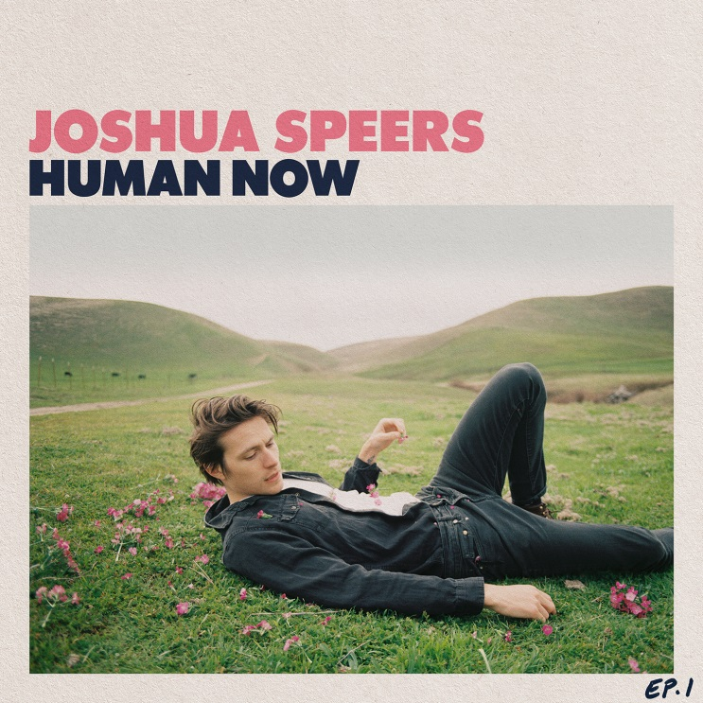

*Hi-res photos/artwork available* [*here*](https://press.warnerrecords.com/joshuaspeers/)

**May 8, 2020 (Los Angeles, CA)** – Emerging singer/songwriter Joshua Speers shares his debut EP *Human Now* today on Warner Records/Let Me Know. Featuring recently-released tracks [“Stray Bullets”](https://warnerr.ec/straybullets_mv) and [“Oh Brother,”](https://warnerr.ec/OhBrother_lv) the 5-track record is an inspired search for honesty, full of driving ‘80s guitar riffs, steady drums and perfectly described by Speers as the lovechild of Bruce Springsteen and Carly Rae Jepsen. An official video for “Can I Fall In Love With A Broken Heart” is also out today.

**Listen/Share the *Human Now* EP** [**HERE**](https://warnerr.ec/humannow)

**Watch/Share “Can I Fall In Love With A Broken Heart” (Video)** [**HERE**](https://warnerr.ec/canifall_v)

Josh Speers is your quintessential All-American hero. A blue-collar rock songwriter, a motorcyclist, a lover of baseball, an extremely well-read guy. On paper he sounds made up, like Dean Moriarty. A workman who has been a pottery apprentice, a carpenter, a busboy, an assistant to a governor, a nanny, a baseball coach; a hopeless romantic who looks like a walking black-and-white Herb Ritts portrait.

One of four brothers from Delaware, Josh moved out to Los Angeles in 2018 to take a real shot at a music career, where he wound up finding kindred spirits in the likes of songwriter Tommy English (Kacey Musgraves) and producer Lars Stalfors (St. Vincent, Cold War Kids), who largely wrote and produced *Human Now* with Speers, as well as Jon Castelli (Khalid, Summer Walker x Drake) who mixed several songs on the EP. While missing the East Coast amid a breakup, the task of being more honest than ever about his experiences forced him to see himself in his least comfortable form. The result is *Human Now*, named in reference to a WH Auden poem.

*Human Now* begins with the epic song [“Bad Night”](https://warnerr.ec/badnightv) and continues with the synth-y ode to solitude [“Happy Birthday You're Alone.”](https://warnerr.ec/hbdyourealonev) [“Can I Fall In Love With A Broken Heart,”](https://warnerr.ec/canifall_v) which features a string arrangement written and performed by Rob Moose (Bon Iver, Alabama Shakes, Arcade Fire), isn't just a song title but a very literal question he was trying to answer. [“Oh Brother”](https://warnerr.ec/OhBrother_lv) is a self-aware reckoning about doomed romance. [“Stray Bullets”](https://warnerr.ec/straybullets_mv) is a tongue-in-cheek meditation on breaking free from our overstimulated world. The songs are inspired by essayist Didion whose main writing goal was always to incorporate honesty, to describe “how it felt to be me.”

To learn more about Josh, click [here](https://warnerrecords.app.box.com/file/649783012671).

***Human Now* Tracklisting**

1. Bad Night
2. Oh Brother
3. Stray Bullets
4. Can I Fall In Love With A Broken Heart
5. Happy Birthday You're Alone

# # #

**For further information contact Warner Records Publicity:**

National: [Jaime.Rosenberg@warnerrecords.com](mailto:Jaime.Rosenberg@warnerrecords.com)

Regional: [Patrice.Compere@warnerrecords.com](mailto:Patrice.Compere@warnerrecords.com)

**Follow Joshua Speers:**

[**Instagram**](https://www.instagram.com/joshuaspeers/?hl=en) **|**[**YouTube**](https://www.youtube.com/channel/UC7ADUcZk5mz6F3O9DK4nvMQ) **|** [**Facebook**](https://www.facebook.com/JoshuaSpeersMusic/) **|** [**Twitter**](https://twitter.com/joshuaspeers?lang=en)

**cid:image001.png@01D5204D.CFB194F0**