KATHLEEN II EP OUT NOW VIA WARNER RECORDS/LET ME KNOW
DEBUTS NEW SONG AND VIDEO “CAN’T SLEEP”
“She paints pictures with words and precise phrasing, cradles them in unique sounds and employs a softness that is all but extinct in modern pop.”—Idolator
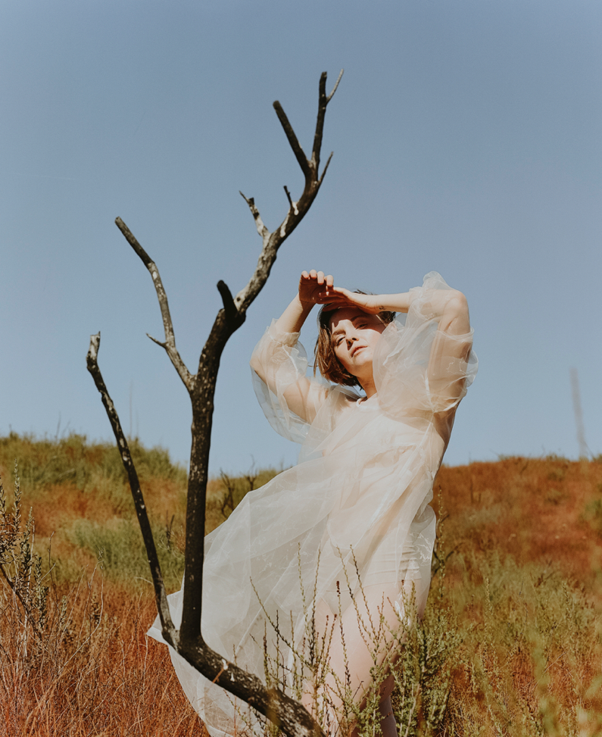
photo credit: Chimera Singer
October 9, 2020 (Los Angeles, CA) —Kathleen II, the second EP from rising songwriter, multi-instrumentalist and vocalist Kathleen, is out today via Let Me Know/Warner Records—listen here. Additionally, she shares a new track “Can’t Sleep” alongside a video—watch it here.
“I wrote ‘Can’t Sleep’ a few years ago,” Kathleen says. “Even then, it felt like we had been blindly and willingly lead into a deep canyon and instead of questioning who threw us in, we just immediately turned and started fighting each other about which side got us here. And in that canyon, the shouts ricochet and the echos get louder until deafening, and it’s a horrible bath of voices and we can’t distinguish one from another, or who’s actually shouting. And at a certain point, you just squat down on the ground with your hands over your ears wondering how you’re gunna get out of this one.”
“This song is about that fight in the canyon. It’s a dancy jam, and when Noah [Conrad] and I wrote the first version, I definitely remember that it was the first song I’d ever written for myself that I’d actually stood up and just teenage-girl-at-a-sleepover danced to. So in the style of The Smiths or Tears For Fears’ “Mad World” or so many other great songs to dance to, I wanted to make the lyrics speak to the darkness of the world, inside the lightness of the dance. It makes understanding how hard and bad everything is, less hard and bad.”
The new EP features “Can’t Sleep,” previously shared singles “August” and “Dark Side of the Moon”—which Vanyaland calls “a delicate folk song about the emotions of finding home” that “creates tension in sparse spaces as her angelic voice dances above the fray”—and a new track, “Glass Piano.” The follow up to her debut EP from May, Kathleen II finds the singer digging deeper into her roots as a poet and environmentalist, using the backdrop of the pandemic to heighten the urgency of the music and contrast the EP’s lighter moments. Kathleen wrote “Dark Side of the Moon,” the EP’s second track, at the beginning of quarantine when uncertainty and chaos abounded, inspired by “everyone running and hiding from this microscopic pathogen,” yet there is a tenderness in Kathleen’s voice as she prepares for a once in a lifetime opportunity to reconnect with her family.
There’s a similar duality on “Can’t Sleep,” which finds Kathleen comparing the state of the world to a bad dream. On one hand, it sometimes feels like the reality we’re collectively enduring would end if we just woke up, and on the other, the song is also about the worst nightmare of those in power—everyone uniting to affect change. The EP, which is in large part produced by Ariel Rechtshaid (Adele, Beyoncé, Vampire Weekend, HAIM, Kelela), references some of Kathleen’s favorite poetry and further highlights the precision of her voice and her devotion to nature, setting the scene for the rising singer’s next chapter.
In May, Kathleen made her Warner Records debut with Kathleen I, which “takes strides toward defining a lane for Kathleen through her poetic and politically conscious songwriting,” according to Under the Radar. The EP features her debut single, “The Longest Year,” and three other tracks; stream it here.
Kathleen recently partnered with Klean Kanteen to create a custom bottle that features Kathleen’s own illustration of the Glacier Lily, a resilient flower found in the Rocky Mountains that often grows right through the snow, symbolizing the spring that awaits us after the quarantine winter. Kathleen will donate a portion of the proceeds to Indigenous ReGeneration, a charitable organization dedicated to the preservation and re-indigenization of Native Communities.
Born on an island in Washington and raised in the Rocky Mountains by a park ranger mother and a pediatrician father, alongside a sister with a degree in evolutionary biology, Kathleen finds her foremost inspiration in nature. From the age of seven, when she began writing songs and poetry, she found herself entranced by the world around her, whether by the sweeping landscapes of her home state of Colorado or the pattern of leaves as a vine climbs a wall or the insects living in a fallen log. She grew up ski racing, but was always more interested in the great silence of the snow beneath the chairlifts and the total freedom inside the forests of the back bowls. Her work investigates these natural extremes and how they apply to our everyday lives.

