SHARES NEW TRACK “AUGUST”
KATHLEEN II EP OUT OCTOBER 9
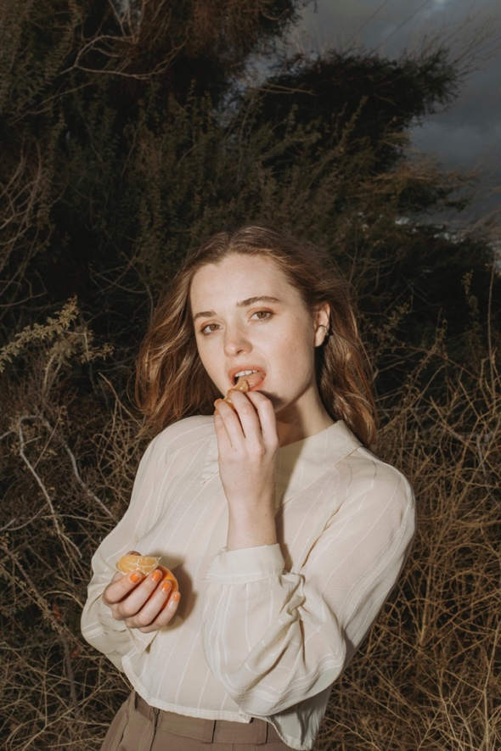
photo credit: Chimera Singer
August 7, 2020 (Los Angeles, CA) —Rising songwriter, multi-instrumentalist and vocalist Kathleen shares a new track “August” today—listen here. The song is from her forthcoming EP Kathleen II, out October 9 via Let Me Know/Warner Records—pre-save it here.
“It’s been a long hard summer,” Kathleen says. “It’s my hope that ‘August’ can be three minutes of the rest, reflection and catharsis we all need in order to keep moving and keep growing into the new world and out of the rubble we’re currently under.”
Tonight, Kathleen will perform an acoustic 3-4 song set for LiveXLive’s Music Lives On series.
Kathleen II, the follow up to her debut EP from May, finds the singer digging deeper into her roots as a poet and environmentalist, using the backdrop of the pandemic to heighten the urgency of the music and contrast the EP’s lighter moments. Kathleen wrote “Dark Side of the Moon,” the EP’s second track, at the beginning of quarantine when uncertainty and chaos abounded, inspired by “everyone running and hiding from this microscopic pathogen,” yet there is a tenderness in Kathleen’s voice as she prepares for a once in a lifetime opportunity to reconnect with her family.
There’s a similar duality on “Can’t Sleep,” which finds Kathleen comparing the state of the world to a bad dream. On one hand, it sometimes feels like the reality we’re collectively enduring would end if we just woke up, and on the other, the song is also about the worst nightmare of those in power—everyone uniting to affect change. The EP, which is in large part produced by Ariel Rechtshaid (Adele, Beyoncé, Vampire Weekend, HAIM, Kelela), references some of Kathleen’s favorite poetry and further highlights the precision of her voice and her devotion to nature, setting the scene for the rising singer’s next chapter.
In May, Kathleen made her Warner Records debut with Kathleen I, an EP that shows how she “paints pictures with words and precise phrasing, cradles them in unique sounds and employs a softness that is all but extinct in modern pop,” according to Idolator, while Under the Radar notes that it “takes strides towards defining a lane for Kathleen through her poetic and politically conscious songwriting.” The EP features her debut single, “The Longest Year,” and three other tracks; stream it here.
Born on an island in Washington and raised in the Rocky Mountains by a park ranger mother and a pediatrician father, alongside a sister with a degree in evolutionary biology, Kathleen finds her foremost inspiration in nature. From the age of seven, when she began writing songs and poetry, she found herself entranced by the world around her, whether by the sweeping landscapes of her home state of Colorado or the pattern of leaves as a vine climbs a wall or the insects living in a fallen log. She grew up ski racing, but was always more interested in the great silence of the snow beneath the chairlifts and the total freedom inside the forests of the back bowls. Her work investigates these natural extremes and how they apply to our everyday lives.

