KEEDRON BRYANT TEAMS UP WITH SYMBA FOR POWERFUL MUSIC VIDEO “I KNOW I BEEN CHANGED”
FEATURING GARY CLARK JR.
WATCH HERE

THE GOSPEL COVER IS THE THEME SONG FOR NATE PARKER’S
NEW FILM AMERICAN SKIN

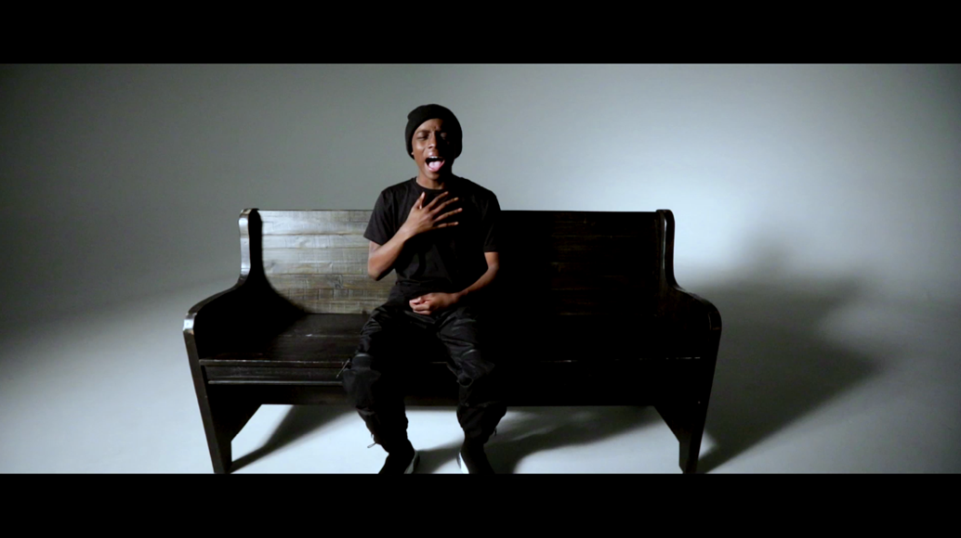
Click here for hi-res image

March 8, 2021 (Los Angeles, CA) – Today, 13-year-old singer and activist Keedron Bryant unveils the powerful and provocative music video for his timely cover of gospel legend LaShun Pace’s classic song “I Know I Been Changed” with rapper Symba, featuring GRAMMY®-winning artist Gary Clark Jr. It stands out as the theme for writer and director Nate Parker’s politically charged film American Skin. Listen to “I Know I Been Changed” via Warner Records HERE.

The video intercuts some of the most intense moments from American Skin with intimate performances from Keedron and Symba. Closeups depict the raw pain of Keedron’s soulful delivery as he sings from an empty bench, while black-and-white security camera-style footage of Symba offers a counterpoint sound tracked by his poignant verses. Meanwhile, Gary Clark Jr.’s guitar cries with a searing solo, uplifting this protest anthem with six-string spirit. “I Know I Been Changed” was notably produced by Dem Jointz (Kanye West, Janet Jackson, Chris Brown, Rihanna). Watch it HERE.

On Martin Luther King Jr. Day, Keedron appeared on The View where he spoke to the hosts and delivered an unforgettable live rendition of “I Just Wanna Live” and “I Know I Been Changed.” Watch it HERE.

Keedron has always had revolutionary potential in his music, and now the world is listening. His fans and supporters include renowned artists like Dr. Dre, Alicia Keys, Kirk Franklin, and Andra Day. He's also garnered attention from publications like Associated Press, who named his breakout hit single “I JUST WANNA LIVE” their 2020 Song of the Year. He recently performed a rendition of Marvin Gaye’s “Mercy, Mercy, Me” on Good Morning America after covering the song for ESPN's The Undefeated compilation, I Can't Breathe / Music for the Movement. For Christmas 2020, he released a charming EP, The Best Time of Year, featuring three holiday classics and a new song with his sister Aiyanna Bryant. Keedron has a lifetime ahead of him, but he’s already making the world a better place with his presence.

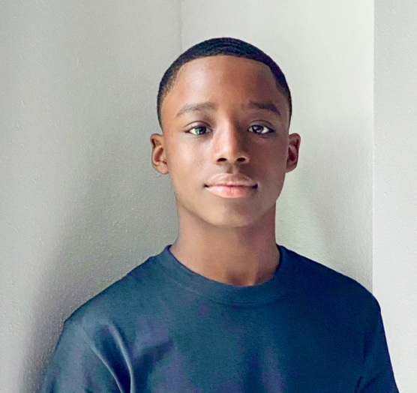
DOWNLOAD PRESS PHOTO HERE [CREDIT: JOHNNETTA BRYANT]

ABOUT KEEDRON BRYANT:
Singing acapella on a smartphone-shot video, Keedron Bryant moved the world to tears with nothing more than his powerhouse voice and the declaration, “I’m a young black man doing all that I can.” The 13-year-old Florida native’s YouTube performance of “I JUST WANNA LIVE” surged around the globe as a clarion call for change and the unassuming soundtrack to a moment of revolution. He performed the song on The Ellen DeGeneres Show via FaceTime, and received acclaim from Good Morning America, CNN, The Steve & Marjorie Harvey Foundation, Access Hollywood, and BBC News. Will Smith incorporated the clip in his “No Justice, No Peace” montage, and LeBron James posted it on Instagram with the caption, “I LOVE YOU KID! I LOVE US!” None other than President Barack Obama also cited it. Keedron's work as a young activist continued with his collaborative performance of Jermaine Dupri's "Change" at the Biden/Harris "I Will Vote" concert and his work on the I Can’t Breathe / Music For the Movement EP, released in tandem by ESPN’s The Undefeated and Disney Music Group. This Christmas, he also performed at the 2020 Disney Park’s Magical Christmas Celebration. Born in Sicily to minister parents, Keedron began singing at just five years old. Attending church regularly, he developed a passion for gospel music. The budding talent first turned heads on season four of Little Big Shots. Represented by Heather Beverly, Esq. in association with Tabetha Plummer, Esq., and legendary producer Dem Jointz, Keedron catapulted to the top of the conversation in 2020, landing a deal with Warner Records and releasing the official “I JUST WANNA LIVE” single as his debut. With R&B energy, soul range, and gospel power, he will undoubtedly make a major impact.

FOLLOW KEEDRON BRYANT
Instagram | Twitter | YouTube

For more information on Keedron Bryant, please contact:
Aishah White | Warner Records
Aishah.White@warnerrecords.com

For more information on Symba, please contact:
Jason Davis | Atlantic Records
Jason.Davis@atlanticrecords.com

For more information on Gary Clark Jr., please contact:
Rick Gershon | Warner Records
Rick.Gershon@warnerrecords.com

