LAUNDRY DAY RETURN WITH NEW SONG AND VIDEO
“DID YOU SLEEP LAST NIGHT?”
LISTEN HERE – WATCH HERE

MAJOR LABEL DEBUT ALBUM WE SWITCHED BODIES OUT FEBRUARY 11TH

NORTH AMERICAN HEADLINE TOUR CONFIRMED FOR SPRING 2022

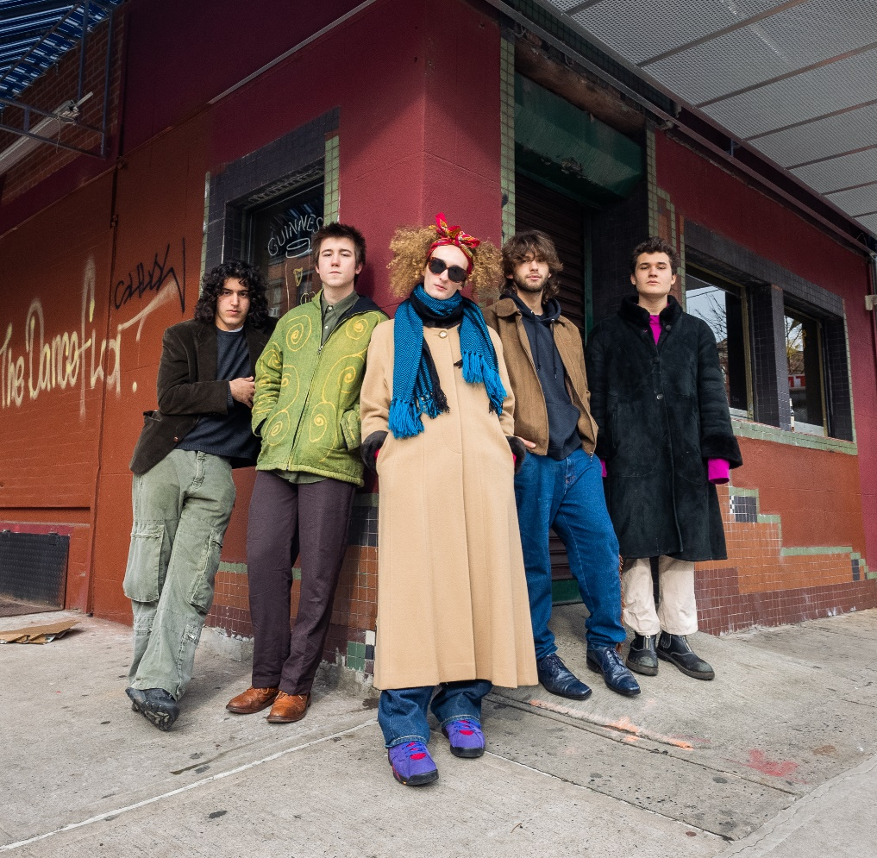

January 14, 2022 (Los Angeles, CA) – Today, New York City's LAUNDRY DAY share new track and video “Did You Sleep Last Night?” the latest off their major label debut, We Switched Bodies, out February 11th on Warner Records. Co-produced by Kevin Abstract and Romil Hemnani [of BROCKHAMPTON] plus veteran rock producer Brendan O’Brien [Bruce Springsteen, Red Hot Chili Peppers], the standout album cut is a fitting memento of the self-taught quintet’s blossoming creative and personal lives, as their recent high school graduation signals the start of an unstoppable new chapter for the band.

Check out “Did You Sleep Last Night?” HERE and pre-order/pre-save We Switched Bodies HERE.

Featuring recently-released favorites “Connect 5” and “Worry Bout Yourself,” We Switched Bodies is a wide-ranging 10-track record that blends the group’s diverse musical interests–’60s psych rock mingles with quick twitch electronic beats and expert production polish. To celebrate the upcoming release, the band will embark on a fast-selling North American headline tour this spring, following standout festival performances at Lollapalooza, Governors Ball, and Firefly Music Festival this past summer. Check out a full list of dates below – tickets are available at www.daundrylay.com.

About LAUNDRY DAY:
All before even graduating from Beacon High School in Manhattan during June 2020, LAUNDRY DAY sold out shows at iconic venues such as The Bowery Ballroom and The Roxy, canvassed the U.S. and Europe on tour – including runs with The 1975 and Clairo – and earned support from the likes of The FADER, NME, Pigeons & Planes, and i-D who raved, “LAUNDRY DAY is reinventing the teen boy band,” as well as HYPEBEAST who named them among “Best Music Artists on the Come Up.” They recorded their 2019 album HOMESICK with producer Romil Hemnani [BROCKHAMPTON] at Rick Rubin’s Shangri-La Studios in Malibu. Of the latter, Lyrical Lemonade attested, “HOMESICK illustrates the galvanizing energy of a young group with the prowess and skill, both technical and intuitively, of a bunch of veterans, all without skipping a beat.” In 2021, they reteamed with Romil and BROCKHAMPTON’s Kevin Abstract, the production duo Video Store, to cultivate their next evolution in the studio. Additionally, they welcomed legendary producer Brendan O’Brien [Pearl Jam, Red Hot Chili Peppers] into the fold to truly shock their vision to life.

SPRING 2022 TOUR DATES
March 11 Washington, DC DC9
March 12 Nashville, TN The End
March 13 Atlanta, GA Aisle 5
March 15 Houston, TX Bronze Peacock at House of Blues
March 22 Phoenix, AZ The Rebel Lounge
March 23 San Diego, CA Voodoo Room at House of Blues
March 25 Los Angeles, CA El Rey
March 26 Santa Ana, CA Constellation Room
March 27 San Francisco, CA Popscene at Brick and Mortar
March 29 Salt Lake City, CA Kilby Court
March 30 Denver, CO Larimer Lounge
April 1 Pontiac, MI The Pike Room at Crofoot
April 2 Columbus, OH The Basement
April 4 Chicago, IL Subterranean
April 5 Toronto, ON The Drake Underground
April 6 Montreal, QC Petit Campus
April 8 Boston, MA Middle East Upstairs
April 16 New York, NY Irving Plaza

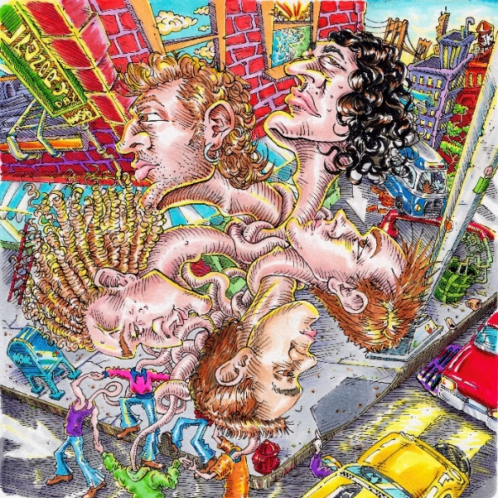

###

Follow LAUNDRY DAY:
Website | Twitter | Instagram | TikTok

For more information, please contact:
Ceri Roberts | Warner Records
Ceri.Roberts@warnerrecords.com

Patrice Compere | Warner Records
Patrice.Compere@warnerrecords.com

