https://www.ladygunn.com/category/culture/

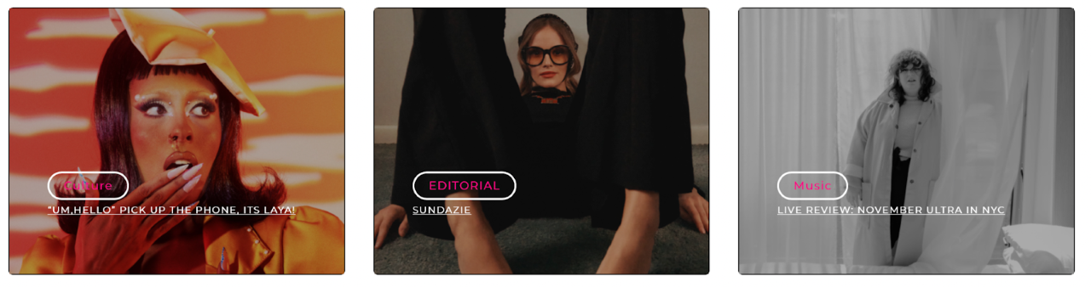
Homepage Inclusion

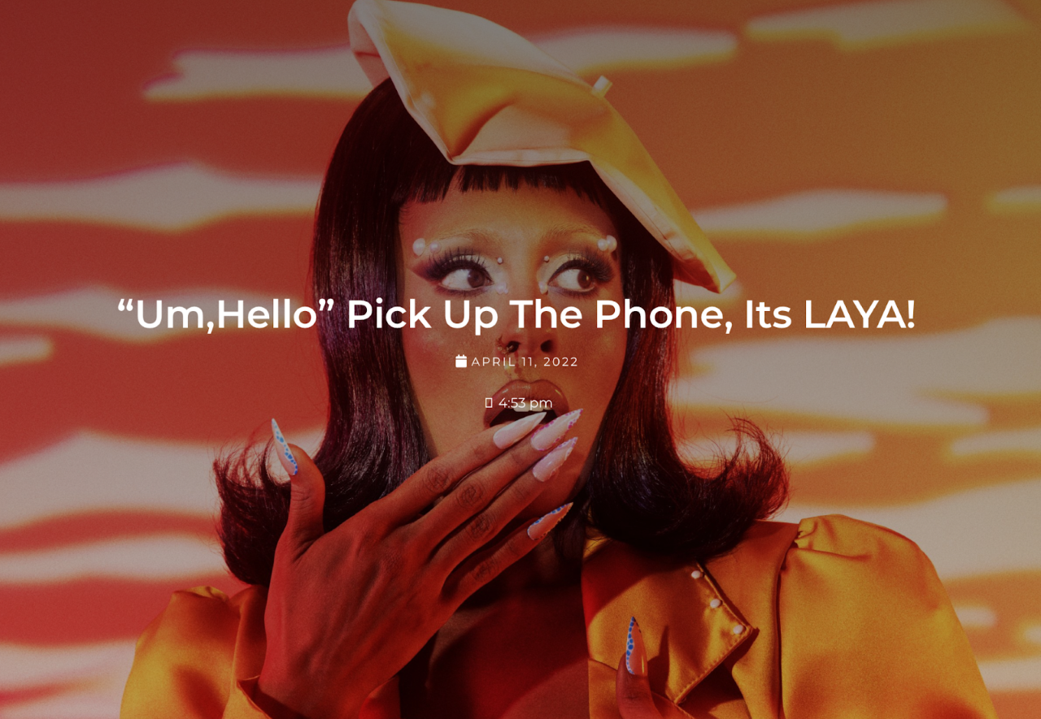

With the endless amount of digital resources available in 2022 almost anyone can create a qualitative masterpiece with just the right amount of dedication and maybe a few online crash courses. An autodidact will seek out intrinsic motivation, self-determination, with a true passion for mastering and perfecting their craft, at their own pace and free will.
“When it comes to creating my art I do it all. I write, I record and mix myself, I shoot, direct and edit all of my own videos, I do my own glam and create my own costumes. The Um, Hello cover was my artistic interpretation of how I take everything into my own hands. I do so many things outside of just singing the songs and I wanted to embody that in an image, all the while grabbing as much attention as possible.” – LAYA
Catapulting onto the scene with full force, Staten Island’s latest emerging singer-songwriter is LAYA, a true creator who is just that. The artist has worked as a singer, songwriter, producer, creative director, and visual artist—constantly evolving and constantly morphing into something bigger and better. “Everything that I’ve gotten to this point, I’ve worked for and made happen,” LAYA says. “It didn’t exist yesterday, but it exists today.” The R&B and Hip-Hop star is creating her own sound and style within the confines of the female music scene. A true creative force in the most natural form, LAYA’s melodic works are composed of lush, smooth vocals and signature harmonics.
With the re-release of her first EP “Um,Hello”, new music video “On Sight” and a very well deserved deal with music giant Warner Records. The project includes her vibey single “Brag” featuring Fivio Foreign, as well as “Bitter” and “Sailor Moon. The result is a forward-looking fusion of radiant R&B pop, nostalgic soul, and blissful sultry love letters disguised as bad bitch anthems.
LAYA Reminds Us That She’s In Her Bag And She Doesn’t Wanna “Brag”, And That She Is Indeed A Bag Full Of Tricks!
On Wednesday I had the chance to attend the “Um,Hello” listening dinner party which took place at an intimate setting at the Elephant Room in the Moxy Hotel in Time Sq.
LAYA arrived strutting an ivory green suede two-piece outfit, super cute yellow glossy kitten heels that reminded me of shiny bananas, all while holding a netted bag full of plastic lemons. And my favorite part of the look, a pair of lemon sliced earrings made by the queen of DIY herself. The whole look was giving Tropic-CUNT!
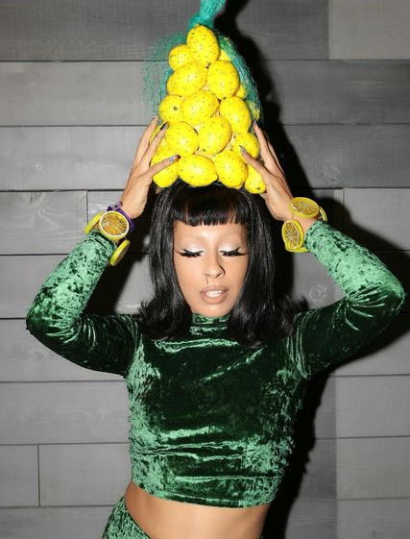

A specialized cocktail menu that consisted of 5 drinks named after the record’s most anticipated songs. The drink named “Brag” took the prize as my top choice which was a refreshing sweet drink made of Lobos Tequila, Fresh Lime Juice, Grapefruit, Soda Water and Simple Syrup. Yum. After guzzling a few drinks and eating fresh quinoa with salmon the EP began to play.
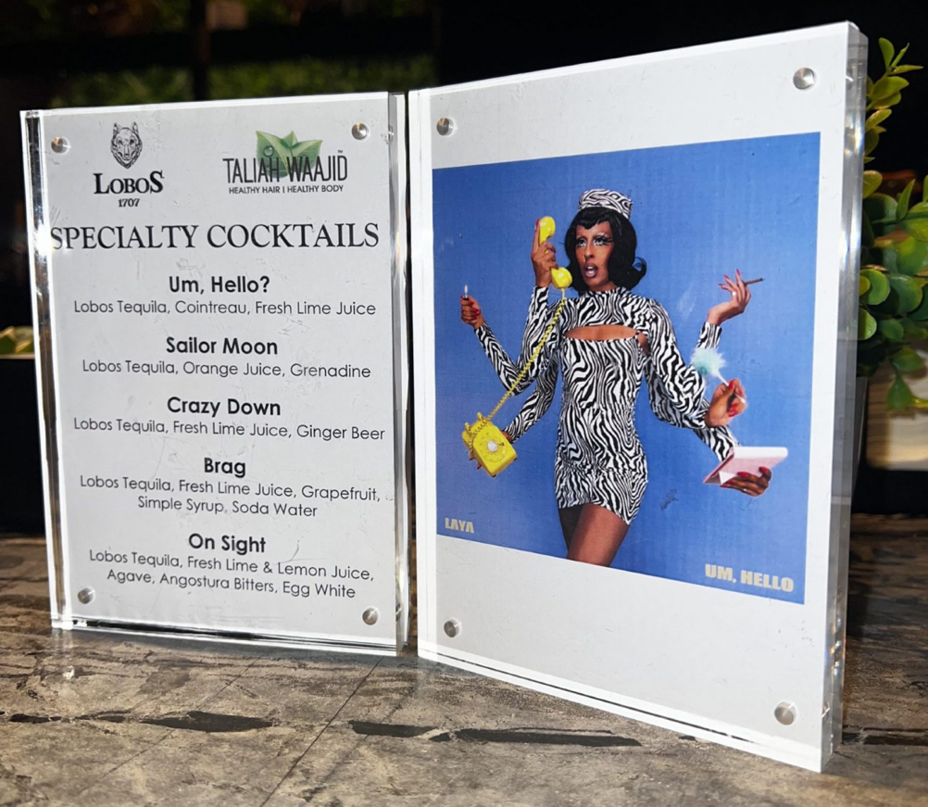

A very on brand moment were the beautiful bags provided from CISE the black-owned Los Angeles based clothing line with a simple idea: Stronger Threads For A Stronger Community!

We love any bag with a statement!
The room was full of love and bright energy, the crowd sang along and danced all the way through. A true 90’s love child existing in 2022 with an incredible sense of atmospheric synths that are soothing and seductively playful.
My personal favorite track on the record is “Crazy Down” which is a combination of heart-pounding drops and melodic interludes. The bass felt electric. Sound waves carried through my chest and into my heart. The track felt empowering, sexy and enthralling. I was on an endless roller coaster where LAYA indeed had me so down.

I am personally excited to see what will come next from LAYA, her humble spirit and bright light will forever shine through.
I had the chance to interview the artist, here is what she had to say.

M: Could you explain what “Um,Hello” means to you and the inspiration behind this EP?
Laya: This EP is my call to the universe. I called it “Um, Hello” because I wanted to grab the world’s attention. At the time when my producers (ORA) and I came together to work on this project we all felt like underdogs. We felt like we were all being slept on and our talents were being overlooked. I’m proud to say that the work we created on this project has absolutely changed that narrative and through it we’ve manifested our dream. We’ve got your attention now.

M : You re-released the project twice, tell me about that experience.
Laya: I originally released it while I was still independent. I had no major push. I simply used the tools and resources at my fingertips to get it around to as many people as possible. It moved slowly at first but it gradually grew into a fan favorite project. Within about a year after I released it, Um, Hello got the attention of a few record labels. Suddenly I was in a position to really change my life. Warner Records was the record label I decided to work with and they expressed to me that they loved the EP so much that they wanted to relaunch it on a much bigger level. How could I say no? This is literally what I had been asking for. To be heard. Um, Hello would finally get its flowers and I couldn’t be more grateful.

M: I’m fascinated by the cover art, you’re like this modern Hindu goddess with six arms, how did this concept find you?
Laya: When it comes to creating my art I do it all. I write, I record and mix myself, I shoot, direct and edit all of my own videos, I do my own glam and create my own costumes. The Um, Hello cover was my artistic interpretation of how I take everything into my own hands. I do so many things outside of just singing the songs and I wanted to embody that in an image, all the while grabbing as much attention as possible.

Laya: There is an underlying romance in your lyrics. How has romance helped influence your storytelling?
Laya: Romance is certainly one of the most inspirational aspects of life in my opinion. Romance is so much more interesting to me than sex. The feelings and magical moments that happen before you get to lay down with someone is what really inspires me. For example, the song “Sailor Moon” is just about having a crush on someone. That’s it. Just a crush. What happens after that is not important. In that moment what is important and inspirational to me is the feelings of whimsy and euphoria that you get when you just really, really like somebody.

M: Is there a certain lyric from a particular song that you’re particularly proud of?
Laya: It’s really hard to choose. I have several favorite lines from Um, Hello. But if I’ve got to pick one I would choose this line from “Calling Me”. It goes “They ain’t hit my number in a while. But now it’s my number that they dial. I been on the line since I was a child. They calling me.” This lyric is special to me because it embodies my experience with Um, Hello and how I went from making my call begging for the world’s attention to now, they calling me.

M : What three words would you use to describe the music you play?
Laya: Bop, slap, and soul. Just like that!

M:What’s your artistic process?
Laya: So many people ask me this question and the more I think about it the more I think to myself (respectfully) it’s none of your business. Lol. I know that when I write or create looks I am channeling something but beyond that I can’t tell you how I work. That’s like a chef giving you the secret ingredient to their signature dish. Not gonna happen.

M: Tell me about the approach from Warner Records and how that moment took place ? How did you feel about such an exciting opportunity?
LAYA: It all happened so fast. My A&R Ericka Coulter had caught wind of my music and with no hesitation she reached out to my team and flew out from LA to NYC within less than 24 hours. She wasted no time. She believed in me 100% and saw exactly where I intended to take my career. It’s been an incredible ride and already my life has changed so much. We’ve only scratched the surface of what we’re really about to do and I truly cannot wait to give everything else we have in store.

M: You recently teamed up with Amazon Music to record a cover of your choice, and you did your own version of Missy Elliott’s 1997 classic “Sock It 2 Me” from her Grammy-nominated debut album, Supa Dupa Fly. What was the reasoning behind this?
LAYA: I love that song! When I was asked to pick a song of my choice “Sock It 2 Me” was the first thing that popped into my head. I really just always loved singing that song. It was just that simple. I can admit it was a bit nerve wracking when it came to actually laying it down because Missy is such an icon and the last thing I wanted to do was ruin her song. However I’m proud of the rendition I created. Nothing will ever top the original but I’m happy with what I did.

M: Who are your style icons ?
LAYA: Drag queens! Drag queens, drag queens, drag queens. I live for them and their ability to not only create their own characters but to create and design all of their looks as well, and many times from scratch. I love the big over the top approach to everything. There is never a dull moment and the possibilities are endless. I’m in love with all things camp and making everything fun. They remind you that you can be smoking hot without taking anything too seriously.

M: Who’s your dream and nightmare blunt rotation?
LAYA: Dream rotation? Would have to be Thundercat, Bill Murray, and Judge Judy.
Nightmare rotation? Anyone who makes the blunt wet with their mouth! Lol. They gotta go. Like, please keep your saliva to yourself!

M: “Sailor Moon” is so dreamy and magical. What are your 3 astrological placements?
LAYA: Oh we’re getting personal over here. Lol. I’m an Aquarius sun, Libra moon, and Virgo rising. So basically I’m a weird, eccentric fortune teller who is super fun to be around, but watch out because I pay very close attention to detail and don’t forget anything.

M: What can fans expect from you and any live shows soon?
LAYA: You can expect the unexpected. My music may be familiar to the soul but my approach to visuals and live performances are completely different. I love the theater and how you can transport the audience to another place. That’s what you can expect from my shows.
CONNECT WITH LAYA
INSTAGRAM // SPOTIFY
Story/Interview : Mateo Palacio
Photos Courtesy : Warner Music Records

