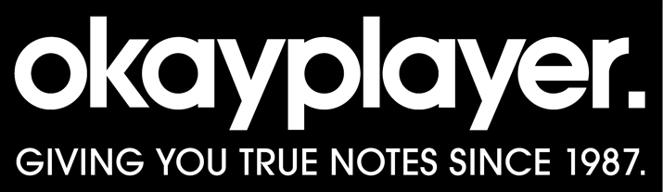
https://www.okayplayer.com/music/new-hip-hop-rb-albums-you-should-be-listening-to-week-of-april-8.html

8 New Hip-Hop & R&B Albums You Should Be Listening To (Week of April 8)

In the realm of R&B Syd has blessed us with the Broken Hearts Club her first solo album since 2017. It’s a superb listen and she’s joined by Lucky Daye, Smino, and Kehlani on the 13-track album. LAYA releases Um, Hello her debut EP; it’s a robust compilation featuring her expansive sound.
LAYA – Um, Hello

