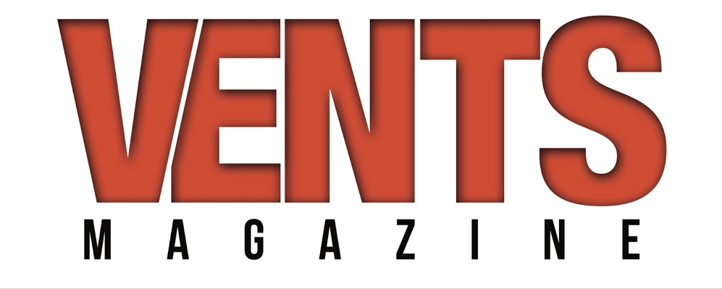
https://ventsmagazine.com/2022/04/08/interview-laya/

INTERVIEW: LAYA
1.) We’re pleased to have a little time today with R&B sensation LAYA, one of the most exciting voices on the recording scene; welcome to Vents, LAYA! Before we get too far down the proverbial rabbit hole, how has your 2022 been treating you?

My 2022 has been absolutely amazing! All the seeds that I’ve planted over time are finally beginning to sprout. I’m very blessed.

2.) Major congratulations are in order for your latest single which just hit the airwaves, Crazy Down! What was the genesis of this infectious and crackling tune?

It all started when I played “Crazy Feelings” by Missy Elliot and Beyonce for ORA (my producers Chad Paul & Dante Carter) and they immediately fell in love with it. It was a song I grew up listening to but it was new to them. Next thing I knew they had cooked up this beat that was insane using a sample of the song. Chad had mentioned that he could hear the opening phrase of Brandy’s classic “I Wanna Be Down” on it. I took that and ran with it. I went into my hole and built the song around those two records. It was an absolute labor of love and you can feel it. Although since then we’ve had to replace the original sample of “Crazy Feelings” it cannot go without saying that “Crazy Down” would not exist were it not for “Crazy Feelings.

3.) It sounds as if you had a fun time cutting Crazy Down. Are you attracted to material that serves as a sort of celebration of life?

Absolutely! That’s all I talk about. Celebrating life. I don’t deny that bad things happen or that we don’t experience them but I don’t like to make music to cry to. If my music brings you to tears it’s for a totally different reason. Never sadness.

4.) Who was your producer on Crazy Down and what did that collaboration in the studio look like between the two of you?

ORA (Chad Paul & Dante Carter) produced Crazy Down as well as all of my other songs. How we work is a bit unconventional. We all live far away from each other so when we create it’s mostly them sending me the beats and then I write to them and record them myself in my room. Most of our work flow is sending files back and forth to one another. I like to be alone when I write and record and they respect that.

5.) Can you talk a little about some of the other incredible music talent that has contributed to Crazy Down?

Well firstly of course “Crazy Feelings” by Missy Elliott and Beyonce which is the foundation on which the song was built and naturally “I Wanna Be Down” by Brandy. These woman have made great contributions in the form of influence for me all my life and this song was an opportunity for me to display that and pay very well deserved respect to each of them.

6.) The music video for Crazy Down is so inspired and outside the conventional box – How much of a hand did you have in structuring the video for the new single?

I made the entire thing from top to bottom by myself. Not one person assisted me in the process of creating that video. I shot the footage on my iPhone with a tripod, edited it myself, styled myself (with my own regular clothes lol), did my own glam, and the whole 9. I’ve created all my own music videos this way.

7. Warner Records is the home of Crazv Down -What makes Warner’s the perfect home base for you and your music?

Warner is a major label and have incredible people working there. They knew instantly that they wanted me on their team and have believed in me whole heartedly from day one. They are perfect for me and my music because they truly see me for the artist that I am and the artist that I am becoming. They’re dreams are just as big as mine and that’s what I believe is important to have in a relationship with a label. I feel very blessed and right at home with Warner.

8.) What do you hope fans walk away feeling after listening to Crazy Down?

I hope they feeling itching sensation to run that sh*t back! Lol. I also hope they take from it the knowing that a song can be super sexy without actually saying too much.

9. Your home turf is in Staten Island. How do those roots inform you and your music?

It’s the underdog of NYC. I have to work that much harder just to prove myself to the rest of my own city. It’s given me a drive to supersede expectations and crush everything in my path.

10.) On April 8 your Um, Hello EP will be reissued. What can you tell readers about this reissue and what they can expect?

It’s an absolute ride from start to finish. It’s loaded with empowering messages and spicy clap backs all while giving you the bounce and bass that you need. There’s something for everyone on this project and I’m so excited to share it with you.

11.) Is it too soon to ask vou about an LP? Can fans look forward to a full-length album in the near future?

Yes! There will be an LP but I can tell you there will be another EP before that happens. Either way there will be a steady stream of new music to look forward to.

12.) Will you be touring to promote Crazy Down and the Um, Hello EP?

Fingers crossed! There are a ton of things opening up at the moment so the best thing I could say right now is to make sure you tap into my socials to stay up to date on upcoming shows.

13.) Musically, who inspires you and your music?

The golden era of 90s R&B, and 70s & 80s funk heavily inspires me musically. There’s so much timeless music there that can still be felt today. It’s really all I listen to.

14. Did you know from the get-go that you wanted to be a musical artist?

Yes. Yes, yes, yes. Since I could speak I would sing and I never considered doing anything else with my life. There was never a plan b. There was never a doubt in my mind that I could do this. I simply had to grow and keep moving forward in my purpose. I knew it would all happen at the right time. Now is that time.
