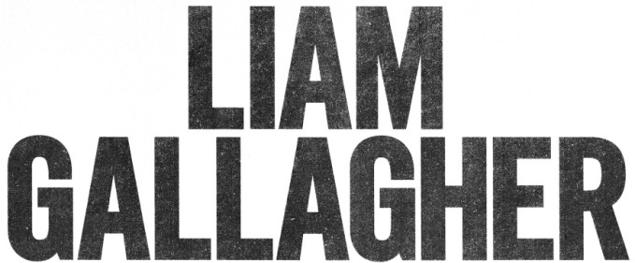

LIAM GALLAGHER MTV UNPLUGGED RELEASE DATE MOVES TO JUNE 12

“Liam shines in an acoustic setting” - Q

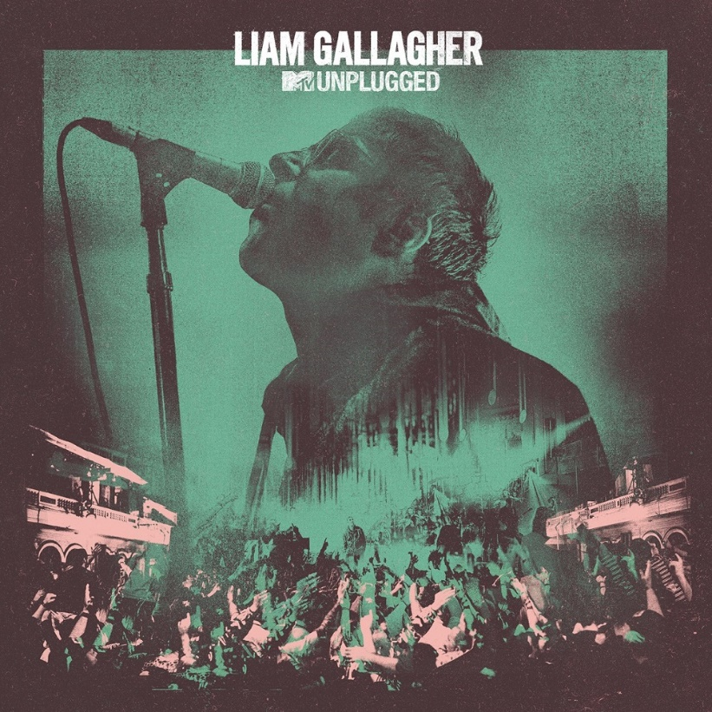

May 7, 2020 (Los Angeles, CA) – The release date of Liam Gallagher’s MTV Unplugged live album has moved back to June 12. Last summer Liam Gallagher joined the list of all-time greats (Paul McCartney, Page and Plant, Nirvana and many more) who have filmed a prestigious MTV Unplugged session. Having missed Oasis’s 1996 session through illness, the show at Hull’s City Hall found Liam fulfilling some unfinished business entirely on his own terms.

Liam commented, “I was honoured to perform at the legendary showcase that is ‘MTV Unplugged’. It was a lovely experience and the people of Hull were biblical and sounded fantastic. I hope you enjoy the record. LG x”

The show’s electrifying atmosphere is palpable from the very beginning with a phenomenal reaction as Liam takes to the stage with “Wall of Glass.” Material from Liam’s solo career such as his personal favorite “Once” and the joyous “Now That I’ve Found You” resonates in this stripped-back format, with his vocal shining alongside a trio of backing singers and string arrangements performed by the 24-piece Urban Soul Orchestra. Stripped of the force of its studio recording, “Gone” is a standout as it reveals new-found bombastic dynamics and an evocative cinematic atmosphere

Oasis guitarist Bonehead features on performances of “Some Might Say,” “Stand By Me,” “Cast No Shadow” and Liam’s first ever live vocal performance of the “Definitely Maybe” bonus track “Sad Song.” The show concludes on a crowd-pleasing high with an emotive take on the classic “Champagne Supernova.”

MTV Unplugged is now available to pre-order from www.liamgallagher.com. It will be available on the following formats: CD, signed CD available exclusively from Amazon, standard vinyl, splattered vinyl, and digitally. All pre-orders receive an instant download of “Gone.”

MTV Unplugged Tracklist:

1. “Wall Of Glass”
2. “Some Might Say”
3. “Now That I Found You”
4. “One of Us”
5. “Stand By Me”
6. “Sad Song”
7. “Cast No Shadow”
8. “Once”
9. “Gone”
10. “Champagne Supernova”

Liam recently announced that he’ll play a free concert for NHS staff at The O2 on October 29. Please see https://www.liamgallagher.com/tour for the latest updates on all future live shows.

For further information contact:
Ceri Roberts / ceri.roberts@warnerrecords.com

Follow Liam Gallagher:
Website | Twitter | Facebook | Instagram | Spotify | Press Site

