RELEASES HIS SOPHMORE SOLO ALBUM WHY ME? WHY NOT.
OUT TODAY

Gallagher To Perform Live On The Tonight Show Starring Jimmy Fallon
On October 28th

West Coast Dates With THE WHO This Fall

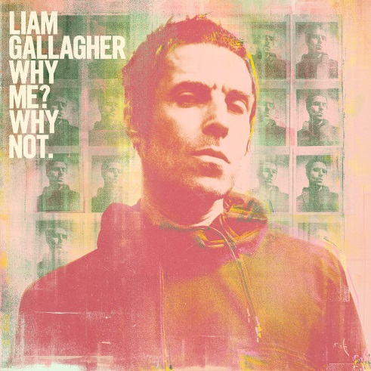

September 20, 2019 (Los Angeles, CA) – Today Liam Gallagher releases his long-awaited second solo album Why Me? Why Not. via Warner Records. Gallagher’s sophomore release was written by Gallagher along with producers Andrew Wyatt and Greg Kurstin, and recorded in both Los Angeles and London. Wyatt and Kurstin previously contributed with writing and producing Gallagher’s internationally-acclaimed debut solo album As You Were. As the four songs released thus far indicate -- “Shockwave” , “The River” , “Once” and “One Of Us” – Why Me? Why Not. is destined to become an instant modern rock ‘n’ roll classic; 14 tracks with that unique brand of charisma, attitude, style showcasing contrasting sides to the ex-Oasis frontman’s iconic voice. From the onset, the media has celebrated Gallagher’s return to the spotlight:

“Emotionally-driven rock songs” – Rolling Stone
“A classic sequel that adds depth of character.” – NME (UK)
“Liken it to Oasis glory days.” – Billboard
“A triumph… The voice of the last generation is a voice of this one too.” – Q Magazine (UK)
“It looks like Gallagher is back to the business of making music! Big riffs and the swagger that Liam brought to Oasis in the first place. ” – Stereogum
“Conjures up a bit of the scrappy feel of early, blown-out Oasis circa Definitely Maybe.” – Spin

On Monday October 28th, Liam Gallagher will take center stage to perform live on The Tonight Show starring Jimmy Fallon. Tune into NBC stations at 11:35PM / 10:35PM CT.

Why Me? Why Not. Tracklisting:
- Shockwave
- One Of Us
- Once
- Now That I’ve Found You
- Halo
- Why Me? Why Not
- Be Still
- Alright Now
- Meadow
- The River
- Gone

Why Me? Why Not. is available in various formats including CD, digital and a collectible D2C package which compiles a deluxe CD, a sun yellow vinyl album and a one-sided etched 12” which features three deluxe bonus tracks along with a demo recording that’s exclusive to this format – all packaged in a hardcover book with two art prints and a poster. Click here to order.

Don’t miss Liam Gallagher on tour this fall with The Who on select dates of their North American Moving On! Tour. Click here for tickets and show details. Gallagher will return to the US to headline his own tour in 2020. Details to be revealed soon. Until then, go to: https://liamgallagher.com

Liam Gallagher on tour with The Who:
Wed Oct 09 Chase Center San Francisco, CA
Fri Oct 11 Hollywood Bowl Hollywood, CA
Sun Oct 13 Hollywood Bowl Hollywood, CA
Wed Oct 16 Viejas Arena at Aztec Bowl/ UCSD San Diego, CA
Sat Oct 19 T-Mobile Park Seattle, WA
Mon Oct 21 Rogers Arena Vancouver, BC
Thur Oct 24 Hollywood Bowl Hollywood, CA

Please see https://liamgallagher.com/tour for a full list of international dates.

For further information contact:
Rick Gershon 818-953-3473 / rick.gershon@warnerrecords.com
Ceri Roberts 212-707-2259 / ceri.roberts@warnerrecords.com

Follow Liam Gallagher:
Twitter
Spotify
Facebook
Instagram
liamgallagher.com

Press materials:
http://press.warnerrecords.com/liamgallagher

