THE FLAMING LIPS RELEASE HOLIDAY VIDEO WITH A COVER OF
“PEACE ON EARTH”/”LITTLE DRUMMER BOY”
The Lips Return To Denver For An Encore Performance of THE SOFT BULLETIN With The Colorado Symphony Orchestra on February 22, 2019
Tickets on Sale December 21 At 10:00 AM MT
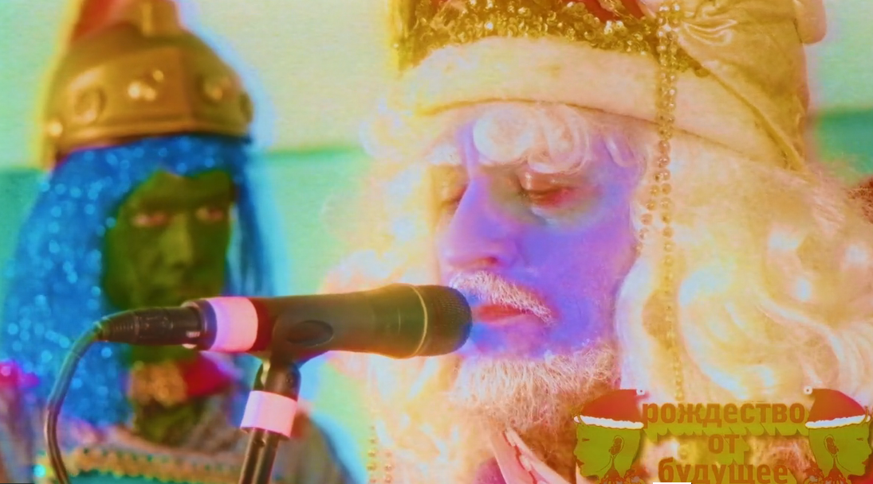
December 20, 2018 (Los Angeles, CA.) – Today THE FLAMING LIPS celebrate the spirit of the season by releasing a performance video of the Christmas classics “Peace On Earth”/ “Little Drummer Boy”. The film and audio recording were captured at Coyne’s Pink Floor Studios in Oklahoma City, Oklahoma and features THE LIPS live line-up of Wayne Coyne, Steven Drozd, Michael Ivins, Derek Brown, Jake Ingalls, Matt Kirksey and Nicholas Ley performing the songs. The video was directed by Wayne Coyne and George Salisbury.
THE LIPS taking on these perennial classics is considered homage to the David Bowie/Bing Crosby medley of “Peace on Earth/Little Drummer Boy” from 1977 under the banner of “Christmas of the Future”.
Click HERE to view and share
Announced this week, THE FLAMING LIPS will reprise their spectacular performance of their groundbreaking 1999 album THE SOFT BULLETIN, accompanied by the Colorado Symphony Orchestra with a show at Denver’s Boettcher Concert Hall on Friday, February 22. Tickets go on sale to the general public on Friday, December 21 at 10:00am MT, and will be available at https://coloradosymphony.org/Tickets, or by visiting or calling the box office: 303-623-7876. THE LIPS originally played THE SOFT BULLETIN in its entirety, along with the Colorado Symphony Orchestra at Red Rocks Amphitheatre in Morrison, Colorado on May 26, 2016 and considered by critics as one of the most important events ever held at Red Rocks in their 75 year history. The show was recorded and is planned for future release.
In other LIPS news, Steven Drozd has created a podcast that covers their 35 year recorded career. This multi-part series will illustrate their inimitable and out there creative process covering their aural oeuvre in their own dulcet tones. Episode Four: The Sorcerer’s Orphan: A song By Song History of The Flaming Lips audio podcast is available now on iTunes. Click HERE for details.
The Flaming Lips Live:

Dec 31 The Caverns Pelham, TN
Jan 22 Moody Theater Austin, TX
A Benefit for The Hi, How Are You Project w/ THE LIPS, Built To Spill, Yo La Tengo, etc)
Feb 22 Boettcher Concert Hall Denver, CO (w/ Colorado Symphony)
Feb 23 Belly Up Aspen Aspen, CO

Click HERE to purchase or stream the Greatest Hits Vol. 1 and Greatest Hits Vol. 1 Deluxe Edition”

Click HERE for exclusive merchandise.

Restless/Rhino reissues available now:
https://rh-ino.co/stufl6cd

# # #

For further information on The Flaming Lips contact:
Rick Gershon 818-953-3473 / rick.gershon@wbr.com

Follow The Flaming Lips:
Website: www.flaminglips.com
Twitter: @TheFlamingLips
Facebook: Facebook.com/FlamingLips
YouTube: YouTube.com/FlamingLips

Press Materials:
press.wbr.com/flaminglips

