MULTIPLATINUM, GRAMMY® AWARD-NOMINATED
LUKAS GRAHAM RETURNS WITH NEW SINGLE “LOVE SOMEONE”

New Album 3 (The Purple Album) Set for Release October 26 via Warner Bros. Records, Available Now for Preorder

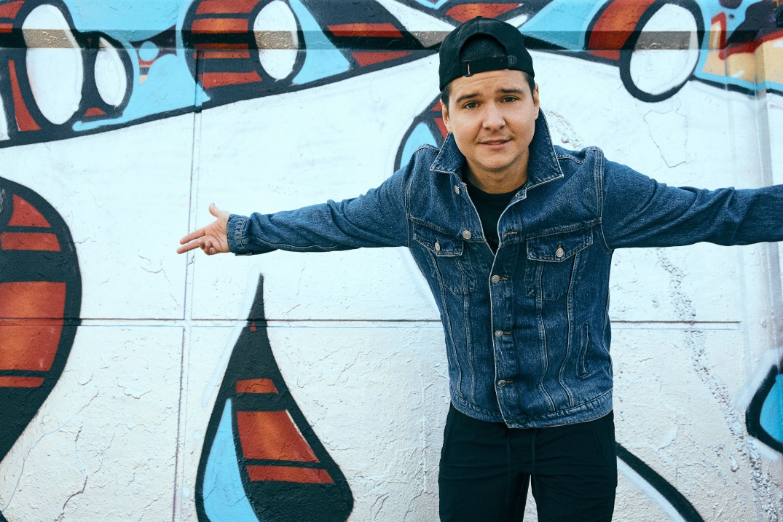

September 7, 2018 (Los Angeles, CA) – GRAMMY® Award-nominated multiplatinum Lukas Graham, who broke out in 2016 with the global smash “7 Years,” returns today with the release of new single “Love Someone.” In true Lukas Graham fashion, the song takes an honest, intimate look at human emotions, and is described by Lukas as being about “the kind of love I’m feeling that I’ve never felt before.” “Love Someone” sets the stage for the release of the highly-anticipated new album, 3 (The Purple Album), on October 26 via Warner Bros. Records. The album is available now for pre-order via all digital retailers, as well as at the band’s official store. By pre-ordering through lukasgraham.com, fans can get early access to tickets for upcoming U.S. tour dates. Pre-order 3 (The Purple Album) HERE and watch the official music video for “Love Someone” HERE.

3 serves as the follow-up to Lukas Graham’s eponymous global debut, which racked up over 23 million units in worldwide consumption, saw “7 Years” hit number one in 13 different countries, and earned the band three GRAMMY® Award nominations – including both Record and Song of the Year. The breakout smash was the highest-selling single by a debut artist in 2016, and catapulted the Danish artist to sold-out tours around the world, critical acclaim from the likes of The New York Times, Rolling Stone, and Billboard, and performances on The Tonight Show Starring Jimmy Fallon, Good Morning America, The Billboard Music Awards, Late Night with Seth Meyers, The Late Late Show with James Corden, CONAN, The GRAMMY® Awards and the MTV Video Music Awards, where he was also nominated for “Best New Artist.”

“7 Years” turned Lukas’ life into a whirlwind—a world away from his beginnings, born on a couch in Christiania, an impoverished, liberal, quasi-commune located in the center of Copenhagen. While Lukas’ roots to his home and community run deep, the singer is far from content with the accolades of the past few years: He’s restless and ready to be known as an artist that supersedes any smash he may have, past or present. Now almost 30, engaged to his long-term girlfriend, and proud father of a little girl, Viola, Lukas is balancing the rigors of the road with family life and the attendant expectations. While the self-titled debut was dedicated in large part to Lukas’ late father, 3 is for his daughter and sees Lukas push deeper still, holding a magnifying glass up to his life, laying bare his vulnerabilities and his fears, his sadness and his joy.

It’s the gamut of these experiences which he’s poured diaristically into 3. Written and recorded almost entirely between September 2017 and April the following year, Lukas spent two months in Copenhagen before decamping to LA with his fiancé and daughter to finish the record alongside his long-term team—“his boys,” producers Morten “Rissi” Ristorp, Morten “Pilo” Pilegaard, songwriter Stefan Forrest and engineer David LaBrel. Together they create a special kind of alchemy: easy pop hooks alongside soul-baring poignancy. Lukas says simply, “It’s a more mature record, definitely, but it has more life in it.”

Official Album Art for 3 (The Purple Album)

###

For further information on Lukas Graham, contact Ceri Roberts at WBR:
212-707-2259 / Ceri.Roberts@wbr.com

Digital Assets:
Watch “Love Someone” video here
Stream/Download “Love Someone” here
Pre-order 3 (The Purple Album) here

Follow Lukas Graham:
Website: www.lukasgraham.com
Facebook: facebook.com/LukasGraham
Twitter: @LukasGraham
Instagram: @lukasgraham

Press Materials:
press.wbr.com/lukasgraham

