LUKAS GRAHAM RELEASES NEW ALBUM 3 (THE PURPLE ALBUM) TODAY
ON WARNER BROS. RECORDS

FEATURING GLOBAL HIT “LOVE SOMEONE”

On Tour in North America in 2019, Tickets On Sale Now

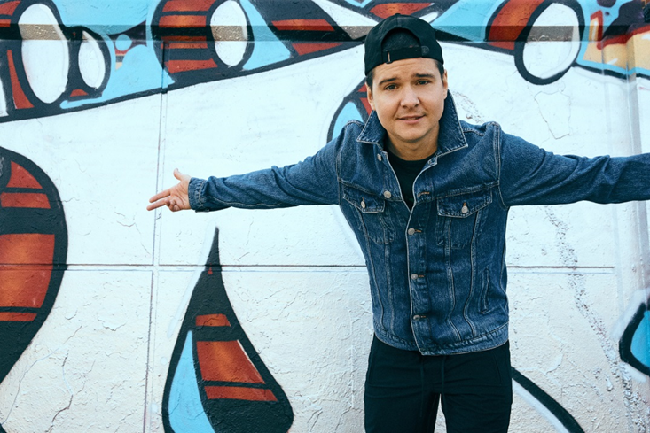

October 26, 2018 (Los Angeles, CA) – GRAMMY® Award-nominated multiplatinum Lukas Graham releases their new album, 3 (The Purple Album) today via Warner Bros. Records. The 10-track record makes its debut as lead single “Love Someone” follows in the footsteps of breakout hit “7 Years,” as it rapidly climbs the Hot AC radio charts, amassing 50 million Spotify streams and 30 million YouTube views before it impacts at Top 40 radio next week. “Love Someone” is on track to become a global smash, reaching #1 in their home country of Denmark and continuing to climb the charts in the U.K., Europe, Australia, and beyond. Lukas Graham recently performed the song on Dancing With The Stars and Jimmy Kimmel Live!.

Listen/Share 3 (The Purple Album):
https://LukasGraham.lnk.to/3ThePurpleAlbum

Lukas Graham recently announced a 2019 North American tour, beginning on February 22 in Portland. Tickets are now available for purchase at lukasgraham.com. See the full itinerary below.

3 (The Purple Album) serves as the follow-up to Lukas Graham’s eponymous global debut, which racked up over 23 million units in worldwide consumption, saw “7 Years” hit number one in 13 different countries, and earned the band three GRAMMY® Award nominations – including both Record and Song of the Year. The breakout smash was the highest-selling single by a debut artist in 2016, and catapulted the Danish artist to sold-out tours around the world, critical acclaim from the likes of The New York Times, Rolling Stone, and Billboard, and countless television performances, including The GRAMMY® Awards and the MTV Video Music Awards, where he was also nominated for “Best New Artist.”

While Lukas wrote the breakout debut album and subsequent smash “7 Years” in his mid-20s, grappling with the loss of his father, the new album sees Lukas push deeper still, holding a magnifying glass up to his life, laying bare his vulnerabilities and his fears, his sadness and his joy. Now 30, engaged to his long-term girlfriend, and proud father of a little girl, Viola, 3 serves as a "growing up" moment for Lukas as he transitions from son to father. Lukas says simply, “It’s a more mature record, definitely, but it has more life in it.”

ALBUM TRACK LISTING:
- Not A Damn Thing Changed
- Lullaby
- You’re Not The Only One (Redemption Song)
- Love Someone
- Promise
- Stick Around
- Unhappy
- Everything That Isn’t Me
- Hold My Hand
- Say Yes (Church Ballad)

LUKAS GRAHAM U.S. TOUR DATES
February 22 Portland, OR Crystal Ballroom
February 24 Seattle, WA The Moore Theatre
February 26 Berkeley, CA The UC Theatre
February 28 Los Angeles, CA The Wiltern
March 2 San Diego, CA House of Blues
March 3 Phoenix, AZ The Van Buren
March 6 Austin, TX Austin City Limits Live at The Moody Theater
March 7 Houston, TX House of Blues
March 8 Dallas, TX House of Blues
March 10 Chicago, IL House of Blues
March 13 Boston, MA House of Blues
March 15 New York, NY Hammerstein Ballroom

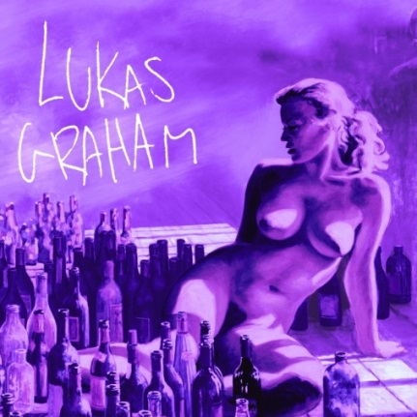
Official Album Art for 3 (The Purple Album)

###
For further information on Lukas Graham, contact:
Jaime Rosenberg / Jaime.Rosenberg@wbr.com
Ceri Roberts / Ceri.Roberts@wbr.com

Digital Assets:
Stream/Download “Not A Damn Thing Changed” here
Watch/Share Video for “Not A Damn Thing Changed” here
Watch “Love Someone” video here
Stream/Download “Love Someone” here

Follow Lukas Graham:
Website: www.lukasgraham.com
Facebook: facebook.com/LukasGraham
Twitter: @LukasGraham
Instagram: @lukasgraham

Press Materials:
press.wbr.com/lukasgraham

