LUKAS GRAHAM SHARE NEW ORIGINAL HOLIDAY SONG
“HERE (FOR CHRISTMAS)”

U.S. HEADLINE TOUR CONCLUDES IN NEW YORK CITY AND BOSTON THIS WEEKEND

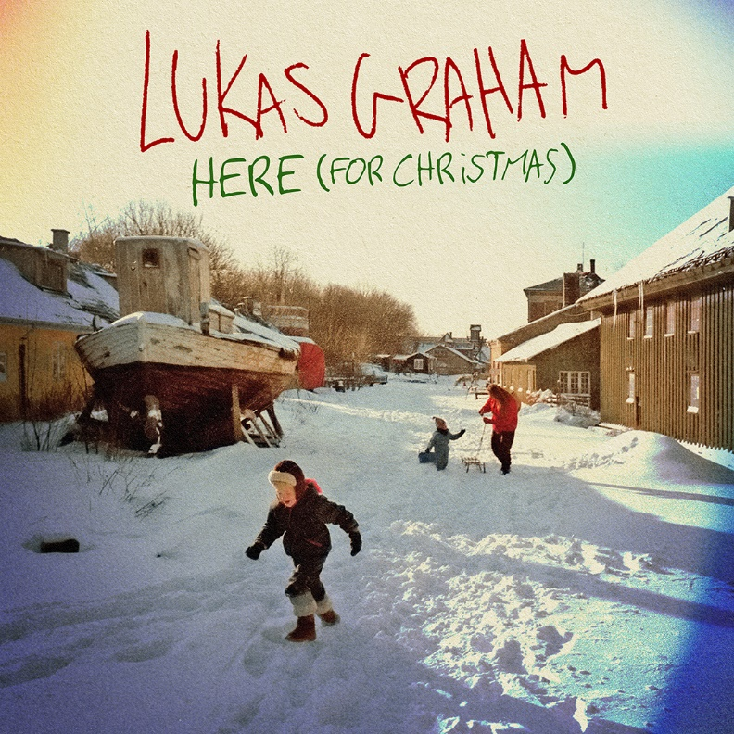

November 8, 2019 (Los Angeles, CA) – GRAMMY® Award-nominated multi-platinum artist Lukas Graham share their new original holiday song, “HERE (For Christmas)” today on Warner Records. The autobiographical track was written about the complex feelings of missing lost loved ones during the holidays. Frontman Lukas Forchammer has always been upfront about how his father’s passing had such a profound effect on his life, which is a recurring theme throughout his music.

The track is released alongside a lyric video, which is filled with Lukas’ personal photos from childhood with William and other loved ones. Lukas explains, "‘HERE (For Christmas)’ is about William, my childhood friend, who is no longer with us. He was renovating this beautiful old boat, but he never got to put it in the water. That boat is a metaphor for all the things I wish I could do with Willy, my dad and all the others that are here no more.”

Watch/Share “HERE (For Christmas)” Lyric Video HERE
Listen/Share “HERE (For Christmas)” HERE

Lukas Graham’s 2019 North American headline tour is currently underway, concluding in New York City and Boston this weekend. “HERE (For Christmas)” follows the band’s recently-released single, “Lie,” written about the beginning of a young, tumultuous teenage relationship that has proven to stand the test of time, and partially inspired by his now-fiancé.

Lukas Graham released their sophomore album, 3 (The Purple Album) last year, alongside its platinum-certified single “Love Someone” which has been streamed over 500M times, with performances on Good Morning America, American Idol, The Bachelorette, Dancing with the Stars, Jimmy Kimmel Live!, The Late Late Show with James Corden, Late Night with Seth Meyers, LIVE with Kelly & Ryan and more. Lukas Graham made their global debut with their 2016 self-titled debut album, racking up over 25 million units in worldwide consumption and spawning the 7X platinum, 3X GRAMMY® nominated hit “7 Years,” which has been streamed 1 BILLION times on Spotify worldwide, a feat that only 25 other artists have accomplished. The breakout smash was the highest-selling single by a debut artist in 2016, and catapulted the Danish artist to sold-out tours around the world, critical acclaim from the likes of The New York Times, Rolling Stone, and Billboard, and countless television performances, including The GRAMMY® Awards and the MTV Video Music Awards, where he was also nominated for “Best New Artist.” The song transformed Danish singer Lukas Forchhammer’s life into a whirlwind — a world away from his beginnings, born on a couch in Christiania, an impoverished quasi-commune located in the center of Copenhagen.

###
For further information on Lukas Graham, contact:
Jaime Rosenberg / Jaime.Rosenberg@warnerrecords.com

Tour Inquiries:
Patrice Compere / Patrice.Compere@warnerrecords.com

Follow Lukas Graham:
Website: www.lukasgraham.com
Facebook: facebook.com/LukasGraham
Twitter: @LukasGraham
Instagram: @lukasgraham

Press Materials:
press.warnerrecords.com/lukasgraham

