LUKAS GRAHAM IS “HAPPY FOR YOU” ON EMOTIONALLY CHARGED NEW SINGLE

WATCH THE CINEMATIC LYRIC VIDEO HERE

NEW ALBUM COMING THS YEAR
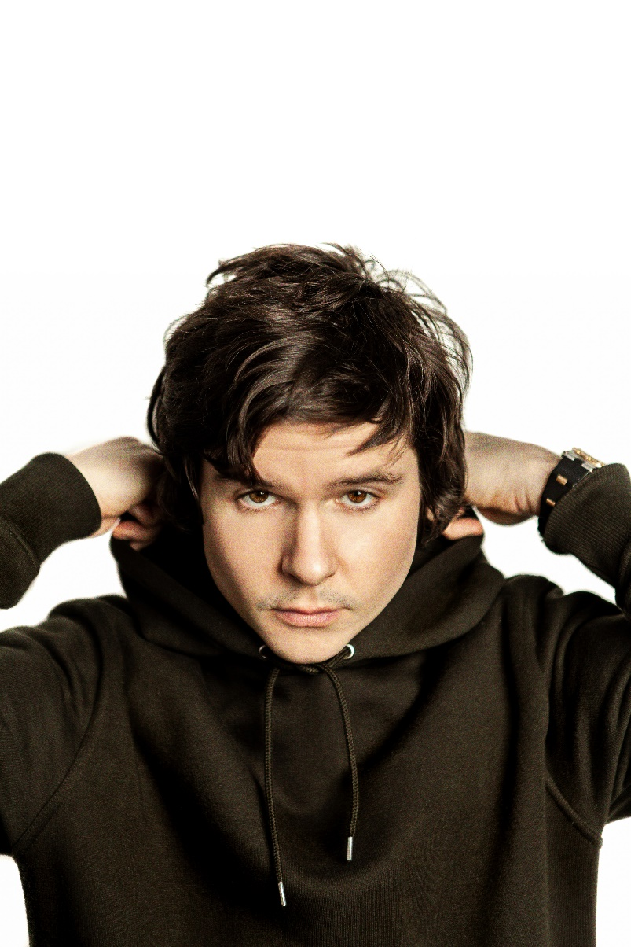
Photo credit: Anders Berg. High-res available here

May 14, 2021 (Los Angeles, CA) – GRAMMY® Award-nominated multi-platinum artist Lukas Graham returns with a new single entitled “Happy For You” out today on Warner Records. After breaking out in 2016 with the global smash “7 Years,” Lukas has continued to impact audiences around the world, earning more than 6.2 Billion streams across his catalogue. “Happy For You” marks his first release of 2021 and officially kicks off the next chapter. To accompany the track, he also revealed a cinematic lyric video.

Listen/share “Happy For You” HERE
Watch the “Happy For You” Cinematic Lyric Video HERE

About the single, Lukas shared, "It’s a song about the terrible ‘what if the worst came to pass,’ and we weren’t together. I’d want you to be happy whatever that entails, and if I didn’t want you to be happy, then was it ever real love? Or, was it just infatuation and desire? ‘Happy For You’ attempts to narrate the broken-heartedness of the breakup, acknowledging the difficulties and the struggle of the one ‘left behind’.”

For the track, Lukas teamed up with multi-GRAMMY® Award-nominated and BRIT Award-winning production trio TMS—notable for producing Lewis Capaldi’s “Someone You Loved” in addition to Top 40 anthems for Dua Lipa, John Legend, Maroon 5, and more. His instantly recognizable vocals sail over heavenly piano as he asks, “Where are you?” This emotionally charged ballad builds towards an acceptance of a romance’s conclusion as he promises, ‘I’m happy for you!’.”

The song paves the way for much more to come from Lukas Graham in 2021. Stay tuned.

About Lukas Graham:
Since his eponymous global debut in 2016, GRAMMY® Award-nominated multi-platinum artist Lukas Graham has solidified his status as one of the biggest breakout acts in music. His multi-platinum song “Love Someone,” from 2018’s 3 (The Purple Album), has now been streamed more than 1 billion times worldwide and is 18X Certified Platinum across multiple continents, with performances on Good Morning America, American Idol, The Bachelorette, Dancing with the Stars, Jimmy Kimmel Live!, The Late Late Show with James Corden, Late Night with Seth Meyers, LIVE with Kelly & Ryan and more. Lukas Graham became a breakthrough star with his 2016 self-titled debut album, spawning the 7X platinum, 3X GRAMMY® nominated hit “7 Years,” which has now been streamed 3 billion times globally. The smash was the highest-selling single by a debut artist in 2016, and catapulted the Danish superstar to sold-out tours around the world, critical acclaim from the likes of The New York Times, Rolling Stone, and Billboard, and countless television performances, including The GRAMMY® Awards and the MTV Video Music Awards, where he was also nominated for “Best New Artist.” The song transformed Lukas’ life into a whirlwind — a world away from his beginnings, born on a couch in Christiania, an impoverished quasi-commune located in the center of Copenhagen. He most recently teamed up with Wiz Khalifa on “Where I’m From” and G-Eazy on “Share That Love,” following a series of track releases over the past year including, “Scars,” “Love Songs” and “Lie.”

###
For further information on Lukas Graham, contact:
Ceri Roberts / Ceri.Roberts@warnerrecords.com
Patrice Compere / Patrice.Compere@warnerrecords.com

Follow Lukas Graham:
Website | Twitter | Facebook | Instagram | Press Site

