LUKAS GRAHAM SHARES NEW SINGLE AND VIDEO “LIE”

U.S. HEADLINE TOUR KICKS OFF OCTOBER 22

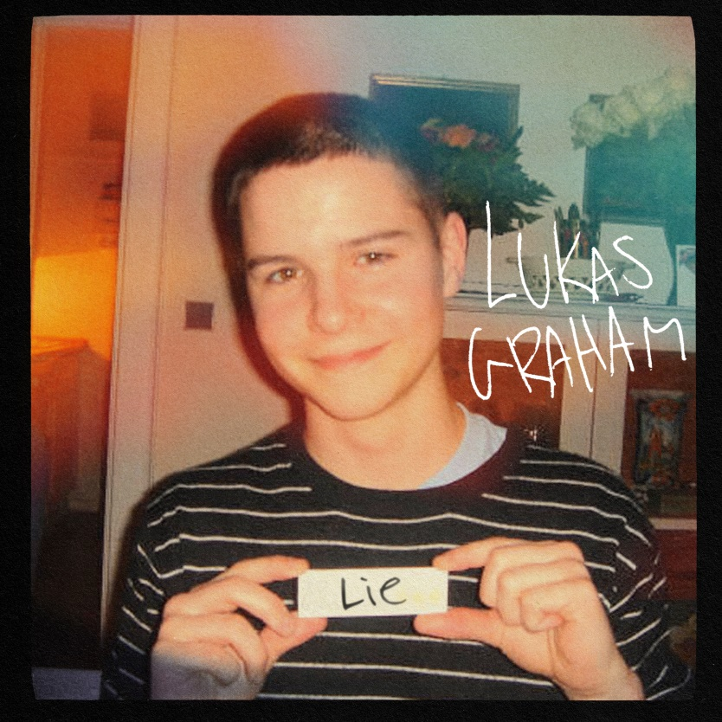

September 27, 2019 (Los Angeles, CA) – GRAMMY® Award-nominated multiplatinum artist Lukas Graham share their latest single, “Lie” today on Warner Records, alongside the official video. On the new track, lead singer Lukas Forchhammer continues to write from a personal and autobiographical place, taking listeners back to the beginning of a young, tumultuous teenage relationship that has proven to stand the test of time, and is partially inspired by his now-fiancé. In fact, the official artwork for “Lie” is a photo taken on the same night that the couple met.

Listen/Share “Lie” HERE
Watch/Share “Lie” (Official Video) HERE

Lukas Graham will embark on their 2019 North American tour next month, beginning on October 22 in Seattle. Tickets are now available for purchase at lukasgraham.com. See the full itinerary below.

Lukas Graham released their sophomore album, 3 (The Purple Album) last year, alongside its platinum-certified single “Love Someone” which has been streamed over 500M times, with performances on Good Morning America, American Idol, The Bachelorette, Dancing with the Stars, Jimmy Kimmel Live!, The Late Late Show with James Corden, Late Night with Seth Meyers, LIVE with Kelly & Ryan and more. Lukas Graham made their global debut with their 2016 self-titled debut album, racking up over 25 million units in worldwide consumption and spawning the 7X platinum, 3X GRAMMY® nominated hit “7 Years,” which has been streamed 1 BILLION times on Spotify worldwide, a feat that only 25 other artists have accomplished. The breakout smash was the highest-selling single by a debut artist in 2016, and catapulted the Danish artist to sold-out tours around the world, critical acclaim from the likes of The New York Times, Rolling Stone, and Billboard, and countless television performances, including The GRAMMY® Awards and the MTV Video Music Awards, where he was also nominated for “Best New Artist.” The song transformed Danish singer Lukas Forchhammer’s life into a whirlwind — a world away from his beginnings, born on a couch in Christiania, an impoverished quasi-commune located in the center of Copenhagen, where he met his “boys” turned bandmates – Mark “Lovestick” Falgren (drums) and Magnús “Magnúm” Larsson (bass).

LUKAS GRAHAM U.S. TOUR DATES
October 22 Seattle, WA The Moore Theatre
October 23 Portland, OR McMenamin’s Crystal Ballroom
October 25 Berkeley, CA The UC Theatre
October 27 San Diego, CA House of Blues
October 28 Los Angeles, CA The Wiltern
October 30 Phoenix, AZ The Van Buren
November 1 Austin, TX ACL Live at the Moody Theater
November 2 Houston, TX House of Blues
November 3 Dallas, TX House of Blues
November 6 Chicago, IL House of Blues
November 9 New York, NY Hammerstein Ballroom
November 10 Boston, MA House of Blues

###
For further information on Lukas Graham, contact:
Jaime Rosenberg / Jaime.Rosenberg@warnerrecords.com

Tour Inquiries:
Patrice Compere / Patrice.Compere@warnerrecords.com

Follow Lukas Graham:
Website: www.lukasgraham.com
Facebook: facebook.com/LukasGraham
Twitter: @LukasGraham
Instagram: @lukasgraham

Press Materials:
press.warnerrecords.com/lukasgraham

