LUKAS GRAHAM DROPS VIDEO FOR NEW SONG “NOT A DAMN THING CHANGED”

PERFORMING LEAD SINGLE “LOVE SOMEONE” ON JIMMY KIMMEL LIVE!
ON OCTOBER 24

New Album 3 (The Purple Album) Out on October 26 via Warner Bros. Records

On Tour in North America in 2019, Tickets On Sale Now

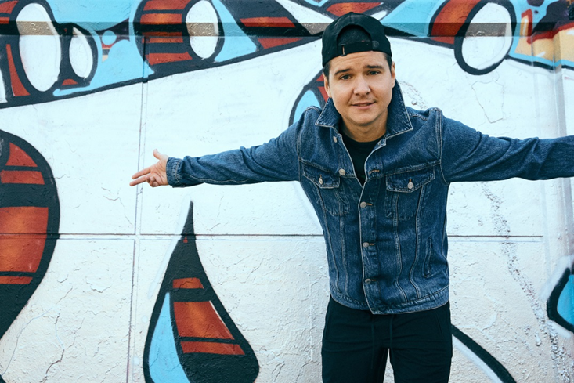

October 12, 2018 (Los Angeles, CA) – Today, GRAMMY® Award-nominated multiplatinum Lukas Graham drops a new song and video “Not A Damn Thing Changed” off the forthcoming album, 3 (The Purple Album), out on October 26 via Warner Bros. Records. The defiant new track follows lead single “Love Someone,” which has been following in the footsteps of global smash “7 Years,” as it rapidly climbs the Hot AC radio charts, amassing 30 million Spotify streams and 21 million YouTube views to date. Following his recent performance on Dancing With The Stars, Lukas Graham will be performing “Love Someone” on the Jimmy Kimmel Live! Outdoor Stage on October 24, audience tickets available here.

Stream/Download “Not A Damn Thing Changed”
https://LukasGraham.lnk.to/NotADamnThingChanged

Watch/Share Video for “Not A Damn Thing Changed”
https://LukasGraham.lnk.to/NADTCVideo

“Not A Damn Thing Changed,” the bold album opener, is about Lukas’ formative years and his resonant experiences growing up in Christiania. “I still live two blocks away from where I grew up, I still hang out with the same guys,” Lukas explains. “The song is a tribute to one of the guys I grew up with who hung himself in January. He was three months older than me and we walked through life together.” As a moving homage to him, the video was filmed with Lukas’ real-life childhood friends around their hometown Christiania and Copenhagen.

Lukas Graham recently announced a 2019 North American tour, beginning on February 22 in Portland. Tickets are now available for purchase at lukasgraham.com. See the full itinerary below.

3 (The Purple Album) serves as the follow-up to Lukas Graham’s eponymous global debut, which racked up over 23 million units in worldwide consumption, saw “7 Years” hit number one in 13 different countries, and earned the band three GRAMMY® Award nominations – including both Record and Song of the Year. The breakout smash was the highest-selling single by a debut artist in 2016, and catapulted the Danish artist to sold-out tours around the world, critical acclaim from the likes of The New York Times, Rolling Stone, and Billboard, and countless television performances, including The GRAMMY® Awards and the MTV Video Music Awards, where he was also nominated for “Best New Artist.”

While Lukas wrote the breakout debut album and subsequent smash “7 Years” in his mid-20s, grappling with the loss of his father, the new album sees Lukas push deeper still, holding a magnifying glass up to his life, laying bare his vulnerabilities and his fears, his sadness and his joy. Now 30, engaged to his long-term girlfriend, and proud father of a little girl, Viola, 3 serves as a "growing up" moment for Lukas as he transitions from son to father. Lukas says simply, “It’s a more mature record, definitely, but it has more life in it.”

LUKAS GRAHAM U.S. TOUR DATES
February 22 Portland, OR Crystal Ballroom
February 24 Seattle, WA The Moore Theatre
February 26 Berkeley, CA The UC Theatre
February 28 Los Angeles, CA The Wiltern
March 2 San Diego, CA House of Blues
March 3 Phoenix, AZ The Van Buren
March 6 Austin, TX Austin City Limits Live at The Moody Theater
March 7 Houston, TX House of Blues
March 8 Dallas, TX House of Blues
March 10 Chicago, IL House of Blues
March 13 Boston, MA House of Blues
March 15 New York, NY Hammerstein Ballroom

###
For further information on Lukas Graham, contact:
Jaime Rosenberg / Jaime.Rosenberg@wbr.com
Ceri Roberts / Ceri.Roberts@wbr.com

Digital Assets:
Stream/Download “Not A Damn Thing Changed” here
Watch/Share Video for “Not A Damn Thing Changed” here
Watch “Love Someone” video here
Stream/Download “Love Someone” here
Pre-order 3 (The Purple Album) here

Follow Lukas Graham:
Website: www.lukasgraham.com
Facebook: facebook.com/LukasGraham
Twitter: @LukasGraham
Instagram: @lukasgraham

Press Materials:
press.wbr.com/lukasgraham

