LUKAS GRAHAM TEAMS UP WITH G-EAZY ON ANTHEMIC NEW SINGLE “SHARE THAT LOVE”

PERFORMING ON GOOD MORNING AMERICA THIS TUESDAY, AUGUST 25TH

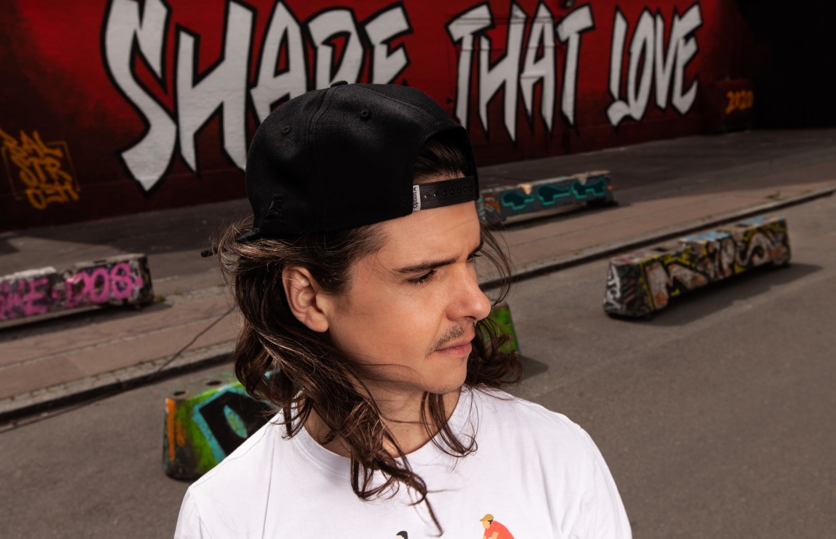
Photo by Anders Berg. Hi-res available here

August 21, 2020 (Los Angeles, CA) – GRAMMY® Award-nominated multi-platinum artist Lukas Graham has teamed up with chart-topping rapper G-Eazy on anthemic new single “Share That Love,” out today via Warner Records. Produced by Lukas’ longtime producer Rissi [Kygo, Julia Michaels], the song is accompanied by a time-lapsed lyric video created by acclaimed Copenhagen street artist Rasmus Balstrøm, who painted a massive “Share That Love” mural at a landmark music venue in Lukas’ hometown Christiania, Denmark. This Tuesday, August 25th, Lukas Graham will perform “Share That Love” for the very first time on Good Morning America.

“Share That Love” (feat. G-Eazy) Lyric Video – WATCH HERE
“Share That Love” (feat. G-Eazy) Audio – LISTEN HERE

Lukas explains, “I grew up in a neighborhood where, if you had something you shared it. The place is called Christiania. It’s an old army base that got squatted in 1971. The community operates from the concept that nobody owns their house and that you can do what you want, as long as you don’t inhibit others from doing what they want. For all the upsides to living in Christiania, there was also trouble with the police, or issues with gangs in the city. I’ve tried to embody all of that in this song, and when I listen to it I’m reminded of some of the ways our community has really come together, like all the great parties we’ve thrown, or the huge protests where we’ve marched against the government threatening to evict us from Christiania. In these troubling times, I guess it is more important than ever to share what we have, especially your love.”

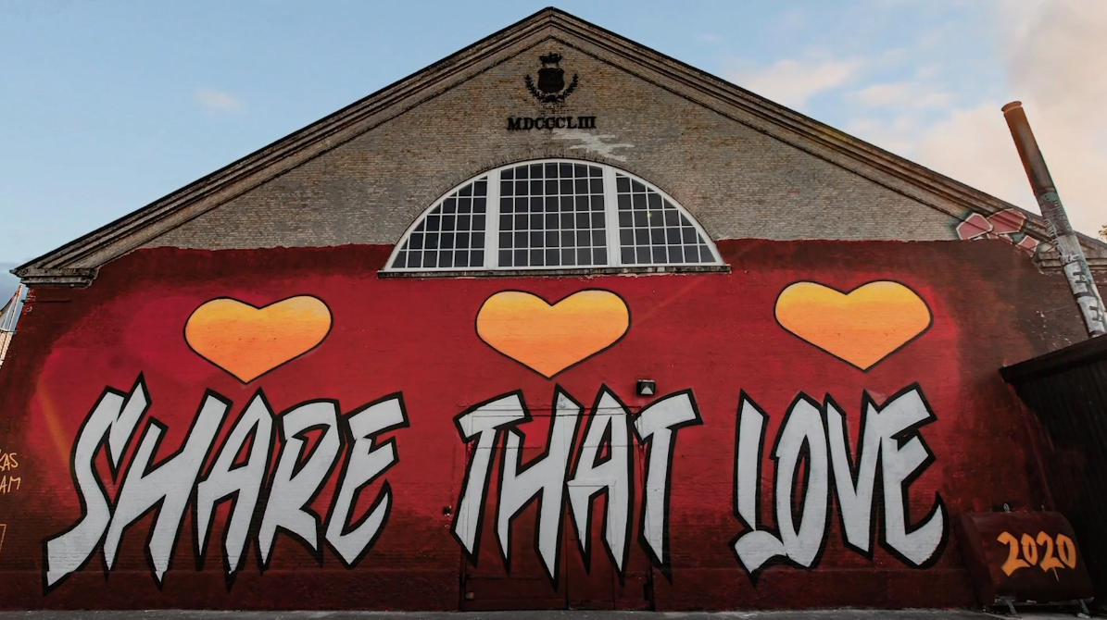
“Share That Love” mural located at The Grey Hall in Christiania, Denmark

More about Lukas Graham
“Share That Love” is the latest from the Danish superstar, who recently achieved 6 billion streams worldwide, following “Love Songs,” “Scars” and last year’s “Lie.” His multi-platinum song “Love Someone,” from 2018’s 3 (The Purple Album), has now been streamed worldwide more than 1 billion times and is 18X Certified Platinum across multiple continents, with performances on Good Morning America, American Idol, The Bachelorette, Dancing with the Stars, Jimmy Kimmel Live!, The Late Late Show with James Corden, Late Night with Seth Meyers, LIVE with Kelly & Ryan and more. Lukas Graham made his global debut with 2016 self-titled debut album, spawning the 7X platinum, 3X GRAMMY® nominated hit “7 Years,” which has been streamed more than 3 billion times globally. The breakout smash was the highest-selling single by a debut artist in 2016, and catapulted the Danish artist to sold-out tours around the world, critical acclaim from the likes of The New York Times, Rolling Stone, and Billboard, and countless television performances, including The GRAMMY® Awards and the MTV Video Music Awards, where he was also nominated for “Best New Artist.” The song transformed Lukas’ life into a whirlwind — a world away from his beginnings, born on a couch in Christiania, an impoverished quasi-commune located in the center of Copenhagen.

###
For further information on Lukas Graham, contact:
National: Jaime Rosenberg / Jaime.Rosenberg@warnerrecords.com
Regional: Patrice Compere / Patrice.Compere@warnerrecords.com

Follow Lukas Graham:
Website | Twitter | Facebook | Instagram | Press Site

