LUKAS GRAHAM TEAMS UP WITH WIZ KHALIFA ON NEW TRACK
“WHERE I’M FROM”

ORIGINAL SONG FEATURED IN NEW DOCUMENTARY 7 YEARS OF LUKAS GRAHAM

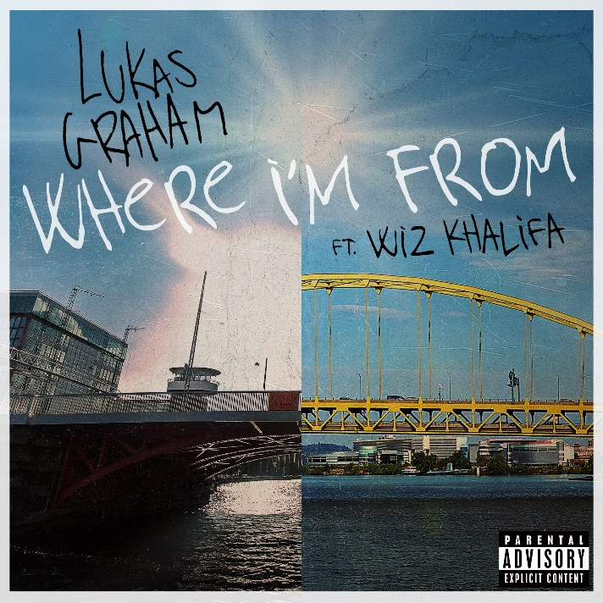

November 5, 2020 (Los Angeles, CA) – GRAMMY® Award-nominated multi-platinum artist Lukas Graham has teamed up Wiz Khalifa on new track “Where I’m From” out today on Warner Records. The new collaboration is the latest from the Danish superstar, who most recently collaborated with G-Eazy on lead single “Share That Love.” Listen/share “Where I’m From” HERE

“Where I’m From” was written for the new documentary 7 Years of Lukas Graham, which premieres today in Denmark ahead of its international release in 2021. Directed by Renè Sascha Johannsen, the film follows lead singer Lukas Forchhammer over seven tumultuous years, from a boy entering the world of fame and success into an adult, who is still struggling to find his footing in a world where all eyes are on him. It is a deeply personal tale about finding where you belong, when life is pulling you in a million different directions.

About the new track, Lukas explains, “It's a song about remembering your roots without losing sight of where you wanna go. Growth is a necessary component in life if you want to be happy, and growth comes in many shapes and forms, most of them personal. I've traveled a long way already but I still live a few blocks away from where I grew up. My point is, that you can grow and move light years and still stay put. It's all about perception and attitude. Usually, to make something good out of something bad, all I need to do is change those two things. My perception and it my attitude. And the attitude we've had as a team has brought us far enough from home to work with legends like DJ Mustard and Wiz Khalifa. I'm stoked to have a song out with them and super proud of the work each of us have put into it.”

###
For further information on Lukas Graham, contact:
National: Jaime Rosenberg / Jaime.Rosenberg@warnerrecords.com
Regional: Patrice Compere / Patrice.Compere@warnerrecords.com

Follow Lukas Graham:
Website | Twitter | Facebook | Instagram | Press Site

