MASTODON CELEBRATES 20 YEARS WITH THE RELEASE OF OFFICIAL VIDEO FOR NEW SONG “FALLEN TORCHES” FROM
MEDIUM RARITIES OUT NOW VIA REPRISE RECORDS

LISTEN HERE AND WATCH HERE

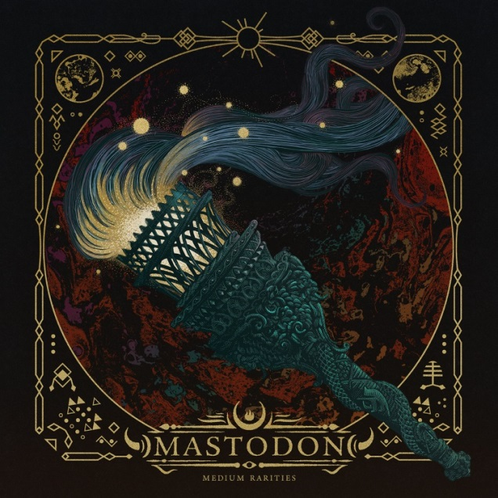
(Click here for hi-res artwork)

September 11th, 2020 (Los Angeles, CA) – Today, GRAMMY®-winning hard rock iconoclasts Mastodon untether the official video for new song “Fallen Torches” from Medium Rarities, available now. Typically true to form, the video for the new track lifts off into psychedelic stellar regions thanks to directorial skills of Hey Beautiful Jerk and Machina-Infinitum. Click here to view/share “Fallen Torches.”

As previously announced, “Fallen Torches” was recorded in Atlanta in 2019, originally planned to be released in support of a European tour, the track was delayed so the band could focus on the release of Stairway to Nick John, a tribute to their late, long time manager Nick John, with proceeds going to the Hirshberg Foundation for Pancreatic Cancer Research in his honor. ‘Fallen Torches’ is written by Mastodon and features guest vocals by longtime friend and collaborator Scott Kelly from the band Neurosis.”
Medium Rarities is a trove of buried audio treasures comprised of classic covers, soundtrack contributions, instrumentals, B-sides, and live recordings unearthed and gathered together for this mammoth collection. Among an eclectic range of covers, the Mastodonians attack “A Commotion” by Feist, “A Spoonful Weighs A Ton” by The Flaming Lips, and “Orion” by Metallica, making each their own. Other highlights include soundtrack cuts such as “White Walker” [Game of Thrones] and “Cut You Up With A Linoleum Knife” [Aqua Teen Hunger Force]. Instrumental versions of “Asleep in the Deep,” “Toe To Toes,” “Jaguar God,” and “Halloween” complete the set. 14 of these tracks have never been available on streaming platforms until now, just in time to celebrate the band’s 20th anniversary. Pre-order the limited-edition pink vinyl edition here (available on Oct. 16th).

By now, you’ve heard yet another new Mastodon track “Rufus Lives” from the Orion Pictures film and soundtrack of Bill & Ted Face The Music, out now on 10K Projects. Click here to stream
Bill & Ted Face The Music, The Original Motion Picture Soundtrack.

Currently, Mastodon are hard at work on their anxiously awaited ninth full-length and first record since the GRAMMY® Award-winning Emperor of Sand in 2017.

Medium Rarities Tracklisting:
- Fallen Torches (Previously Unreleased)
- A Commotion (Feist Cover)
- Asleep in the Deep (Instrumental version)
- Capillarian Crest (Live)
- A Spoonful Weighs A Ton (The Flaming Lips Cover)
- Toe To Toes (Instrumental version)
- Circle of Cysquatch (Live)
- Atlanta (Feat. Gibby Haynes)
- Jaguar God (Instrumental)
- Cut You Up With A Linoleum Life (Aqua Teen Hunger Force)
- Blood & Thunder (Live)
- White Walker (Game of Thrones)
- Halloween (Instrumental version)
- Crystal Skull (Live)
- Orion (Metallica Cover)
- Iron Tusk (Live)

# # #

For all Mastodon inquiries, please contact:
Rick Gershon at Warner Records / Reprise Records
rick.gershon@warnerrecords.com

Follow Mastodon:
Website | Facebook | YouTube | Twitter | Instagram | Spotify

Press materials:
https://press.warnerrecords.com/mastodon/

