GRAMMY® AWARD-WINNING MASTODON RELEASE ACOUSTIC VERSION OF “TEARDRINKER” FROM HUSHED AND GRIM

TICKETS ON SALE NOW FOR SECOND LEG OF
CO-HEADLINE TOUR WITH OPETH

NOMINATED FOR “BEST METAL PERFORMANCE” AT 2022 GRAMMY® AWARDS

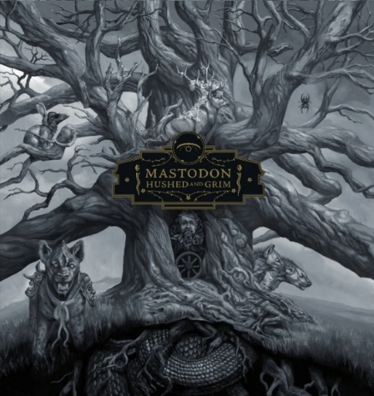
(Hi-res cover image by Paul Romano here)

March 18, 2022 (Los Angeles, CA) – GRAMMY® Award winners Mastodon celebrate their upcoming co-headline tour with Opeth with an acoustic version of “Teardrinker” from their internationally acclaimed album Hushed and Grim. The reimagined version features a wistful element that underscores its lyrical heartbreak with sweeping backing harmonies and piano supported by the acoustic guitar pattern. “Teardrinker (Acoustic)” displays a new side to Mastodon’s musical prism that is as equally powerful as the original but through a more plaintive lens. The track was composed by all four band members and features lead vocals by Brann Dailor, with backing vocals by Brent Hinds, Troy Sanders, and Dailor as well. Joao Nogueira provides keyboards and will also be touring with Mastodon. Click here to stream.

As previously announced, 2022 GRAMMY® nominated Mastodon will return to the road for the second leg of their acclaimed co-headline tour with Opeth this Spring. The North American jaunt resumes on April 21 at Place Bell in Montreal, QC, stops in major markets coast-to-coast, and concludes on May 14 at The Observatory North Park in San Diego, CA. Tickets are on sale now. Click here for more details.

Hushed and Grim took the #1 position on the Billboard Hard Rock Album Chart with the band’s first double album. The band had achieved the same feat with their last studio album Emperor Of Sand in 2017. Concurrently, Hushed and Grim also topped the official Rock and Metal Chart in the U.K.

Hushed and Grim was recorded in Atlanta at the bands very own studio, West End Sound. Produced by David Bottrill (Tool, Rush, Muse, Peter Gabriel), the 15-track album is easily their most ambitious studio work to date, and demonstrates Mastodon’s disparate confluence of textures that include classic rock, psychedelia, punk, metal, alternative, and prog interwoven by their innately expressive musical interplay. The album also serves as a tribute to their old friend, confidant, and longtime manager the late Nick John who tragically passed away from Pancreatic cancer in September 2018. Always pushing their creative process to greater expanse, the ever-evolving music of Mastodon defies categorization. It is simply Mastodon music. Click here to view and share an inside view into the band’s unique creative process.

2022 MASTODON TOUR DATES – co-headline with Opeth plus support from Khemmis:
# Indicates newly added headline show with support from Khemmis
* Indicates European headline dates
Apr 21 Montreal, QC Place Bell
Apr 22 Toronto, ON Queen Elizabeth Theatre
Apr 23 Cleveland, OH The Agora
Apr 24 Pittsburgh, PA Stage AE
Apr 26 Philadelphia, PA The Met
Apr 28 Chicago, IL Aragon Ballroom
Apr 29 Detroit, MI The Masonic
Apr 30 Milwaukee, WI Eagles Ballroom
May 01 St. Paul, MN The Myth
May 03 Saskatoon, SK TCU Place
May 04 Calgary, AB Grey Eagle Events Centre
May 05 Edmonton, AB EDM Expo Center
May 07 Vancouver, BC Thunderbird Sports Centre
May 08 Seattle, WA Paramount Theater
May 09 Portland, OR Keller Auditorium
May 11 Riverside, CA Municipal Auditorium
# May 12 Reno, NV Grand Sierra Resort
# May 13 Las Vegas, NV House of Blues
# May 14 San Diego, CA The Observatory North Park

*Jun 01 Leipzig, GER Parkbuehne Held’
Jun 02 Gdansk, POL Mystic Festival
Jun 04 Nurburgring, GER Rock Am Ring
Jun 05 Nurnburg, GER Rock Im Park
*Jun 07 Paris, FRA Salle Pleyel
*Jun 09 Tilburg, NL O13
Jun 11 Donington Park, UK Download Festival
*Jun 13 Dortmund, GER FZW
*Jun 14 Bremen, GER Pier 2
Jun 16 Dessel, BEL Graspop
Jun 17 Clisson, FRA Hellfest
Jun 18 Copenhagen, DK Copenhell
*Jun 20 Gothenburg, SWE Pustervik
*Jun 21 Malmo, SWE KB
Jun 23 Oslo, NOR Tons of Rock
Jun 26 Verona, ITA Rock The Castle
Jun 27 Vienna, AUT Open Air
*Jun 28 Zagreb, CRO Culture Factorycopenhel
Jul 01 Lisbon, POR VOA Festival National Stadium
Jul 02 Vivero, SPA Resurrection Festival

Sep 23 Louisville, KY Louder Than Life Festival

# # #

Contacts:
Rick Gershon at Warner Records / Reprise Records
rick.gershon@warnerrecords.com

Regional Press: Jenny Huynh at Warner Records / Reprise Records
jenny.huynh@warnerrecords.com

Follow Mastodon:
Website | Facebook | YouTube | Twitter | Instagram | Spotify | Press Materials

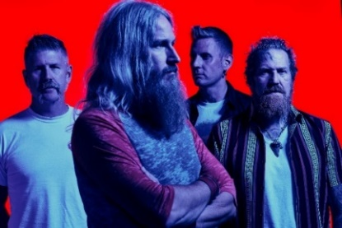
(Click here for Hi-res image by Clay McBride)

