LOS ANGELES DUO ‘MORE’ ANNOUNCE THE RELEASE OF THEIR
DEBUT EP 1/2 – LISTEN HERE

FEATURES THE TRACK “ELABORATE ATTRACTIONS” – WATCH HERE

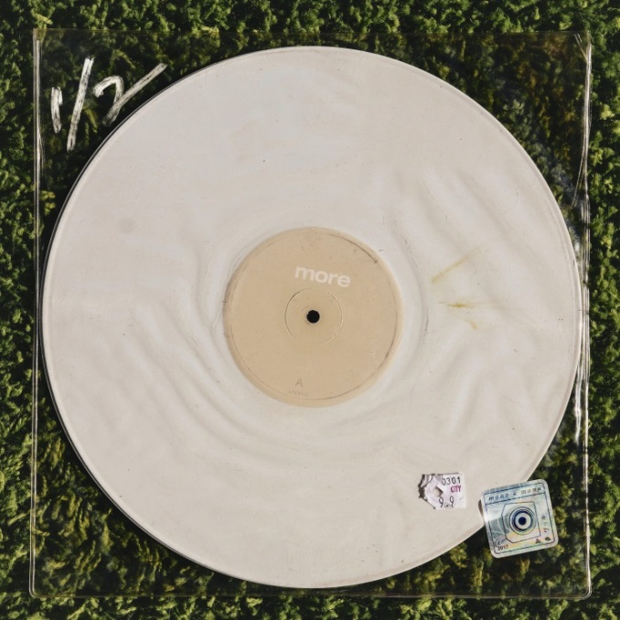
(Click here for hi-res artwork)

July 17, 2020 (Los Angeles, CA) – Eclectic Angelino rock duo more, comprised of songwriters, vocalists, and multi-instrumentalists Kane Ritchotte and Malcolm McRae, announce the release of their debut EP titled 1/2 - available now via Warner Records. The five-song EP contains the recently released tracks “Settled In” and “God’s in the Details,” along with new compositions “All-American Guts,” “The Way,” and “Elaborate Attractions.” Click HERE to listen to EP 1/2.

Today, more release a lysergically-laced short film for the focus track “Elaborate Attractions,” filmed in Los Angeles and directed by Keene McRae, brother of more’s Malcolm McRae. The video is as compelling as the track itself. Click HERE to listen to “Elaborate Attractions” and HERE to watch the official video.

Richotte (vocals, drums, guitar, bass and percussion) and McRae (vocals, guitar) recorded the tracks at the famed Sound City Studios in Los Angeles with veteran producer Tony Berg (Bandura, guitar, keys) at the helm. Additional backing vocals courtesy of: Maddy Baltor, Joseph Lorge and Will Maclellan.

1/2 EP Tracklisting:
Settled In
God’s in the Details
Elaborate Attractions
All-American Guts
The Way

Click HERE to view “God’s In The Details (Riley Keough version).”
Click HERE to view “Settled In” and HERE to listen.
Click HERE to view “God’s in the Details (original version)” and HERE to listen.
# # #
For further information, contact Warner Record Publicity:
National: Rick Gershon | rick.gershon@warnerrecords.com

Regional: Bre Flores | breanne.flores@warnerrecords.com

Follow more:
Official | Instagram | Facebook | Twitter | Press Materials

