RELEASES NEW VIDEO FOR “GOD’S IN THE DETAILS
(RILEY KEOUGH VERSION)” TODAY – WATCH HERE

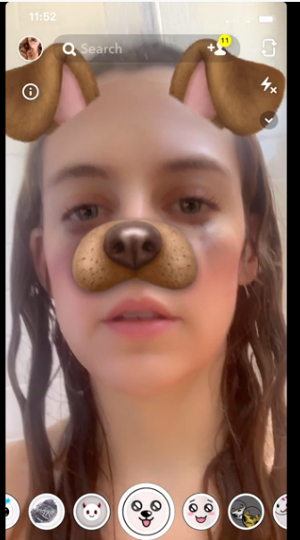

July 7, 2020 (Los Angeles, CA) – Today, Los Angeles rock duo more releases a brand-new version of the video for the track “God’s In The Details (Riley Keough version).” Keough, an award-winning actor, stars in the video as well as co-directed along with Gina Gammell. The video depicts life in the age of isolation as we try – or fail – to remain connected while stranded in quarantineland.

Comprised of songwriters, vocalists, and multi-instrumentalists Kane Ritchotte and Malcolm McRae, together, more have created a seductively alluring song cycle informed by a disparate and deep confluence of inspirations. Their brand of melodic rock combines pop, rock, art, literary and filmic influences together into a seamless sonic fabric. Can and Squeeze will coexist with Emitt Rhodes and Yellow Magic Orchestra or Robert Wyatt with Kendrick Lamar. The end result will sound and feel familiar and modern; classic and forward-thinking.

Click HERE to stream “God’s in the Details” and HERE to view the original video.
Click HERE to view “Settled In” and HERE to listen.

Richotte (vocals, drums, guitar, bass and percussion) and McRae (vocals, guitar) recorded the tracks at the famed Sound City Studios in Los Angeles with veteran producer Tony Berg (Bandura, guitar, keys) at the helm. Additional backing vocals courtesy of: Maddy Baltor, Joseph Lorge and Will Maclellan.

Together, more have created a seductively alluring song cycle informed by a disparate and deep confluence of inspirations. Their brand of melodic rock combines pop, rock, art, literary and filmic influences together into a seamless sonic fabric. Can and Squeeze will coexist with Emitt Rhodes and Yellow Magic Orchestra or Robert Wyatt with Kendrick Lamar. The end result will sound and feel familiar and modern; classic and forward-thinking.

Ritchotte, a well-known session drummer, musician and gifted songwriter/vocalist, has played with Portugal The Man and Grouplove. McRae, an architecture school dropout and new to the LA scene from his native city of Birmingham, AL was on a quest to expand his music talents as a singer/songwriter with an incredibly charismatic voice and a profound musical knowledge.
# # #
For further information, contact Warner Record Publicity:
Rick Gershon | rick.gershon@warnerrecords.com

Follow more:
Official | Instagram | Facebook | Twitter | Press Materials

