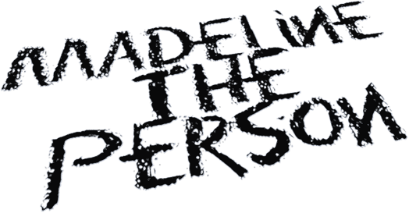

BIOGRAPHY

Music is a coping mechanism for Madeline The Person. The 19-year-old alt-pop newcomer uses her songs to process trauma, triumph, and every confounding human experience in-between. Complete transparency is a compulsion for her, a trait that shaped her critically acclaimed debut EP, Chapter 1: The Longing. Like old diary entries, those four songs document the highs and lows that shaped her outlook on life. Chapter 2: The Shedding, is a snapshot of where she is right now. “I've always written things down to get them out of my brain,” Madeline says.

That unfiltered honesty is especially apparent on Chapter 2. This time, she explores matters of the heart, identity, and sexuality. Take “Haunted,” an acoustic-pop anthem that doubles as a coming-out statement. “It's important to let people know these things about me,” Madeline insists. The arc of the song — losing a lover who’s gone “back in the closet” — mirrors her first romantic experience. “It felt so true, and then all of a sudden it was so not that,” she says. “No one really talks about how hard it is to live your truth after coming out.” The song struck a chord with listeners and gave Madeline the opportunity to share her story as authentically as possible.

Like many pop prodigies, Madeline got a head start while growing up in Houston, Texas. From her mother playing the piano to her father’s extensive album collection, Madeline grew up in a house filled with music. The Warner Records signee began her musical journey by posting on Instagram. Things really took off for her, however, when she switched over to TikTok.

The singer/songwriter’s scalpel-like pen and haunting vocals soon earned her hundreds of thousands of followers as well as praise from superstars like Billie Eilish and Olivia Rodrigo. “Sometimes I suffer from imposter syndrome,” Madeline says. “Anyone who comes out of high school and gets a record deal would. Getting support from those artists is really affirming. It's something I can look at to remind myself that I’m actually quite good at this.” Still, all along she’s stayed true to the purpose of her music since she first started writing songs. The breakout star began exploring her own sound in music in sixth grade, but really embraced the craft at 15 when her father passed away. “It started out as — and still is — a form of therapy,” Madeline says.

A perfect example is Chapter 1 highlight “As a Child,” which is cloaked in the long shadow of grief cast by that loss. Instead of feeling vulnerable, Madeline’s transparency empowers her. “It scares me that it doesn't scare me to be so open,” she says. “But I don't see any reason not to share my story. I know it helps me to put it all out there and I've now seen how it helps other people.”

While Madeline’s often written about pain and loss, part of the joy of listening to Chapter 2 is that it also weaves in hope. “August,” a collaboration with Adam Melchor, is about a flourishing long-distance relationship. And, yes, it’s autobiographical. Another highlight is “Unrecognizable.” The acoustic toe-tapper encapsulates the EP’s central metaphor of shedding her old ways better than any other track. “It’s essentially about change and growth,” she says.

Madeline’s music, which often times unveils a juxtaposition, draws you in with her vivid lyrics, painting stories that keep the listeners connected. “I like to present things in a way that shows beauty and pain,” she explains. “It’s really important to me because they both exist at the same time. My stories are supposed to make you feel a lot of things at once.”

Madeline’s star will, no doubt, continue to rise with the arrival of Chapter 2, the second part of a planned trilogy of EPs. But as the moniker she’s chosen suggests, she plans to keep her feet firmly on the ground. “I learned that I didn’t want to be put in a box and that I can't please people to the point of hurting myself,” says Madeline The Person, as open as she is as an artist. “I have lots of flaws and faults and feelings that hurt, but also all the good stuff. I'm just a person.”

