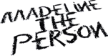

MADELINE THE PERSON RELEASES INTIMATE NEW EP CHAPTER 3: THE BURNING – LISTEN HERE

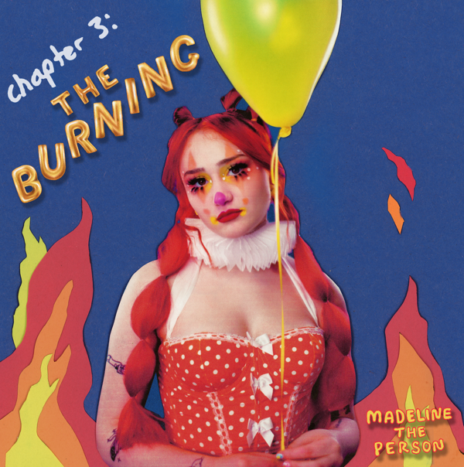

July 15, 2022 (Los Angeles, CA) – Today, breakout alt-pop artist Madeline The Person releases her intimate new EP, CHAPTER 3: The Burning. Listen HERE via Warner Records. The project finds the newcomer entirely in her element, weaving sly, atmospheric anthems teeming with insight and beauty. The 7-track set includes a remix of her viral hit “MEAN!” featuring Noah Kahan, the bouncy breakup anthem “Why I Broke Up With You,” and new heartbreakingly tender cut “Step On Flowers.” Watch the lyric video for “Step On Flowers” HERE.

On CHAPTER 3: The Burning, Madeline delivers a series of introspective tracks that explore coming-of-age in stark detail, full of both heartbreak and self-love in all its forms. “The Burning represents the rage that’s been brewing inside of us all for so long, just because we are afraid to talk about it,” the rising songstress shared.

Inspired by an unrequited love at 17, “Step On Flowers” finds Madeline opening up about the crushing feeling of being unappreciated. “I hope this song comforts the people who feel as if their flowers aren’t treated properly. I assure you that your garden is beautiful and will be an absolute treasure to someone someday.”

On “Why I Broke Up With You,” she breaks down the demise of a once-flourishing romance. This is an extension of the disarming candor she first expressed on “MEAN!,” a pointed response to the cruelty she has experienced as a young person. “One thing I like about me is that I’m nothing like you and I never will be,” she proudly proclaims on the track’s catchy chorus. “Someone who loves how it sounds when they speak, you're not telling the truth — no, you're just being mean.”

It’s an empowering theme, which Madeline further explores on the EP’s “MEAN!” remix featuring co-writer Noah Kahan. Other notable tracks include the stormy pop song “Not Sorry,” the dramatic acoustic track “Stupid Dog,” and the soaring “Baby Boy.”

The 20-year-old’s bold songwriting has already connected with fans in a big way. “MEAN!” conquered TikTok, landing on the app’s Top Sounds for six consecutive weeks and garnering over 910K video creates. Last year, Madeline hit the road for the very first time, supporting The Aces on their headline tour. The rising songwriter also delivered an electrifying set at Los Angeles’ OUTLOUD Music Festival. This year, she is heading to the Wonderbus Music & Arts Festival. With Chapter 3: The Burning, Madeline The Person is coming to her own as an artist brimming with vibrant melodies, intimate emotions, and infectious hooks—her songs will surely resonate with even more new fans soon.

CHAPTER 3: THE BURNING TRACKLIST:
- MEAN!
- Why I Broke Up With You
- Not Sorry
- Stupid Dog
- Baby Boy
- Step on Flowers
- MEAN! (Noah Kahan remix) by Madeline the Person & Noah Kahan

About Madeline The Person:
Music is therapy for Madeline The Person. The alt-pop newcomer uses songwriting to process trauma, triumph, and every confounding feeling in-between. Complete transparency is a compulsion for her, a trait that characterized the 20-year-old’s 2021 debut project, Chapter 1: The Longing. Like old diary entries, those four songs document the highs and lows that forged Madeline’s outlook on life. Unfiltered and unflinching, the EP immediately struck a chord with fans and critics, amassing more than 2 million audio and video streams, and winning recognition from Billboard and People magazine, who included her in their Emerging Artists roundup. While Chapter 1 looked to the past, Chapter 2: The Shedding, also released in 2021, was a snapshot of the present. The second of a planned quartet of EPs, it tackles themes such as sexuality, identity, and growth. The lead single “Haunted” is a perfect example: the acoustic-pop anthem doubled as the Houston, Texas, native’s coming-out statement. Like many pop prodigies, Madeline grew up in a house filled with music. Her talent was nurtured from an early age and she was discovered by Warner Records after posting a series of viral covers on TikTok that garnered her 942,000 followers. Madeline’s star will, no doubt, continue to rise as she adds chapters to her story. But as the moniker she’s chosen suggests, the breakout artist plans to keep her feet firmly on the ground. “I have lots of flaws, faults, and feelings that hurt,” she says, “but also all the good stuff. I'm just a person.”
# # #
For further information, please contact:
Darren Baber | Warner Records
Darren.Baber@warnerrecords.com

Follow Madeline the Person:
TikTok | Instagram | Twitter | YouTube | Press Materials

